UNITED STATES

SECURITIES AND EXCHANGE COMMISSION

Washington, D.C. 20549

______________________________________

FORM 10-K

ANNUAL REPORT PURSUANT TO SECTION 13 OR 15(d) OF THE SECURITIES EXCHANGE ACT OF 1934

For the fiscal year ended December 31, 2019

Commission file number 001-37437

______________________________________

XBIOTECH INC.

(Exact name of Registrant as specified in its charter)

British Columbia, Canada

(State or other jurisdiction of incorporation or organization)

N/A

(IRS Employer Identification No.)

5217 Winnebago Ln, Austin, TX 78744

(Address of principal executive offices, including zip code)

Telephone Number (512) 386-2900

(Registrant's telephone number, including area code)

______________________________________

Securities registered pursuant to Section 12(b) of the Act:

Title of each class |  | Trading Symbol(s) | Name of each exchange on which registered
Common Stock, no par value |  | XBIT | NASDAQ Global Select Market
 | Securities registered pursuant to Section 12(g) of the Act:
 |  | None
 | ______________________________________
Indicate by check mark if the registrant is a well-known seasoned issuer, as defined in Rule 405 of the Securities Act. |  |  |  | Yes ☐ | No ☒
Indicate by check mark if the registrant is not required to file reports pursuant to Section 13 or Section 15(d) of the Act. |  |  |  | Yes ☐ | No ☒

Indicate by check mark whether the registrant (1) has filed all reports required to be filed by Section 13 or 15(d) of the Securities Exchange Act of 1934 during the preceding 12 months (or for such shorter period that the registrant was required to file such reports), and (2) has been subject to such filing requirements for the past 90 days. Yes ☒ No ☐

Indicate by check mark whether the registrant has submitted electronically, every Interactive Data File required to be submitted pursuant to Rule 405 of Regulation S-T (§ 232.405 of this chapter) during the preceding 12 months (or for such shorter period that the registrant was required to submit such files). Yes ☒ No ☐

Indicate by check mark whether the registrant is a large accelerated filer, an accelerated filer, a non-accelerated filer, a smaller reporting company or an emerging growth company. See the definitions of “large accelerated filer,” “accelerated filer,” “smaller reporting company” and “emerging growth company” in Rule 12b-2 of the Exchange Act.

Large accelerated filer ☐

Accelerated filer ☒

Non-accelerated filer ☐

Smaller Reporting Company ☒ Emerging Growth Company ☒

If an emerging growth company, indicate by check mark if the registrant has elected not to use the extended transition period for complying with any new or revised financial accounting standards provided pursuant to Section 13(a) of the Exchange Act. ☐

Indicate by check mark whether the registrant is a shell company (as defined in Rule 12b-2 of the Act). Yes ☐ No ☒

The aggregate market value of the voting and non-voting common equity held by non-affiliates of the registrant as of December 31, 2019, was approximately $581,565,527, based upon the closing sales price for the registrant’s common stock, as reported on the NASDAQ Global Market. The calculation of the aggregate market value of voting and non-voting common equity excludes 10,369,899 shares of common stock the registrant held by executive officers, directors and shareholders that the registrant concluded were affiliates of the registrant on that date. Exclusion of such shares should not be construed to indicate that any such person possesses the power, direct or indirect, to direct or cause the direction of management or policies of the registrant or that such person is controlled by or under common control with the registrant.

As of March 16, 2020, 28,852,927 shares of the registrant’s Common Stock were outstanding.

Documents incorporated by reference:

Certain portions, as expressly described in this Annual Report on Form 10-K, of the registrant’s Proxy Statement for the 2019 Annual Meeting of the Stockholders, to be filed not later than 120 days after the end of the year covered by this Annual Report, are incorporated by reference into Part III of this Annual Report where indicated.

 |  |  |  |  |  |  |  |  |  |  |  |  |  | TABLE OF CONTENTS
 |  |  |  |  |  |  |  |  |  |  |  |  |  |  |  |  |  | PART I
ITEM 1. BUSINESS |  |  |  |  |  |  |  |  |  |  |  |  |  |  |  |  |  |  |  |  |  |  |  |  |  |  |  |  |  |  |  |  | 5
ITEM 1A. RISK FACTORS |  |  |  |  |  |  |  |  |  |  |  |  |  |  |  |  |  |  |  |  |  |  |  |  |  |  |  |  |  |  |  |  |  | 14
ITEM 1B. UNRESOLVED STAFF COMMENTS |  |  |  |  |  |  |  |  |  |  |  |  |  |  |  |  |  |  |  |  |  |  |  |  |  |  |  |  |  |  |  |  | 35
ITEM 2. PROPERTIES |  |  |  |  |  |  |  |  |  |  |  |  |  |  |  |  |  |  |  |  |  |  |  |  |  |  |  |  |  |  |  |  |  | 35
ITEM 3. LEGAL PROCEEDINGS |  |  |  |  |  |  |  |  |  |  |  |  |  |  |  |  |  |  |  |  |  |  |  |  |  |  |  |  |  |  |  |  | 35
ITEM 4. MINE SAFETY DISCLOSURES |  |  |  |  |  |  |  |  |  |  |  |  |  |  |  |  |  |  |  |  |  |  |  |  |  |  |  |  |  |  |  |  | 35
 |  |  |  |  |  |  |  |  |  |  |  |  |  |  |  |  |  | PART II
ITEM 5. MARKET FOR REGISTRANT’S COMMON EQUITY, RELATED STOCKHOLDER MATTERS AND ISSUER
PURCHASES OF EQUITY SECURITIES. |  |  |  |  |  |  |  |  |  |  |  |  |  |  |  |  |  |  |  |  |  |  |  |  |  |  |  |  |  |  |  |  |  | 36
ITEM 6. SELECTED FINANCIAL DATA |  |  |  |  |  |  |  |  |  |  |  |  |  |  |  |  |  |  |  |  |  |  |  |  |  |  |  |  |  |  |  |  |  | 36
ITEM 7. MANAGEMENT’S DISCUSSION AND ANALYSIS OF FINANCIAL CONDITION |  |  |  |  |  |  |  |  |  |  |  |  |  |  |  |  |  |  |  |  |  |  |  |  |  |  |  |  |  |  |  |  |  | 37
ITEM 7A. QUANTITATIVE AND QUALITATIVE DISCLOSURE OF MARKET RISKS |  |  |  |  |  |  |  |  |  |  |  |  |  |  |  |  |  |  |  |  |  |  |  |  |  |  |  |  |  |  |  |  |  | 43
ITEM 8. FINANCIAL STATEMENTS AND SUPPLEMENTARY DATA |  |  |  |  |  |  |  |  |  |  |  |  |  |  |  |  |  |  |  |  |  |  |  |  |  |  |  |  |  |  |  |  | 44
ITEM 9. CHANGES IN AND DISAGREEMENTS WITH ACCOUNTANTS ON ACCOUNTING AND FINANCIAL
DISCLOSURE |  |  |  |  |  |  |  |  |  |  |  |  |  |  |  |  |  |  |  |  |  |  |  |  |  |  |  |  |  |  |  |  | 62
ITEM 9A. CONTROLS AND PROCEDURES. |  |  |  |  |  |  |  |  |  |  |  |  |  |  |  |  |  |  |  |  |  |  |  |  |  |  |  |  |  |  |  |  |  | 62
ITEM 9B. OTHER INFORMATION |  |  |  |  |  |  |  |  |  |  |  |  |  |  |  |  |  |  |  |  |  |  |  |  |  |  |  |  |  |  |  |  | 62
 |  |  |  |  |  |  |  |  |  |  |  |  |  |  |  | PART III
ITEM 10. DIRECTORS, EXECUTIVE OFFICERS AND CORPORATE GOVERNANCE |  |  |  |  |  |  |  |  |  |  |  |  |  |  |  |  |  |  |  |  |  |  |  |  |  |  |  |  |  |  |  |  |  | 63
ITEM 11. EXECUTIVE COMPENSATION |  |  |  |  |  |  |  |  |  |  |  |  |  |  |  |  |  |  |  |  |  |  |  |  |  |  |  |  |  |  |  |  |  | 63
ITEM 12. SECURITY OWNERSHIP OF CERTATIN BENEFICIAL OWNERS AND MANAGEMENT AND RELATED
STOCKHOLDER MATTERS |  |  |  |  |  |  |  |  |  |  |  |  |  |  |  |  |  |  |  |  |  |  |  |  |  |  |  |  |  |  |  |  |  | 63
ITEM 13. CERTAIN RELATIONSHIPS AND RELATED TRANSACTIONS AND DIRECTOR INDENDENCE |  |  |  |  |  |  |  |  |  |  |  |  |  |  |  |  |  |  |  |  |  |  |  |  |  |  |  |  |  |  |  |  | 63
ITEM 14. PRINCIPAL ACCOUNTING FEES AND SERVICES |  |  |  |  |  |  |  |  |  |  |  |  |  |  |  |  |  |  |  |  |  |  |  |  |  |  |  |  |  |  |  |  |  | 63
 |  |  |  |  |  |  |  |  |  |  |  |  |  |  |  |  | PART IV
ITEM 15. EXHIBITS AND FINANCIAL STATEMENT SCHEDULES |  |  |  |  |  |  |  |  |  |  |  |  |  |  |  |  |  |  |  |  |  |  |  |  |  |  |  |  |  |  |  |  | 63
ITEM 16. FORM 10-K SUMMARY |  |  |  |  |  |  |  |  |  |  |  |  |  |  |  |  |  |  |  |  |  |  |  |  |  |  |  |  |  |  |  |  |  | 66
2

CAUTIONARY STATEMENT REGARDING FORWARD-LOOKING STATEMENTS

This annual report contain forward-looking statements that involve substantial risks and uncertainties. All statements, other than statements of historical facts, included in this annual report, including, without limitation, statements regarding the assumptions we make about our business and economic model, our dividend policy, business strategy and other plans and objectives for our future operations, are forward-looking statements.

These forward-looking statements include declarations regarding our management’s beliefs and current expectations. In some cases, you can identify forward-looking statements by terminology such as “may,” “will,” “should,” “would,” “could,” “expects,” “plans,” “contemplate,” “anticipates,” “believes,” “estimates,” “predicts,” “projects,” “intend” or “continue” or the negative of such terms or other comparable terminology, although not all forward-looking statements contain these identifying words. Forward-looking statements are subject to inherent risks and uncertainties in predicting future results and conditions that could cause the actual results to differ materially from those projected in these forward-looking statements. Some, but not all, of the forward-looking statements contained in this annual report include, among other things, statements about the following:

- our ability to obtain regulatory approval to market and sell our product candidates in the United States, Europe and elsewhere;

- the initiation, timing, cost, progress and success of our research and development programs, preclinical studies and clinical trials for our product candidates;

- our ability to advance product candidates into, and successfully complete, clinical trials;

- our ability to successfully commercialize the sale of our product candidates in the United States, Europe and elsewhere;

- our ability to recruit sufficient numbers of patients for our future clinical trials for our pharmaceutical products;

- our ability to achieve profitability;

- our ability to obtain funding for our operations, including research funding;

- our ability to identify additional new products using our True Human™ antibody discovery platform;

- the implementation of our business model and strategic plans;

- our ability to develop and commercialize product candidates for orphan and niche indications independently;

- our commercialization, marketing and manufacturing capabilities and strategy;

- our ability to protect our intellectual property and operate our business without infringing upon the intellectual property rights of others;

- our expectations regarding federal, state and foreign regulatory requirements;

3

- the therapeutic benefits, effectiveness and safety of our product candidates;

- the accuracy of our estimates of the size and characteristics of the markets that may be addressed by our products and product candidates;

- the rate and degree of market acceptance and clinical utility of our future products, if any;

- the timing of and our collaborators’ ability to obtain and maintain regulatory approvals for our product candidates;

- our expectations regarding market risk, including interest rate changes, foreign currency fluctuations and regional or global economic impacts caused by public health threats, such as the outbreak of coronavirus or other infectious diseases;

- our belief in the sufficiency of our cash flows to meet our needs for at least the next 12 to 24 months;

- our expectations regarding the timing during which we will be an emerging growth company under the JOBS Act;

- our ability to engage and retain the employees required to grow our business;

- our future financial performance and projected expenditures;

- developments relating to our competitors and our industry, including the success of competing therapies that are or become available; and

- estimates of our expenses, future revenue, capital requirements and our needs for additional financing.

You should also read the matters described in the “Risk Factors” and the other cautionary statements made in this annual report as being applicable to all related forward-looking statements wherever they appear in this annual report. We cannot assure you that the forward-looking statements in this annual report will prove to be accurate and therefore you are encouraged not to place undue reliance on forward-looking statements. You should read this annual report completely.

4

PART I

ITEM 1 BUSINESS

Overview

XBiotech Inc. (“XBiotech” or the “Company) is a biopharmaceutical company that discovers and develops True Human™ monoclonal antibodies for treating a variety of diseases.

True Human™ monoclonal antibodies are derived from those which occur naturally in human beings—as opposed to being derived from animal immunization or otherwise engineered. XBiotech’s belief is that naturally occurring monoclonal antibodies have the potential to be safer, more effective and faster to develop than their non-naturally occurring counterparts. XBiotech is developing a pipeline of product candidates targeting both inflammatory and infectious diseases and has developed commercial scale manufacturing technology and infrastructure that reduces the cost and time to launch new product candidates. The Company has fully integrated development capabilities at its headquarters in Austin, Texas including non-clinical and clinical operations and manufacturing.

The Company’s major medical focus is developing anti-inflammatory therapies by using human derived True Human™ antibodies that neutralize the inflammation-causing substance interleukin-1 alpha (IL-1a). IL-1a is a protein that is on or in cells of the body and causes inflammation in response to injury. In almost all chronic and in some acute injury scenarios (such as stroke or heart attack), IL-1a can cause pathological inflammation, resulting in harm

or disease exacerbation. In a recent transaction, XBiotech sold a True Human™ antibody that blocked IL-1a activity and was used successfully in a number of clinical trials (the “Janssen Transaction”). The sale of the antibody generated $675 million in upfront cash with an additional $75 million held in an escrow account and up to $600 million in potential milestone payments. As part of the Janssen Transaction, XBiotech agreed not to further develop any anti-

IL-1a antibodies in dermatology. The Company is pursuing the development of other True Human™ antibodies targeting IL-1a for areas of medicine outside of dermatology. Due to the speed and effectiveness of the Company’s True Human™ antibody discovery technology, the Company has already identified

new IL-1a targeting product candidates that it is planning to bring into the clinic. While the Company previously was focused on a single True Human™ antibody targeting IL-1a, it now plans to develop multiple product candidates, which will target IL-1a in specific areas of medicine.

In addition to the upfront payment, other revenue streams were achieved from the recent sale of the Company’s IL-1a targeting product candidate. XBiotech agreed to use its proprietary manufacturing technology to produce the drug candidate for two years under a supply agreement starting January 1, 2020. In addition, XBiotech is providing clinical trial operation services to complete two ongoing Phase II clinical studies evaluating the drug in Hidradenitis Suppurativa and Atopic Dermatitis. The financial strength generated from the Janssen Transaction will enable expansion of IL-1a targeting product development and infectious disease programs.

IL-1a plays a key role in pathological inflammation. While it is produced naturally by the body, when not properly controlled, in situations of acute or chronic injury, inflammation caused by IL-1a can contribute to the development and progression of a variety of medical conditions, such as cancer, stroke, heart attack or arthritis, to name a few. Completed clinical studies and a myriad of scientific research have shown that blocking IL-1a may have a beneficial effect in numerous medical conditions. The potential unmet medical need for blocking inflammation through neutralizing IL-1a is vast. The Company’s new resources will enable them to better exploit the development potential for anti-IL-a therapy. The Company plans to reenter the clinic with more than one additional anti-IL-1⍺ therapy, beginning in early 2021.

XBiotech believes there is substantial unmet medical need for True Human™ antibody therapy targeting IL-1⍺ related inflammation. The Company is considering initial indications in stroke, cancer, psoriatic arthritis and end-stage renal disease patients undergoing hemodialysis. Because the potential

medical uses for anti-IL-1a therapy is so large, the Company plans to develop more than one True Human™ antibody, each neutralizing IL-1a, but designating different antibodies for use in specific areas of medicine. This will potentially allow XBiotech to individually partner different antibodies according to unique medical areas. The Company expects this will diversify risk for anti-IL-1a therapies, allow multiple partnerships, maximize value and facilitate greater resource dedication to these True Human™ anti-inflammatory therapeutics.

5

XBiotech continued to achieve significant milestones with its infectious disease pipeline in 2019. The Company has identified several major areas of urgent unmet medical need for True Human™ anti-infective antibody therapies. True Human™ antibodies may be used therapeutically or prophylactically to supplement immunity in aging individuals where a natural decline in the robustness of the immune system leaves gaps and vulnerability to specific

infectious diseases. True Human™ antibodies derived from healthy individuals with strong natural immunity to specific diseases are the source of our product candidates that can be used to supplement the weakening immune system that occurs with age. The Company believes this can be a highly effective means for providing protection against specific diseases. Outbreak of varicella virus (the cause of chicken pox, shingles), caused by a long dormant virus infection, or the intestinal disease caused by the bacteria C. difficiles are two such examples.

True Human™ antibodies may also be used to provide highly potent and targeted immunity against infectious diseases in young healthy individuals that have robust immune systems but where infectious agents have been introduced into the body through injury or some other means that allowed an infection to gain a foothold (typically using some immune evasion mechanism) and overwhelm the immune defense of the individual. For example, this can occur during intravenous drug use, from a deep puncture wound, or from the result of surgery, where bacteria has gained entry into a body compartment that allows it to grow and evade the immune system.

Yet another patient population where True Human™ antibodies may also be used is in infants that have yet to develop strong immunity. Particularly premature infants who may need supplemental immunity against specific infectious agents.

We believe True Human™ antibody therapies have a very important application in the case of potent viruses, like for example, influenza, where the aggressive nature of the virus takes even strong immune systems to the limits. Here again, in elderly, the young or weakened immune condition, an aggressive virus like influenza can have a high degree of mortality.

In 2019, XBiotech completed the construction of a new infectious disease and animal facility laboratory. Located in a separate building on our campus, just a short walk from the Company’s main manufacturing headquarters, the new facility incorporates an animal biological safety level 2 (ABSL2)

laboratory and other laboratories for in vitro and in vivo testing of the Company’s True Human™ antibodies against infectious disease targets. The ABSL2 facility is a temporary laboratory, as the Company builds its new 30,000 Ft² state-of-the-art R&D center adjacent to the temporary structure.

The ABSL2 laboratory is currently being used to test XBiotech’s True Human™ antibodies derived from healthy persons with natural immunity to the varicella virus. Natural human immunity is very effective at neutralizing varicella for most of our lives, when we might have billions of different antibodies. Later in life, as we age, the quantity and diversity of our antibody repertoires diminishes. We produce less antibodies against fewer targets. Even though we may have had decades of antibodies protecting us against varicella, as we age a “hole” can develop in the antibody repertoire that was responsible for controlling varicella. When this happens, varicella virus that has been “hiding” in cells of our body can resurge, spread about the body and cause debilitating disease. XBiotech has isolated potent True Human™ antibodies from healthy donors with potent neutralizing antibodies against varicella. We

believe that patients suffering from resurgent varicella due to aging immune systems can be effectively treatment by supplementing with True Human™ antibody therapy against varicella. There is a substantial unmet medical need for shingles therapy. There are also other indications where uncontrolled varicella infections, such in infants whose immune systems are not yet adequately developed, would be treatable with such a product.

Along with other infectious disease targets in the Company’s pipeline, the ABSL2 laboratory has been testing True Human™ product candidates against C. difficile bacteria, the cause of debilitating and deadly intestinal infections. Healthy individuals with no history of C. difficile have potent antibodies against the potentially deadly bacteria. We believe this indicates that these natural antibodies are capable of providing protection against the

disease and could be useful medically. The Company’s C. difficile program has resulted in the discovery of novel True Human™ antibodies that are able to block both the motility and prevent adhesion of C. difficile bacteria, two features of the bacteria essential to its maneuvering and adhering to the lining of the

intestine, respectively. The Company has been developing a first-of-its-kind oral therapy, which would allow a True Human™ antibody to be delivered in pill form to the intestine, where the drug could neutralize the bacteria such that it is carried away harmlessly and lost with fecal matter. A manufacturing process is in development to further reduce the cost of production for this oral product by more than 75% compared to injectable antibody preparations (all marketed monoclonal antibody products are currently delivered by injection).

6

The Company is also working on a number of other infectious disease products. With analyses of genetic information from over one century of influenza virus, which kills tens of thousands of individuals each year, the Company identified common genetic variants that allowed them to search healthy humans for True Human™ antibodies that could potentially provide immunity to a range of pathogenic influenza strains. XBiotech’s scientists found True

Human™ antibodies from healthy individuals capable of specifically blocking the influenza neuraminidase across multiple, potentially lethal, strains of the virus. The antibody blocks the enzymatic activity of the virus neuraminidase (like other current antiviral drugs on the market), stopping the action of the enzyme involved in releasing the virus from infected cells. This is a necessary step for spread of the virus in the body. As an antibody therapy, however, there is an additional benefit over current antiviral drugs, as it can bind virus particles at their surface and facilitate clearance of the virus by white blood cells, enhancing the immune system’s ability to fight the infection.

XBiotech previously launched a therapy for S. aureus infections and completed Phase I/II double blinded placebo controlled clinical study. The study was performed in patients with so called bacteremia, where the S. aureus had sufficiently overwhelmed the patients’ immune systems such that the bacteria could be observed and cultured from the blood of the infected individual. Once S. aureus gains access into the body, it has an immune evasion mechanism that can allow it to overwhelm defense and establish uncontrolled and lethal infections. Prognosis is very poor in individuals with bacteremia. The study showed a 52% reduction in the incidence of S. aureus related serious adverse events and a 30% reduction in the duration of hospital stays of those

receiving True Human™ antibody therapy compared with placebo controls. With the opioid epidemic, S. aureus infections in the blood, and consequent infections of the heart as a result of needle use, are having a devastating impact. S. aureus infections are also the second leading cause of death for end-stage

renal disease patients undergoing hemodialysis. We plan to continue clinical development of our S. aureus True Human™ antibody therapy that can be effective in areas of serious unmet medical need.

In 2018, XBiotech took advantage of an opportunity to in-license a novel anti-tumor True Human™ antibody isolated by German and Swiss scientists. In 2019, the anti-NY-ESO-1 antibody was put into XBiotech’s manufacturing development pipeline and high producing cell lines with output relevant for clinical and commercial production scales were isolated. Process development work was also performed to optimize the purification and formulation process for this novel molecule. The Company has the ability to produce kilogram quantities of the antibody for possible clinical studies in the future if a suitable partner is found.

All of XBiotech’s True Human™ antibody therapeutics are developed in-house using proprietary discovery platform. Identifying True Human™ antibodies useful for therapeutics involves screening what could be hundreds of blood donors. XBiotech’s proprietary Super High Stringency Antibody Mining (SHSAM™) technology is used to distinguish the clinically relevant antibodies from billions of irrelevant background antibodies in the individual. Once a blood with desired antibodies has been identified, XBiotech uses its proprietary technology to identify the unique gene in the individual that produced the antibodies of interest. Once the gene is identified, gene sequences are introduced into production cells to manufacture large quantities of drug product for use in humans. All patents and other intellectual property relating to both the composition of matter and methods of use of our True Human™

antibodies are still owned by XBiotech subsequent to recent sale of the company’s bermekimab True Human™ antibody. True Human™ antibodies discovered by XBiotech are manufactured by yet another proprietary technology, including technology licensed from Lonza Sales AG.

To accelerate advance of the Company’s pipeline, the Company is planning to build a 30,000 square foot Research & Development center on its 48-acre property in Austin, TX which is wholly owned by the Company. This will be in addition to the custom-built 33,000 square foot combined manufacturing and R&D facility that currently exist on the campus. XBiotech owns the 48-acre campus—and all structures on the property—debt-free and envisions further expansion of facilities on the property.

The sale of the anti-IL-1a antibody provided sufficient capital to allow the Company to complete a modified Dutch auction tender offer in February 2020, in which the Company repurchased $420 million of its stock from shareholders. The tender offer provided liquidity to the Company’s shareholders while allowing them to continue to share in the future success of XBiotech. Final results of the tender offer were announced on February 19, 2020 and reported that the Company purchased 14,000,000 common shares at a price of $30.00 per share for an aggregate price of approximately $420 million (excluding fees and expenses related to the offer). The shares repurchased represented approximately 32.67% of the common shares outstanding. The final proration factor for shares that XBiotech has purchased pursuant to the tender offer was approximately 33.25%. With the repurchase of shares, XBiotech’s share capital is now 28,852,927 shares issued and outstanding as of March 16, 2020. The Company regularly evaluates its capital resources and efficient means of deploying its capital and is considering additional share repurchases.

7

A Background on Therapeutic Antibodies

A century ago scientists and physicians envisioned being able to custom design therapeutic agents that were highly specific for a single biological target. By selectively attacking disease while sparing healthy tissue, these “magic bullets” were thought to be ideal therapeutic agents. It was not until the early 1970’s, however, that this vision was realized when Kohler and Milstein developed a ground-breaking method for making target-specific monoclonal antibodies—a Nobel prize-winning endeavor. Using this new approach, numerous monoclonal antibody-based research, diagnostic, and therapeutic products have been developed.

Kohler and Milstein’s discovery was based on their knowledge that the immune system of higher animals produces antibodies as a method of protecting them from various, potentially damaging, agents, such as viruses, bacteria, and diseased cells. White blood cells, known as B cells, produce billions of different types of antibodies, each with a unique potential to selectively attach to and neutralize different disease targets. The vast array of possible treatments based on antibodies led to the development of what is now a major industry around the use of therapeutic antibodies.

True Human™ Antibodies

White blood cells in the human body secrete billions of different antibodies that circulate through the blood to react and protect us from toxins, infectious agents or even other unwanted substances produced by our body. True Human™ antibodies, as the name implies, are simply those that are derived from a natural antibody identified from the blood of an individual. To develop a True Human™ antibody therapy, donors are screened to find an individual that has a specific antibody that matches the desired characteristics needed to obtain the intended medical benefit. White blood cells from that individual are obtained, the unique gene that produced the antibody is cloned, and the genetic information is used to produce an exact replica of the antibody sequence. A True Human™ antibody is, therefore, not to be confused with other marketed antibodies, such as so-called “fully human” antibodies—where antibody reactivity is developed through gene sequence engineering in the laboratory.

8

Fundamental Science of True Human™ Antibodies

To appreciate the background safety and tolerability of True Human™ antibodies, it is important to consider the fundamental biology of natural antibody production.

Billions of different white blood cells secrete billions of unique antibodies every day into circulation. The vast number of different antibodies (and cells that produce them), are essential to enable adequate molecular diversity to ward off a vast range of potential infectious or toxic threats. In other words, since antibodies act to bind and thereby neutralize unwanted agents, any given circulating antibody must be able to react with a potentially limitless number of existing or evolving disease entities.

The staggering number of different antibodies needed to achieve this level of preparedness, however, is a daunting concept from a genetics point of view. If an individual antibody gene was needed to encode each of a billion different antibodies, there would be approximately 20,000 times as many genes needed just for antibodies as there would be needed to encode the rest of the entire human genome. Individual cells would need to be gigantic, and monumental resources of the body would be required to make, copy and maintain all of the DNA. Clearly, the system of antibodies could not have evolved to protect us, had not an elegant solution emerged to deal with this genetic conundrum.

Thus, a hallmark of the immune physiology of all vertebrates (all have antibodies) is the ability to recombine and selectively mutate a relatively small number of gene segments to create a phenomenal and effectively unlimited number of antibody genes. By rearranging, recombining and mutating the genetic code, specialized white blood cells, or B lymphocytes, are able to create an unlimited array of antibody genes. The consequence of this genetic engineering, however, is that each antibody gene is unique to the individual B lymphocyte that created it—and no copy of the gene exists in the human germline. The only place to find a unique antibody gene is in the individual cells that created it.

The extraordinary process of gene rearrangement and mutation results in a multitude of unique B lymphocytes and consequently an incredibly diverse repertoire of antibodies in any given individual.

Elucidating the mechanisms behind the production of unique antibody genes must be considered one of the major achievements of medical research in the 20th century. Yet unfolding this mystery created another problem to solve: If antibodies were not produced from genes encoded in the human genome and the products of these genes were new to the body, why were these antibody molecules not recognized by the immune system as foreign substances—like any other foreign substance that they were intended to eradicate? How could the body distinguish the apparently “foreign” antibody molecules from the bona fide infectious intruders?

Unraveling the genetics of antibody production led to another major advance in medicine: the discovery of how an endless array of antibody proteins could be made in a way that individual molecules were always tolerated by the body.

In the early 1990s, research began to demonstrate that the production of antibodies was not an unregulated process. Rather, it was learned that the antibodies produced by each and every B lymphocyte were subject to intense scrutiny. Studies showed that B lymphocytes which produced acceptable antibodies were stimulated to grow while those that produced “autoreactive” antibodies were not. B lymphocytes that produced “good” antibodies were stimulated to proliferate, and enabled to produce copious amounts of antibody in the event it was needed to ward off a harmful agent. B lymphocytes that rearranged genes to produce antibodies that were ineffective or were autoreactive were given signals that instructed them to engage in a process of programmed cell death. Thus B lymphocytes producing harmful or useless antibodies are simply killed off. This mechanism for creating antibody diversity on the one hand, while protecting the individual from a mass of unwanted or intolerable antibody molecules on the other, was as elegant as it was fundamental to the success of vertebrate immune physiology.

This process of “selection” has been elucidated in great detail. There can be no more important feature of immune physiology than the process of selection. Selection is a fundamental step to enable the body to produce an extremely diverse set of antibody molecules without, in the process, producing an array of novel molecules that cause harm.

9

Industry Context

Until now each and every therapeutic antibody on the market has been derived from animals and/or through gene sequence modification in the laboratory to produce a desired antibody reactivity. Marketed antibodies to date, described as “fully human”, are not derived from human gene sequences that have undergone the crucial process of selection in a human.

Without exception, all marketed products to date that are described as “fully human”, are in fact engineered and are not selected based on natural tolerance in the human body. The use of the term “fully human” to describe these products has thus created considerable confusion. To our knowledge, there are at present no True Human™ antibodies manufactured, using recombinant protein technology, currently marketed.

Platform Technology

Our True Human™ antibody therapeutics are developed in-house using our proprietary discovery platform. There are significant technical challenges in identifying and cloning genes for True Human™ antibodies. A key problem to overcome can be to first identify individuals with the desired antibody reactivity. This can involve screening thousands of blood donors to enable the identification of a single, clinically relevant antibody—discovered from literally trillions of irrelevant background antibody molecules in the blood of donors. To distinguish the clinically relevant antibodies from irrelevant background antibody molecules in donor bloods, we use our Super High Stringency Antibody Mining (SHSAM™) technology. White blood cells from that individual can then be isolated, and the unique gene that produced the native antibody obtained. We currently obtain blood donor samples through a Research and Collaboration Agreement with the South Texas Blood & Tissue Center, a Texas 501(c)(3) non-profit corporation. See "Intellectual Property-Other Commercial Licenses."

Novel cloning technologies developed at XBiotech have enabled us to clone the crucial antibody gene sequences from these donors in order to reproduce a True Human™ antibody for use in clinical therapy. A True Human™ monoclonal antibody should therefore not be confused with other marketed therapeutic monoclonal antibodies, such as those currently referred to as “fully human” antibodies.

Market Opportunity

We have a number of indications in various stages of clinical or pre-clinical development with significant market opportunities. These include an array of inflammatory conditions as well as infectious disease indications. The potential market opportunities in these various indications are vast and we believe our research and manufacturing technologies, designed to more rapidly, cost-effectively and flexibly produce new therapies, will be advantageous in each market space.

Our Strategy

Our objective is to fundamentally change the way drugs are developed and commercialized and become a leading biopharmaceutical company focused on the discovery, development and commercialization of therapeutic True Human™ antibodies. The key goals of our business strategy are to:

- Advance our pipeline of therapeutic antibodies and initiate clinical programs in strategic therapeutic areas;

- Discover other True Human™ antibody therapies using our proprietary platform; and

- Leverage our manufacturing technology.

10

Product Pipeline

Our product development status for the end of the fourth quarter of 2019 was as follows:
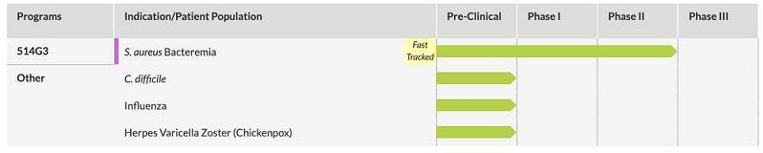

Competition

The therapeutic antibody space is dynamic as there continues to be a highly active commercial pipeline of therapeutic antibodies globally, involving a complex array of development cycles as products reach the end of their patent life and as new candidate products proceed into pivotal studies and approach registration. There are numerous independent reviews on the subject in both trade journals and academic press (one such example being Reichert JM, Antibodies to watch in 2018 MAbs. 2018 Jan 4:1-21).

We believe True Human™ therapeutic antibodies have important differentiating factors from other monoclonal antibodies currently marketed. The unique activity of our lead anti-cancer therapeutic has the potential ability to both improve well-being and extend life. We feel our product candidates will be highly differentiated in the market place for therapeutics in various indications including but not limited to cancer and dermatology. However, regardless of the potential advantages or uniqueness of our current or future product candidates in the market, we do expect these products to compete head-to-head with the numerous existing candidate antibody products in development, including emerging biosimilar therapeutic antibodies.

Current Clinical and/or Regulatory Activity

Phase II Study for Atopic Dermatitis (AD)

There is an ongoing phase a randomized, double-blind, placebo-controlled Phase 2 clinical study to evaluate bermekimab in patients with moderate to severe Atopic Dermatitis (AD). The Company is working closely with Janssen to execute these studies on their behalf (IND transferred from XBiotech to Janssen on 30 January 2020). The multi-center study has enrolled approximately 90 patients into three arms which will receive 32 weeks of treatment: a weekly dosing group, a biweekly dosing group, and a placebo group. Percentage of patients who achieve a 75% reduction in skin disease after 16 weeks of treatment will be the primary measure of response. The Eczema Area Severity Index (EASI) scoring system will be used to assess severity of inflammatory skin lesions. Another crucial assessment will be patient itch, which is often severe and unrelenting in this disease. A numeric rating scale (NRS) will be used to assess itch and pain at various timepoints ranging from 4-32 weeks.

Phase II Study for Hidradenitis Suppurativa (HS)

There is an ongoing phase a randomized, double-blind, placebo-controlled Phase 2 clinical study to evaluate bermekimab in patients with moderate to severe Hidradenitis Suppurativa (HS). The Company is working closely with Janssen to execute these studies on their behalf (IND transferred from XBiotech to Janssen on 30 January 2020). The multi-center study has enrolled approximately 150 patients into three arms: two bermekimab dosing regimens versus a placebo arm over 32 weeks of treatment. The study’s primary endpoint is the percentage of subjects achieving Hidradenitis Suppurativa Clinical Response (HiSCR) at week 12. Multiple secondary efficacy endpoints will be assessed at various time points ranging between 8 and 32 weeks of therapy, including: Numerical Rating Scale (NRS) for pain and itch; Modified Sartorius Score; Dermatology Life Quality Index (DLQI); Hospital Anxiety and Depression Scale (HADS); and Patient Global Impression of Change and Severity (PGI-c, PGI-s).

11

Summary of Clinical Findings to Date

Safety

The Company’s True Human™ antibodies are derived from a natural human immune response. It is expected that this would facilitate better tolerability when used as a therapeutic compared to humanized or “fully human” monoclonal antibodies. Antibody therapies are known to be associated with significant risk for infusion reactions, including serious anaphylactic reactions. It is the Company’s belief that these reactions are the result of using antibodies that were not derived from natural human immunity but rather had engineered specificities. Based on scientific principles of antibody physiology,

a fundamentally important premise was that True Human™ antibody therapies should be safer and result in less infusion-related complications than engineered human antibodies when used in clinical studies.

Therapeutic monoclonal antibodies, even those so-called “fully human,” have been associated with infusion reactions. In the past, product candidates developed by the Company have been associated with a reduced number of infusion related reactions and injection site reactions.

To date the Company’s anti-IL-1⍺ therapy has been featured in 9 publications from 7 of the Company’s past clinical studies. The table below outlines each of these publications.

Indication | Journal | Title
Oncology | Oncoimmunology | Interleukin-1 receptor antagonist levels predict favorable outcome after bermekimab, a
 |  | first-in-class true human interleukin-1α antibody, in a phase III randomized study of
 |  | advanced colorectal cancer
Oncology | The Lancet Oncology | MABp1 as a novel antibody treatment for advanced colorectal cancer: a randomized,
 |  | double-blind, placebo-controlled, phase 3 study
Oncology | The Lancet Oncology | MABp1, a first-in-class true human antibody targeting interleukin-1α in refractory
 |  | cancers: an open-label, phase 1 dose-escalation and expansion study
Oncology | Investigational New Drugs | Xilonix, a novel true human antibody targeting the inflammatory cytokine interleukin-1
 |  | alpha, in non-small cell lung cancer
Psoriasis | JAMA Dermatology | Open-label trial of MABp1, a true human monoclonal antibody targeting interleukin 1α,
 |  | for the treatment of psoriasis
Acne | Journal of Drugs in Dermatology | An open label, phase 2 study of MABp1 monotherapy for the treatment of acne vulgaris
 |  | and psychiatric comorbidity
Cardiovascular | Journal of Vascular Surgery | A randomized phase II study of Xilonix, a targeted therapy against interleukin 1α, for the
 |  | prevention of superficial femoral artery restenosis after percutaneous revascularization
Diabetes | Journal of Diabetes and Its Complications | Safety, pharmacokinetics, and preliminary efficacy of a specific anti-IL-1alpha
 |  | therapeutic antibody (MABp1) in patients with type 2 diabetes mellitus
Hidradenitis | Journal of Investigative Dermatology | MABp1 Targeting Interleukin-1Alpha for Moderate to Severe Hidradenitis Suppurativa
Suppurativa |  | not Eligible for Adalimumab: A Randomized Study

Intellectual Property

XBiotech has developed a large international intellectual property (IP) portfolio to protect important aspects of its technology, services, and products, including patents, trademarks and trade secrets.

Sale of a Portion of XBiotech’s IL-1a Patent Portfolio and Retention of Certain Rights Thereto.

On December 7, 2019, XBiotech entered into an Asset Purchase Agreement (the “Purchase Agreement”) under which it received $750 million upfront payment and the potential to receive another $600 million in milestone payments. Under the Purchase Agreement, XBiotech assigned a substantial portion of its patent portfolio covering a candidate drug product that blocks the action of interleukin-1 alpha (IL-1a). Pursuant to the Purchase Agreement, on December 30, 2019, XBiotech assigned to the purchaser 12 patent families related to the aforesaid candidate drug product and the use of IL-1α-specific antibodies for treating various conditions, including arthritis, neoplastic diseases, dermatological pathologies, vascular diseases, inflammatory skin disease and psychiatric conditions, cachexia, diabetes, atopic dermatitis and hidradenitis suppurativa.

12

An IP non-assertion and license agreement (the “IP Agreement”) incorporated into the Purchase Agreement allows XBiotech to develop and commercialize new antibody products which block IL-1a for all areas of medicine outside of dermatology without infringing the patent rights assigned under the Purchase Agreement. The IP Agreement further provides XBiotech the opportunity to enforce certain patent rights within the assigned portfolio that relate to the use of anti-IL-1a antibodies to treat non-dermatological disease against third parties in the event the purchaser elects not to do so.

Patent Rights Controlled by XBiotech.

In addition to the aforementioned beneficial rights to IL-1a patent rights under the Purchase Agreement, as of December 31, 2019, XBiotech directly owns or controls through licenses the rights to 11 patent families, which included 63 issued patents and 39 pending patent applications in various countries around the world. As set forth below, these include IL-1a related patent rights not assigned in the Purchase Agreement as well as others directed to our proprietary antibody discovery platform and to antibodies for treating and preventing S. aureus infections and cancer.

Patent rights owned by XBiotech.

A. Treatment of Cancer with Anti- IL-1α Antibodies. This patent family relates to the use of anti-IL-1α antibodies to inhibit the metastatic potential of tumors by interrupting the role that tumor-derived IL-1α plays in tumor metastasis. As of December 31, 2019, XBiotech has been granted five patents for this family; including one in Australia, one in Canada, two in Japan, and one in Europe. As of December 31, 2019, this family has three pending patent applications (US, China, and Hong Kong). Unless extended, patents in this family expire in 2027.

B. Diagnosis, Treatment, and Prevention of Vascular Disorders. This patent family relates to methods of diagnosing, treating and preventing a variety of vascular disorder using IL-1a autoantibody. As of December 31, 2019, XBiotech has been granted seven patents in this family, including two in the U.S., one in Australia, one in Canada, one in Europe and two in Japan. As of December 31, 2019, this family has one pending patent application (China). Unless extended, patents in this family expire in 2026.

C. IL-1 Alpha Immunization Induces Autoantibodies Protective Against Atherosclerosis. This patent family relates to the use of IL-1α in a vaccine to generate anti-IL-1a antibodies to protect against atherosclerosis. As of December 31, 2019, XBiotech has been granted patents for this family in Australia and Europe. Unless extended, patents in this family expire in 2027.

D. Methods, Compositions, And Kits For Reducing Anti-Antibody Responses. This patent family relates to methods and compositions for reducing immune system-mediated reactions to allotypic determinants on administered antibody products. As of December 31, 2019, XBiotech has been granted one Australian patent in this family. Unless extended, patents in this family expire in 2030.

E. Identifying Affinity-Matured Human Antibodies. This patent family relates to methods and compositions for identifying affinity-matured True HumanTM monoclonal antibodies from donors. As of December 31, 2019, XBiotech has been granted 11 patents in this family (four in the U.S., two in Australia, one in China, one in Israel, one in Mexico, one in Russia, and one in Hong Kong). As of December 31, 2019, this family has 10 pending patent applications (US, Canada, China, Europe, India, Israel, Japan, Mexico, South Korea, and Russia). Unless extended, patents in this family expire in 2032.

F. Compositions and Methods for Treating S. Aureus Infections. This patent family relates to antibodies for preventing and treating S. aureus infections. As of December 31, 2019, XBiotech has been granted 17 patents in this family, including four in the U.S, two in Australia, one in China, one in Colombia, one in Indonesia, one in Japan, one in Mexico, one in the Philippines, one in Russia, one in Singapore, one in South Africa, and two in South Korea. As of December 31, 2019, this family has 19 pending patent applications (US, Brazil, Canada, China, Chile, Europe, India, Israel, two in Japan, Malaysia, Mexico, New Zealand, Philippines, two in Hong Kong, Singapore, South Korea, and Russia) of which one (US) has been allowed. Unless extended, patents in this family expire in 2035.

G. Treatment of S. Aureus Infections. This patent family relates to the use of antibodies (Abs) which specifically bind interleukin-1α (IL-1α) for treating S. aureus bloodstream infections in human patients. As of December 31, 2019, XBiotech has one pending US application and one pending international (PCT) patent application. Unless extended, patents in this family expire in 2038.

G. Treatment of S. Aureus Infections. This patent family relates to the use of antibodies (Abs) which specifically bind interleukin-1α (IL-1α) for treating S. aureus bloodstream infections in human patients. As of December 31, 2019, XBiotech has one pending US application and one pending international (PCT) patent application. Unless extended, patents in this family expire in 2038.

13

XBiotech has licensed exclusive rights to the intellectual property described below.

H. Antibacterial Antibodies and Methods of Use. This patent family relates to antibodies for preventing and treating S. aureus infections. XBiotech acquired the use of patents within this family pursuant to its exclusive license agreement with STROX Biopharmaceuticals, LLC. The patents within this family expired in 2019.

I. Staphylococcus Aureus-Specific Antibody Preparations. This patent family relates to antibodies for preventing and treating S. aureus infections. XBiotech acquired use of patents within this family pursuant to its exclusive license agreement with STROX Biopharmaceuticals, LLC. As of December 31, 2019, this family has one pending patent application in India. Unless extended, patents in this family expire in 2029.

J. Monoclonal Human Tumor-Specific Antibody. This patent family relates generally to human tumor-specific antibodies as well as fragments, derivatives and variants thereof that recognize tumor-associated antigen NY-ESO-1. XBiotech acquired the use of patents within this family pursuant to its exclusive license agreement with CT Atlantic AG. As of December 31, 2019, this patent family includes one pending application in Europe and 15 issued patents, including one in the U.S., one in Australia, one in Brazil, one in Canada, two in Europe, one in China, one in Israel, one in India, one in Japan, one in South Korea, one in New Zealand, one in Mexico, one in Russia, and one in South Africa. Unless extended, patents in this family expire in 2028.

K. Combination Therapy Including Tumor Associated Antigen-Binding Antibodies. This patent family relates generally to a combination therapy including tumor associated antigen binding antibodies. XBiotech acquired the use of patents within this family pursuant to its exclusive license agreement with CT Atlantic AG. As of December 31, 2019, this patent family includes pending applications in India and the U.S., and five issued patents, including one in Canada, one in China, one in Europe, one in Japan, and one in South Korea. Unless extended, patents in this family expire in 2032.

Assignment to Janssen Biotech, Inc.

On December 30, 2019, pursuant to the terms and conditions of the Purchase Agreement, XBiotech assigned to Janssen 12 patent families related to

the development of IL-1α-specific True HumanTM monoclonal antibodies, including bermekimab, the treatment of various conditions, including arthritis, neoplastic diseases, dermatological pathologies, vascular diseases, inflammatory skin disease and psychiatric conditions, cachexia, diabetes, atopic dermatitis and hidradenitis suppurativa, and associated matters.

ITEM 1A RISK FACTORS

Risks Related to our Financial Condition and Capital Requirements

We have incurred significant losses since our inception and may incur significant losses in the future.

We are a pre-market pharmaceutical company with a limited operating history. We had no net income prior to the fourth quarter of 2019, when we sold certain assets to Janssen Biotech, Inc. and entered into certain related commercial agreements (the “Janssen Transaction”). Investment in pharmaceutical product development is highly speculative because it entails substantial upfront capital expenditures and significant risk that any potential product candidate will fail to demonstrate adequate efficacy or an acceptable safety profile, gain regulatory approval or become commercially viable. We do not have any products approved by regulatory authorities for marketing or commercial sale and have not generated any revenue from product sales, or otherwise, to date, and we continue to incur significant research, development and other expenses related to our ongoing operations. As a result, we incurred losses in every reporting period from our inception in 2005 through the third quarter of 2019. Although we were profitable during the fourth quarter and fiscal year ended December 31, 2019 due to the cash received in the Janssen Transaction, that was an extraordinary transaction outside of normal business operations that had never previously occurred and may not be repeated.

We expect to continue to incur significant expenses and may incur operating losses for the foreseeable future. We anticipate these expenses will increase as we continue the research and development of, and seek regulatory approvals for our current and future product candidates in various indications, and potentially begin to commercialize any products that may achieve regulatory approval. We may encounter unforeseen expenses, difficulties, complications, delays and other unknown factors that may adversely affect our financial condition. The amount of our future net losses will depend, in part, on the rate of future growth of our expenses and our ability to generate revenues. Our prior losses have had, and any future losses may continue to have, an adverse effect on our financial condition. If any of our product candidates fail in clinical trials or do not gain regulatory approval, or if approved fail to achieve market acceptance, we may never sustain profitability. We will need to raise significant additional funding, which may not be available on acceptable terms, if at all. Failure to obtain this necessary capital when needed may force us to delay, limit or terminate our product development efforts or other operations.

14

Since inception, we have dedicated a majority of our resources to the discovery and development of our proprietary preclinical and clinical product candidates, and we expect to continue to expend substantial resources doing so for the foreseeable future. These expenditures will include costs associated with conducting research and development, manufacturing product candidates and products approved for sale, conducting preclinical experiments and clinical trials and obtaining and maintaining regulatory approvals, as well as commercializing any products later approved for sale. During the year ending December 31, 2019, we recognized approximately $24.1 million in expenses associated with research and development and clinical trials.

We completed our initial public offering on April 15, 2015 and additional registered offerings in March 2017 and May 2019. We also received a significant amount of cash proceeds from the Janssen Transaction. However, the net proceeds from these transactions and cash on hand may not be sufficient to complete clinical development of any of our product candidates nor may it be sufficient to commercialize any product candidate. In addition, we completed a modified Dutch auction tender offer for our common shares in February 2020, which consumed $420 million of our cash resources. Accordingly, we may require substantial additional capital beyond the offering to continue our clinical development and potential commercialization activities. Our future capital requirements depend on many factors, including but not limited to:

- the number and characteristics of the future product candidates we pursue;

- the scope, progress, results and costs of researching and developing any of our future product candidates, and conducting preclinical research and clinical trials;

- the timing of, and the costs involved in, obtaining regulatory approvals for any future product candidates we develop;

- the cost of future commercialization activities for our product candidates and the cost of commercializing any future products approved for sale;

- the cost of manufacturing our future products; and

- the costs involved in preparing, filing, prosecuting, maintaining, defending and enforcing patents, including litigation costs and the outcome of any such litigation.

We are unable to accurately estimate the funds we will actually require to complete research and development of our product candidates or the funds required to commercialize any resulting product in the future or the funds that will be required to meet other expenses. Our operating plan may change as a result of many factors currently unknown to us, and our expenses may be higher than expected. We may need to seek additional funds sooner than planned, through public or private equity or debt financings, government or other third-party funding, marketing and distribution arrangements and other collaborations, strategic alliances and licensing arrangements or a combination of these approaches. Raising funds in the future may present additional challenges and future financing may not be available in sufficient amounts or on terms acceptable to us, if at all.

Raising additional capital may cause dilution to our existing shareholders, restrict our operations or require us to relinquish rights to our technologies or product candidates.

The terms of any financing arrangements we enter into may adversely affect the holdings or the rights of our shareholders and the issuance of additional securities, by us, or the possibility of such issuance, may cause the market price of our shares to decline. The sale of additional equity or convertible securities would dilute all of our shareholders. The incurrence of indebtedness would result in increased fixed payment obligations and, potentially, the imposition of restrictive covenants. Those covenants may include limitations on our ability to incur additional debt, limitations on our ability to acquire, sell or license intellectual property rights and other operating restrictions that could adversely impact our ability to conduct our business. We could also be required to seek funds through arrangements with collaborators or otherwise at an earlier stage than otherwise would be desirable resulting in the loss of rights to some of our product candidates or other unfavorable terms, any of which may have a material adverse effect on our business, operating results and prospects. Additional fundraising efforts may divert our management from their day-to-day activities, which may adversely affect our ability to develop and commercialize our products.

15

Risks Related to Our Business

We currently have no source of product revenue and may never sustain profitability.

To date, we have not generated any revenues from commercial product sales. Our ability to generate revenue in the future from product sales and achieve profitability will depend upon our ability, alone or with any future collaborators, to commercialize products successfully, including any current product candidates or any product candidates that we may develop, in-license or acquire in the future. Even if we are able to achieve regulatory approval for any current or future product candidates, we do not know when any of these products will generate revenue from product sales, if at all. Our ability to generate revenue from product sales from any of our product candidates also depends on a number of additional factors, including our ability to:

- complete development activities, including the necessary clinical trials;

- complete and submit new drug applications, or NDAs, to the US Food and Drug Administration, or FDA, and obtain regulatory approval for indications for which there is a commercial market;

- complete and submit applications to, and obtain regulatory approval from, foreign regulatory authorities such as the European Medicines Agency, or EMA;

- establish our manufacturing operations;

- develop a commercial organization capable of sales, marketing and distribution for our product candidates and any products for which we obtain marketing approval and intend to sell ourselves in the markets in which we choose to commercialize on our own;

- find suitable distribution partners to help us market, sell and distribute our approved products in other markets;

- obtain coverage and adequate reimbursement from third-party payers, including government and private payers;

- achieve market acceptance for our products, if any;

- establish, maintain and protect our intellectual property rights; and

- attract, hire and retain qualified personnel.

In addition, because of the numerous risks and uncertainties associated with pharmaceutical product development, including that our product candidates may not advance through development or achieve the endpoints of applicable clinical trials, we are unable to predict the timing or amount of increased expenses, or if we will be able to sustain profitability. In addition, our expenses could increase beyond expectations if we decide to or are required by the FDA, or foreign regulatory authorities, to perform studies or trials in addition to those that we currently anticipate. Even if we are able to complete the development and regulatory process for our product candidates, we anticipate incurring significant costs associated with commercializing these products.

Even if we are able to generate revenues from the sale of any of our product candidates that may be approved, we may not become profitable and may need to obtain additional funding to continue operations. If we are unable to sustain profitability on a continuing basis, then we may be unable to continue our operations at planned levels and be forced to reduce our operations.

16

Our future success is dependent on the regulatory approval and commercialization of our product candidates.

We do not have any products that have gained regulatory approval. As a result, our ability to finance our operations and generate revenue, are substantially dependent on our ability to obtain regulatory approval for, and, if approved, to successfully commercialize our product candidates in a timely manner. We cannot commercialize our other product candidates in the U.S. without first obtaining regulatory approval for each product from the FDA; similarly, we cannot commercialize any product candidates outside of the U.S. without obtaining regulatory approval from comparable foreign regulatory authorities, including the EMA. The FDA review process typically takes years to complete and approval is never guaranteed. Before obtaining regulatory approvals for the commercial sale of any of our potential product candidates for a target indication, we must demonstrate with substantial evidence gathered in preclinical and well-controlled clinical studies, including two well-controlled Phase III studies, and, with respect to approval in the U.S. to the satisfaction of the FDA, and in Europe, to the satisfaction of the EMA, that the product candidate is safe and effective for use for that target indication; and that the manufacturing facilities, processes and controls are adequate. Obtaining regulatory approval for marketing of our current or future product candidates in one country does not ensure we will be able to obtain regulatory approval in other countries. A failure or delay in obtaining regulatory approval in one country may have a negative effect on the regulatory process in other countries.

Even if any of our product candidates were to successfully obtain approval from the FDA or comparable foreign regulatory authorities, any approval might contain significant limitations related to use restrictions for specified age groups, warnings, precautions or contraindications, or may be subject to burdensome post-approval studies or risk management requirements. If we are unable to obtain regulatory approval for our product candidates in one or more jurisdictions, or any approval contains significant limitations, we may not be able to obtain sufficient funding or generate sufficient revenue to continue the development of any of our other product candidates that we are developing or may discover, in-license, develop or acquire in the future. Also, any regulatory approval of our product candidates, once obtained, may be withdrawn. Furthermore, even if we obtain regulatory approval for any of our product candidates, their commercial success will depend on a number of factors, including the following:

- development of a commercial organization within XBiotech or establishment of a commercial collaboration with a commercial infrastructure;

- establishment of commercially viable pricing and obtaining approval for adequate reimbursement from third-party and government payers;

- our ability to manufacture quantities of our product candidates using commercially satisfactory processes and at a scale sufficient to meet anticipated demand and enable us to reduce our cost of manufacturing;

- our success in educating physicians and patients about the benefits, administration and use of our product candidates;

- the availability, perceived advantages, relative cost, relative safety and relative efficacy of alternative and competing treatments;

- the effectiveness of our own or our potential strategic collaborators’ marketing, sales and distribution strategy and operations;

- acceptance as a safe and effective therapy by patients and the medical community; and

- a continued acceptable safety profile following approval.

Many of these factors are beyond our control. If we are unable to successfully commercialize our product candidates, we may not be able to earn sufficient revenues to continue our business.

17

New laws or regulations may be promulgated or modified in the United States, in Europe, or other jurisdictions that could impact our ability to receive the necessary approvals to successfully market and commercialize our product candidates.

The pharmaceutical and biotechnology industry is one of the most regulated on a state, federal and international level. There are a number of laws, regulations, and court decisions which impact the daily activities of our business. As a result, we must ensure that strategies and planning in relation to our product candidates are in line with the current regulations governing our industry. When there are changes in leadership, whether within the U.S., or elsewhere, we must anticipate the possibility of shifts in regulatory policies as they pertain to our business. New or modified regulations may impact our ability to quickly respond with updates to our programs. While we may be able to anticipate certain changes, policy statements often are not always translated into actionable legislation. We continue to track updates and changes internally to ensure we are in compliance with regulatory authority guidelines and expectations. Court decisions at both the state and federal level can also impact the way in which we operate and make specific product related program decisions. New laws, regulations, or court orders could materially alter or impact our ability to receive necessary approvals from regulatory authorities to market and commercialize our product candidates.

Because the results of earlier clinical trials are not necessarily predictive of future results, product candidates we advance into clinical trials, may not have favorable results in later clinical trials or receive regulatory approval.

Success in preclinical testing and early clinical trials does not ensure that later clinical trials will generate adequate data to demonstrate the efficacy and safety of an investigational drug. A number of companies in the pharmaceutical and biotechnology industries, including those with greater resources and experience, have suffered significant setbacks in clinical trials, even after seeing promising results in earlier clinical trials. We do not know whether the clinical trials we are conducting, or may conduct, will demonstrate adequate efficacy and safety to result in regulatory approval to market any of our product candidates in any particular jurisdiction. Even if we believe that we have adequate data to support an application for regulatory approval to market our product candidates, the FDA or other comparable foreign regulatory authorities may not agree and could require us to conduct additional research studies, including late-stage clinical trials. If late-stage clinical trials do not produce favorable results, our ability to achieve regulatory approval for any of our product candidates may be adversely impacted.

If we are unable to enroll subjects in clinical trials, we will be unable to complete these trials on a timely basis.

Patient enrollment, a significant factor in the timing of clinical trials, is affected by many factors including the size and nature of the patient population, the proximity of subjects to clinical sites, the eligibility criteria for the trial, the design of the clinical trial, ability to obtain and maintain patient consents, risk that enrolled subjects will drop out before completion, competing clinical trials and clinicians’ and patients’ perceptions as to the potential advantages of the drug being studied in relation to other available therapies, including any new drugs that may be approved for the indications we are investigating. Furthermore, we rely on Clinical Research Organizations (CRO’s) and clinical trial sites to ensure the proper and timely conduct of our clinical trials, and while we have agreements governing their committed activities, we have limited influence over their actual, day-to-day performance. We may experience delays in starting-up clinical trial sites in a timely manner, enrolling subjects in our trials, and may not be able to enroll a sufficient number of subjects to complete the trials. In addition, in December 2019, an outbreak of a novel strain of coronavirus originated in Wuhan, China, and has since spread to a number of other countries, including the United States and various countries in Europe, resulting in the declaration by the World Health Organization of a global pandemic. To date, concerns related to the spread of coronavirus have already resulted in travel restrictions, shutdowns of certain businesses, bans on large public gatherings and declarations of states of emergency in cities, states and countries around the world. Concentrations of infected patients or reactions to the coronavirus outbreak or future similar regional or global health concerns could negatively affect our ability to recruit and retain subjects in clinical trials if they disproportionately impact the sites in which we conduct any of our trials, which would have a material adverse effect on our business and our results of operation and financial condition.

If we experience delays in the completion or if there is termination of, any clinical trial of any current or future product candidates, the commercial prospects of our product candidates will be harmed, and our ability to generate product revenues from any of these product candidates will be delayed. In addition, any delays in completing our clinical trials will increase our costs, slow down our product candidate development and approval process and could shorten any periods during which we may have the exclusive right to commercialize our product candidates or allow our competitors to bring products to market before we do, and jeopardize our ability to commence product sales, which would impair our ability to generate revenues and may harm our business, results of operations, financial condition and cash flows and future prospects. In addition, many of the factors that could cause a delay in the commencement or completion of clinical trials may also ultimately lead to the denial of regulatory approval of our product candidates.

18

The regulatory approval processes of the FDA and comparable foreign regulatory authorities are lengthy, time consuming and inherently unpredictable, and if we are ultimately unable to obtain regulatory approval for our product candidates, our business may fail.

The time required to obtain approval by the FDA and comparable foreign regulatory authorities is unpredictable, but typically takes several years following the commencement of preclinical studies and clinical trials and depends upon numerous factors, including the substantial discretion of the regulatory authorities and any shifts in regulatory policy. In addition, approval policies, regulations, or the type and amount of clinical data necessary to gain approval may change during the course of a product candidate’s clinical development and may vary among jurisdictions. We have not obtained regulatory approval for any product candidate, and it is possible that none of the product candidates we are developing or may discover, in-license or acquire and seek to develop in the future will ever obtain regulatory approval.

Our product candidates could fail to receive marketing approval from the FDA or a comparable foreign regulatory authority for many reasons, including but not limited to:

- disagreement over the design or implementation of our clinical trials;

- failure to demonstrate that a product candidate is safe and effective;

- failure of clinical trials to meet the level of statistical significance required for approval;

- failure to demonstrate that a product candidate’s clinical and other benefits outweigh its safety risks;

- disagreement over our interpretation of data from preclinical studies or clinical trials;

- disagreement over whether to accept efficacy results from clinical trial sites outside the United States where the standard of care is potentially different from that in the United States;

- the insufficiency of data collected from clinical trials of our product candidates to support the submission and filing of an NDA or other submission or to obtain regulatory approval;

- irreparable or critical compliance issues relating to our manufacturing and/clinical trial processes; or

- changes in the approval policies or regulations that render our preclinical and clinical data insufficient for approval.

The FDA or a comparable foreign regulatory authority may require more information, including additional preclinical or clinical data to support approval, which may delay or prevent approval and our commercialization plans, or we may decide to abandon the development program altogether. Even if we do obtain regulatory approval, our product candidates may be approved for fewer or more limited indications than we request, approved contingent on the performance of costly post-marketing clinical trials, or approved with a label that does not include the labeling claims necessary or desirable for the successful commercialization of that product candidate. In addition, if any of our product candidates produce undesirable side effects or safety issues, the FDA may require the establishment of Risk Evaluation Mitigation Strategies, or REMS, or a comparable foreign regulatory authority may require the establishment of a similar strategy, that may, restrict distribution of our products and impose burdensome implementation requirements. Any of the foregoing scenarios could materially harm the commercial prospects for our product candidates.

Even if we believe any completed, current or planned clinical trials are successful, the FDA or a comparable foreign regulatory authority may not agree that our completed clinical trials provide adequate data on the safety or efficacy of our product candidates, permitting us to proceed to additional clinical trials. Approval by comparable foreign regulatory authorities does not ensure approval by the FDA and approval by one or more foreign regulatory authorities does not ensure approval by regulatory authorities in other countries or by the FDA. However, a failure or delay in obtaining regulatory approval in one country may have a negative impact on the regulatory process in others. We may not be able to file for regulatory approvals, and even if we file we may not receive the necessary approvals to commercialize our products in any market.

19

Our product candidates may cause undesirable side effects or have other properties that could delay or prevent their regulatory approval, limit the commercial profile of an approved label, or result in significant negative consequences following any marketing approval.

Undesirable side effects caused by our product candidates could cause us or regulatory authorities to interrupt, delay or halt clinical trials and could result in a more restrictive label or the delay or denial of regulatory approval by the FDA or other comparable foreign regulatory authority. If toxicities occur in our current or future clinical trials they could cause delay or even the discontinuation of further development of our product candidates, which would impair our ability to generate revenues and would have a material adverse effect our business, results of operations, financial condition and cash flows and future prospects. There can be no assurance that side effects from our product candidates in future clinical trials or that side effects in general will not prompt the discontinued development or possible market approval of our product candidates. If serious side effects or other safety or toxicity issues are experienced in our clinical trials in the future, we may not receive approval to market any of our product candidates, which could prevent us from ever generating revenues from commercial product sales or sustaining profitability. Results of our trials could reveal an unacceptably high severity and prevalence of side effects. In such an event, our trials could be suspended or terminated and the FDA or comparable foreign regulatory authorities could order us to cease further development of or deny approval of our product candidates for any or all targeted indications. The drug-related side effects could affect patient recruitment or the ability of enrolled subjects to complete the trial or result in potential product liability claims. Any of these occurrences may have a material adverse effect on our business, results of operations, financial condition and cash flows and future prospects.

Additionally, if any of our product candidates receives marketing approval, and we or others later identify undesirable side effects caused by such product, a number of potentially significant negative consequences could result, including:

- we may be forced to suspend marketing of such product;

- regulatory authorities may withdraw their approvals of such product;

- regulatory authorities may require additional warnings on the label that could diminish the usage or otherwise limit the commercial success of such product;

- the FDA or other regulatory bodies may issue safety alerts, Dear Healthcare Provider letters, press releases or other communications containing warnings about such product;

- the FDA may require the establishment or modification of REMS or a comparable foreign regulatory authority may require the establishment or modification of a similar strategy that may, for instance, restrict distribution of our product and impose burdensome implementation requirements on us;

- we may be required to change the way the product is administered or conduct additional clinical trials;

- we could be sued and held liable for harm caused to subjects or patients;

- we may be subject to litigation or product liability claims; and

- our reputation may suffer.

Any of these events could prevent us from achieving or maintaining market acceptance of the particular product candidate, if approved.

20

Even if our product candidates receive regulatory approval, they may still face future development and regulatory difficulties.

Even if we obtain regulatory approval for any of our product candidates, it would be subject to ongoing requirements by the FDA and comparable foreign regulatory authorities governing the manufacture, quality control, further development, labeling, packaging, storage, distribution, safety surveillance, import, export, advertising, promotion, recordkeeping and reporting of safety and other post-market information. The safety profile of any product will continue to be closely monitored by the FDA and comparable foreign regulatory authorities after approval. If the FDA or comparable foreign regulatory authorities become aware of new safety information after approval of any product candidate, they may require labeling changes or establishment of a REMS or similar strategy, impose significant restrictions on a product’s indicated uses or marketing, or impose ongoing requirements for potentially costly post-approval studies or post-market surveillance. For example, the label ultimately approved for any product candidate, if it achieves marketing approval, may include restrictions on use.

In addition, manufacturers of drug products and their facilities are subject to continual review and periodic inspections by the FDA and other regulatory authorities for compliance with current good manufacturing practices, or cGMP, and other regulations. If we or a regulatory agency discover previously unknown problems with a product, such as adverse events of unanticipated severity or frequency, or problems with the facility where the product is manufactured, a regulatory agency may impose restrictions on that product, our manufacturing facility, including requiring recall or withdrawal of the product from the market or suspension of manufacturing. If we, our product candidates or our manufacturing facilities for our product candidates fail to comply with applicable regulatory requirements, a regulatory agency may:

- issue warning letters or untitled letters;

- impose restrictions on the marketing or manufacturing of the product candidates;

- mandate modifications to promotional materials or require us to provide corrective information to healthcare practitioners;

- require us or any future collaborator to enter into a consent decree, which can include imposition of various fines, reimbursements for inspection costs, required due dates for specific actions and penalties for noncompliance;

- seek an injunction or impose civil or criminal penalties or monetary fines;

- suspend or withdraw regulatory approval;

- suspend any ongoing clinical trials;

- refuse to approve pending applications or supplements to applications filed by us;

- suspend or impose restrictions on operations, including costly new manufacturing requirements; or

- seize or detain products, refuse to permit the import or export of products, or require us to initiate a product recall.

The occurrence of any event or penalty described above may inhibit our ability to commercialize our product candidates and generate revenue.

The FDA strictly regulates the advertising and promotion of drug products, and drug products may only be marketed or promoted for their FDA approved uses, consistent with the product’s approved labeling. Advertising and promotion of any product candidate that obtains approval in the U.S., and is covered by federal insurance programs such as Medicare or Medicaid, will be heavily scrutinized by the FDA, the Department of Justice, (DOJ), the Office of Inspector General of the Department of Health and Human Services, (HHS), state attorneys general, members of Congress and the public. Violations, including promotion of our products for unapproved or off-label uses, are subject to enforcement letters, inquiries and investigations, and civil, criminal and/or administrative sanctions by the FDA and/or the DOJ. Additionally, advertising and promotion of, any product candidate that obtains approval outside of the U.S. will be heavily scrutinized by comparable foreign regulatory authorities.

21

In the U.S., engaging in impermissible promotion of our future products for off-label uses can also subject us to false claims litigation under federal and state statutes, which can lead to civil, criminal and/or administrative penalties and fines and corporate integrity agreements that materially restrict the manner in which we promote or distribute our drug products. The federal False Claims Act, allows any individual to bring a lawsuit against a pharmaceutical company on behalf of the federal government alleging submission of false or fraudulent claims, or causing to present such false or fraudulent claims, for payment by a federal program, such as Medicare or Medicaid. If the government prevails in the lawsuit, the individual may share in any fines or settlement funds. Since 2004, False Claims Act lawsuits against pharmaceutical companies have increased significantly in volume and breadth, leading to several substantial civil and criminal settlements based on certain sales practices promoting off-label drug uses. This growth in litigation has increased the risk that a pharmaceutical company will have to defend a false claims action, pay settlement fines or restitution, agree to comply with burdensome reporting and compliance obligations, and be excluded from Medicare, Medicaid and other federal and state healthcare programs. If we do not lawfully promote our approved products, we may become subject to such litigation and, if we are not successful in defending against such actions, those actions could have a material adverse effect on our business, results of operations, financial condition and cash flows and future prospects.

Existing government regulations may change and additional government regulations may be enacted that could prevent, limit or delay regulatory approval of our product candidates. If we are slow or unable to adapt to changes in existing requirements or the adoption of new requirements or policies, or if we are not able to maintain regulatory compliance, we may lose any marketing approval that we may have obtained and/or be subject to fines or enhanced government oversight and reporting obligations, which would adversely affect our business, prospects and ability to sustain profitability.

Failure to obtain regulatory approval in foreign jurisdictions would prevent our product candidates from being marketed in those jurisdictions.

In order to market and sell our products in the European Union and many other jurisdictions, we must obtain separate marketing approvals and comply with numerous and varying regulatory requirements. The approval procedure varies among countries and can involve additional testing. The time required to obtain approval may differ substantially from that required to obtain FDA approval. The regulatory approval process outside the U.S. generally includes all of the risks associated with obtaining FDA approval. Additionally, in many countries outside the U.S., it is required that the product be approved for reimbursement before the product can be effectively commercialized in that country. Obtaining foreign regulatory approvals and compliance with foreign regulatory requirements could result in significant delays, difficulties and costs for us and could delay or prevent the introduction of our products in certain countries. We may not obtain approvals from regulatory authorities outside the U.S. on a timely basis, if at all. Approval by the FDA does not ensure approval by regulatory authorities in other countries or jurisdictions, and approval by one regulatory authority outside the U.S. does not ensure approval by regulatory authorities in other countries or jurisdictions or by the FDA. A failure or delay in obtaining regulatory approval in one country may have a negative effect on the regulatory approval process in others. We may not be able to file for marketing approvals and may not receive necessary approvals to commercialize our products in any market. If we are unable to obtain approval of any of our product candidates by regulatory authorities in the European Union or another jurisdiction, the commercial prospects of that product candidate may be significantly diminished and our business prospects could decline.

Even if we are able to commercialize our product candidates, the products may not receive coverage and adequate reimbursement from third-party payers, which could harm our business.

Our ability to commercialize any products successfully will depend, in part, on the extent to which coverage and adequate reimbursement for these products and related treatments will be available from government authorities, private health insurers, health maintenance organizations and third-party payers. Patients who are prescribed medications for the treatment of their conditions generally rely on third-party payers to reimburse all or part of the costs associated with their prescription drugs. Coverage and adequate reimbursement from government healthcare programs, such as Medicare and Medicaid, and private health insurers are critical to new product acceptance. Patients are unlikely to use our product candidates unless coverage is provided and reimbursement is adequate to cover a significant portion of the cost of our product candidates. A primary trend in the US healthcare industry and elsewhere is cost containment. As a result, government authorities and other third-party payers have attempted to control costs by limiting coverage and the amount of reimbursement for particular medications. Increasingly, third-party payers are requiring that drug companies provide them with predetermined discounts from list prices and are challenging the prices charged for medical products. Third-party payers may also seek additional clinical evidence, beyond the data required to obtain marketing approval, demonstrating clinical benefits and value in specific patient populations before covering our products for those patients. We cannot be sure that coverage and adequate reimbursement will be available for any product that we commercialize and, if reimbursement is available, what the level of reimbursement will be. Coverage and reimbursement may impact the demand for, or the price of, any product candidate for which we obtain marketing approval. If coverage and reimbursement are not available or are available only at limited levels, we may not be able to successfully commercialize any product candidate for which we obtain marketing approval.

22

There may be significant delays in obtaining coverage and reimbursement for newly approved drugs, and coverage may be more limited than the purposes for which the drug is approved by the FDA or comparable foreign regulatory authorities. Moreover, obtaining coverage does not imply that any drug will be paid for in all cases or at a rate that covers our costs, including research, development, manufacture, sales and distribution. Interim reimbursement levels for new drugs, if applicable, may also be insufficient to cover our costs, and may only be temporary. Reimbursement rates may vary according to the use of the drug and the clinical setting in which it is used. Reimbursement rates may also be based in part on existing reimbursement amounts for lower cost drugs or may be bundled into the payments for other services. Net prices for drugs may be reduced by mandatory discounts or rebates required by government healthcare programs or private payers and by any future relaxation of laws that presently restrict imports of drugs from countries where they may be sold at lower prices than in the U.S. Coverage and reimbursement for drug products can differ significantly from payer to payer. As a result, the coverage and reimbursement determination process is often a time-consuming and costly process with no assurance that coverage and adequate reimbursement will be obtained or applied consistently. Third-party payers often rely upon Medicare coverage policy and payment limitations in setting their own coverage and reimbursement policies. Our inability to promptly obtain coverage and profitable reimbursement rates from both government-funded and private payers for any approved products that we develop could have a material adverse effect on our operating results, our ability to raise capital needed to commercialize products, and our overall financial condition.

We have never marketed a drug before, and if we are unable to establish an effective sales force and marketing infrastructure, or enter into acceptable third-party sales and marketing or licensing arrangements, we may be unable to generate any revenue.

We do not currently have a comprehensive infrastructure for the sales, marketing and distribution of pharmaceutical drug products. The cost of establishing and maintaining such an infrastructure may exceed the cost-effectiveness of doing so. In order to market any products that may be approved by the FDA and comparable foreign regulatory authorities, we must build our sales, marketing, managerial and other non-technical capabilities or make arrangements with third parties to perform these services for which we would incur substantial costs. If we are unable to establish adequate sales, marketing and distribution capabilities, whether independently or with third parties, we may not be able to generate product revenue and may not sustain profitability. We will be competing with many companies that have extensive and well-funded sales and marketing operations. Without an internal commercial organization or the support of a third party to perform sales and marketing functions, or a combination of both, we may be unable to compete successfully against more established companies.

Our product candidates, if approved, may not achieve adequate market acceptance among physicians, patients, and healthcare payers and others in the medical community necessary for commercial success.

Even if we obtain regulatory approval for any of our product candidates, such product(s) may not gain market acceptance among physicians, healthcare payers, patients or the medical community within the U.S. or globally. Our commercial success also depends on coverage and adequate reimbursement of our product candidates by third-party payers, including government payers, generally, which may be difficult or time-consuming to obtain, may be limited in scope and may not be obtained in all jurisdictions in which we may seek to market our products. Market acceptance of any of our product candidates for which we receive approval depends on a number of factors, including:

- the efficacy and safety of such product candidates as demonstrated in clinical trials;

- the clinical indications for which the product candidate is approved;

- acceptance by physicians and patients of the product candidate as a safe and effective treatment;

- the potential and perceived advantages of product candidates over alternative treatments;

23

- the safety of product candidates seen in a broader patient group, including a product candidate’s use outside the approved indications;

- the prevalence and severity of any side effects;

- product labeling or product insert requirements of the FDA or other regulatory authorities;

- the timing of market introduction of our products as well as competitive products;

- the cost of treatment in relation to alternative treatments;

- the availability of coverage and adequate reimbursement and pricing by third-party payers and government authorities;

- relative convenience and ease of administration;

- the effectiveness of our sales and marketing efforts and those of our collaborators; and

- unfavorable publicity relating to the product candidate or the Company.

If any of our product candidates are approved but fail to achieve market acceptance among physicians, patients, or healthcare payers, we will not be able to generate significant revenues, which would compromise our ability to sustain profitability.

Our research programs may not succeed.

In the last couple of years, XBiotech has positioned itself with a pipeline of potential drug candidates at all stages of development, from pre-clinical through Phase III clinical trial stage. Even though we have many drugs in development at this time, none of these research programs may succeed. There are several reasons why a drug program may fail, including the following:

- In the development stage, we may be unable to develop a therapy, which would mean us succeeding in isolating appropriate antibodies to reach the clinical trial stage;

- Any partnerships for the development of antibodies could fail to produce results that would necessitate clinical trials;

- We may not receive approval from regulatory bodies to move from early stage clinical trials to later stage clinical trials;

- Even if we are able to move to later stage clinical trials, it may prove to be difficult to enroll patients into the studies according to schedule, or at all;

- During the clinical trial, there could be unexpected serious adverse events causing severe injury or death in patients, requiring us to cease further enrollment or causing regulatory authorities to place the trial on clinical hold for an indefinite period of time;

- If a clinical trial is completed, we may not have the appropriate personnel to submit a marketing application to regulatory authorities for approval, and to further respond to the variety of follow up questions that regulatory authorities may have during the review process;

- Regulatory authorities may reject drug candidates for a variety of reasons, preventing us from proceeding with marketing and commercialization of approved products; and

- We may run out of the funds necessary to complete development for any of our potential drug candidates.

Even an effective drug candidate might not be commercially successful.

Even if we ultimately succeed in creating a safe and effective drug, as determined by regulatory authorities, based on our current product pipeline, there is no assurance it would be commercially successful. Competitive products might become available faster or with lower costs or adverse risks to patients, resulting in few sales of any product developed by XBiotech. Occurrences of certain disease indications, such as those in our pipeline, might become sufficiently rare, or victims might be sufficiently impoverished, that commercial production is uneconomic. Furthermore, we must have sufficient buy-in from patients and healthcare professionals to guarantee market exposure for our drug candidates. If the end-users are not reached with our products, then it will be difficult to generate revenue from our development efforts. And even though we could obtain regulatory approval for any of our drug candidates, it is not necessarily the case that government or third-party payers will decide to add our products to their respective prescription drug formularies for reimbursement, thus inhibiting the ability for our drug candidates to reach the target patient populations, and health care professionals serving those patients.

24

We face substantial competition, which may result in others discovering, developing or commercializing products before or more successfully than we do.

The development and commercialization of new drug products is highly competitive. We face competition with respect to our current or future product candidates to treat any relevant indication(s). There are a number of large pharmaceutical and biotechnology companies that currently market and sell products or are pursuing the development of products for the treatment of the disease indications for which we are developing our future product candidates. Some of these competitive products and therapies are based on scientific approaches that are the same as or similar to our approach, and others are based on entirely different approaches. Potential competitors include academic institutions, government agencies and other public and private research organizations that conduct research, seek patent protection and establish collaborative arrangements for research, development, manufacturing and commercialization.

More established companies may have a competitive advantage over us due to their greater size, cash flows and institutional experience. Compared to us, many of our competitors may have significantly greater financial, technical and human resources. As a result of these factors, our competitors may obtain regulatory approval of their products before we do, which will limit our ability to develop or commercialize any of our product candidates. In addition, many companies are developing new therapeutics to supplant or expand upon the standard of care for a number of diseases, as a result, we cannot predict what the standard of care will be as our product candidates progress through clinical development.

Our failure to successfully identify, acquire, develop and commercialize additional product candidates or approved products could impair our ability to grow.

Although a substantial amount of our efforts will focus on the continued clinical testing and potential approval of our current product candidates, a key element of our growth strategy is to acquire, develop and/or market additional products and product candidates. All of these potential product candidates remain in the discovery and clinical study stages. Research programs to identify product candidates require substantial technical, financial and human resources, whether or not any product candidates are ultimately identified. Because our internal research capabilities are limited, we may be dependent upon pharmaceutical and biotechnology companies, academic scientists and other researchers to sell or license products or technology to us. The success of this strategy depends partly upon our ability to identify, select and acquire promising pharmaceutical product candidates and products. The process of proposing, negotiating and implementing a license or acquisition of a product candidate or approved product is lengthy and complex. Other companies, including some with substantially greater financial, marketing and sales resources, may compete with us for the license or acquisition of product candidates and approved products. We have limited resources to identify and execute the acquisition or in-licensing of third-party products, businesses and technologies and integrate them into our current infrastructure. Moreover, we may devote resources to potential acquisitions or in-licensing opportunities that are never completed, or we may fail to realize the anticipated benefits of such efforts. Any product candidate that we acquire may require additional development efforts prior to commercial sale, including extensive clinical testing and approval by the FDA and applicable foreign regulatory authorities. All product candidates are prone to risks of failure typical of pharmaceutical product development, including the possibility that a product candidate will not be shown to be sufficiently safe and effective for approval by regulatory authorities. In addition, we cannot provide assurance that any products that we develop or approved products that we acquire will be manufactured profitably or achieve market acceptance.

25

Product liability lawsuits against us could cause us to incur substantial liabilities and to limit commercialization of any products that we may develop.

We face an inherent risk of product liability exposure related to the testing of our product candidates in clinical trials and will face an even greater risk if we commercially sell any products that we may develop. Product liability claims may be brought against us by subjects enrolled in our clinical trials, patients, healthcare providers or others using, administering or selling our products. If we cannot successfully defend ourselves against claims that our product candidates or products caused injuries, we could incur substantial liabilities. Regardless of merit or eventual outcome, liability claims may result in:

- decreased demand for any product candidates or products that we may develop;

- termination of clinical trial sites or entire clinical trial programs;

- injury to our reputation and significant negative media attention;

- withdrawal of clinical trial participants;

- significant costs to defend the related litigation;

- substantial monetary awards to clinical trial subjects or patients;

- loss of revenue;

- diversion of management and scientific resources from our business operations; and

- the inability to commercialize our product candidates.

We will obtain insurance coverage for products to include the sale of commercial products if we obtain marketing approval for our product candidates, but we may be unable to obtain commercially reasonable product liability insurance for any products approved for marketing. Large judgments have been awarded in class action lawsuits based on drugs that had unanticipated side effects. A successful product liability claim or series of claims brought against us, particularly if judgments exceed our insurance coverage, could decrease our cash and adversely affect our business.

We will need to expand our operations and grow the size of our organization in the future, and we may experience difficulties in managing this growth.

As of March 12, 2020, we had 60 employees. As our development and commercialization plans and strategies develop, or as a result of any future acquisitions, we will need additional managerial, operational, sales, marketing, scientific, and financial headcount and other resources. Our management, personnel and systems currently in place may not be adequate to support this future growth. Future growth would impose significant added responsibilities on members of management, including:

- managing our clinical trials effectively, which we anticipate potentially being conducted at numerous clinical sites on a global scale;

- identifying, recruiting, maintaining, motivating and integrating additional employees with the expertise and experience we will require;

- managing our internal development efforts effectively while complying with our contractual obligations to licensors, licensees, contractors and other third parties;

- managing additional relationships with various strategic partners, suppliers and other third parties;

- improving our managerial, development, operational and finance reporting systems and procedures; and

- expanding our facilities.

26

Our failure to accomplish any of these tasks could prevent us from successfully growing our Company.

We have ongoing obligations to manufacture bermekimab for use by Janssen in clinical trials, and any failure to satisfy our obligations under that agreement would have a

material adverse effect on our financial condition and business reputation.

In connection with the Janssen Transaction, one of our subsidiaries entered into a clinical manufacturing agreement with an affiliate of Janssen, under which our subsidiary agreed to manufacture bermekimab for use by Janssen in clinical trials in return for quarterly cash payments. If we fail to manufacture bermekimab in sufficient quantities to satisfy our obligations under the clinical manufacturing agreement, we would be in breach of our contractual obligations, in which case Janssen could cease making payments to us and could also sue us for default. Any such litigation would be expensive and time-consuming and could damage our business reputation, causing potential business partners to be less willing to do business with us in the future. Any of these events could adversely affect our business, financial condition and operating results.

We may never achieve any of the potential milestone payments that were negotiated as a part of the Janssen Transaction.

As part of the Janssen Transaction, we are eligible to receive milestone payments of $150 million for each instance that Janssen, in its sole and absolute discretion, develops pharmaceutical products that contain bermekimab and that are for non-dermatological indications, provided that Janssen receives certain required commercial authorizations for such products within a specified timeframe. We are entitled to earn up to four milestone payments, for a maximum of $600 million. However, because the payment of these funds is subject to Janssen’s business decisions and discretion, as well as regulatory approvals and other factors outside our control, we may never receive any of these amounts. If we do not receive all or any of the milestone payments, we may be required to seek additional funding from other sources, which may not be available on terms acceptable to us or at all.

We are highly dependent on our Chief Executive Officer.

Our future success depends in significant part on the continued service of our Chief Executive Officer, John Simard. Mr. Simard is critical to the strategic direction and overall management of our company as well as our research and development process. Although we have an employment agreement with Mr. Simard, it has no specific duration. The loss of Mr. Simard could adversely affect our business, financial condition and operating results.

We depend on key personnel to operate our business, and many members of our current management team are new. If we are unable to retain, attract and integrate qualified personnel, our ability to develop and successfully grow our business could be harmed.

In addition to the continued services of Mr. Simard, we believe that our future success is highly dependent on the contributions of our significant employees, as well as our ability to attract and retain highly skilled and experienced sales, research and development and other personnel in the United States and abroad. Some of our significant employees include our Chief Scientific Officer, our Vice President of Quality Assurance, our Vice President of Quality Control, and our Vice President of Finance and Human Resources. Changes in our management team may be disruptive to our business.

All of our employees, including our Chief Executive Officer, are free to terminate their employment relationship with us at any time, subject to any applicable notice requirements, and their knowledge of our business and industry may be difficult to replace. If one or more of our executive officers or significant employees leaves, we may not be able to fully integrate new personnel or replicate the prior working relationships, and our operations could suffer. Qualified individuals with the breadth of skills and experience in the pharmaceutical industry that we require are in high demand, and we may incur significant costs to attract them. Many of the other pharmaceutical companies that we compete against for qualified personnel have greater financial and other resources, different risk profiles and a longer history in the industry than we do. They also may provide more diverse opportunities and better chances for career advancement. Our failure to attract and retain key personnel could impede the achievement of our research, development and commercialization objectives.

27

If we fail to comply with environmental, health and safety laws and regulations, we could become subject to fines or penalties or incur costs that could have a material adverse effect on the success of our business.

We are subject to numerous environmental, health and safety laws and regulations in the U.S. and elsewhere, including, as a result of our leased laboratory space, those governing laboratory procedures and the handling, use, storage, treatment and disposal of hazardous materials and wastes. Our operations involve the use of hazardous and flammable materials, including chemicals and biological materials. Our operations also produce hazardous waste products. We generally contract with third parties for the disposal of these materials and wastes.

We cannot eliminate the risk of contamination or injury from these materials. In the event of contamination or injury resulting from our use of hazardous materials, we could be held liable for any resulting damages, and any liability could exceed our resources. We also could incur significant costs associated with civil or criminal fines and penalties.

Although we maintain insurance for employee injury to cover us for costs and expenses we may incur due to injuries to our employees resulting from the use of hazardous materials, this insurance may not provide adequate coverage against potential liabilities. We do not maintain insurance for environmental liability or toxic tort claims that may be asserted against us in connection with our storage or disposal of biological or hazardous materials. In addition, we may incur substantial costs in order to comply with current or future environmental, health and safety laws and regulations. These current or future laws and regulations may impair our research, development or production efforts. Failure to comply with these laws and regulations may also result in substantial fines, penalties or other sanctions.

Business disruptions caused by natural disasters, infrastructure interruptions, coronavirus or other public health threats could seriously harm our future revenues and financial condition and increase our costs and expenses.

Our operations could be subject to earthquakes, power shortages or outages, telecommunications failures, water shortages, floods, hurricanes, typhoons, fires, extreme weather conditions, medical epidemics such as contagious disease outbreaks, and other natural or manmade disasters or business interruptions, for which we are predominantly self-insured. We do not carry insurance for all categories of risk that our business may encounter. The occurrence of any of these business disruptions could seriously harm our operations and financial condition and increase our costs and expenses. We rely on third-parties to supply various items which are critical for producing our product candidates. Our ability to produce clinical supplies of product candidates could be disrupted, if the operations of these suppliers are affected by a man-made or natural disaster, a public health crisis or other business interruption. For example, the ongoing coronavirus threat has spread to a number of countries, including the United States and various countries in Europe, resulting in the declaration by the World Health Organization of a global pandemic and the announcement of extended travel restrictions, business shutdowns, cancellations and prohibitions of large public gatherings and declarations of states of emergency in cities, states and countries around the world. The imposition of any of these restrictions in one of the regions where our facilities or those of our third-party suppliers are located would have a disproportionately negative impact on us. The extent of the ultimate impact to us, our significant suppliers and our general infrastructure resulting from concentration in certain geographical areas is unknown and cannot be estimated, but our operations and financial condition would likely suffer in the event of a major earthquake, fire or other natural disaster or public health threat such as the coronavirus pandemic in one or more of those areas. Further, any significant uninsured liability may require us to pay substantial amounts, which would adversely affect our business, results of operations, financial condition and cash flows from future prospects.

Risks Related to Intellectual Property

If we are unable to obtain or protect intellectual property rights, our competitive position could be harmed.

We depend on our ability to protect our proprietary technology. We rely on trade secret, patent, copyright and trademark laws, and confidentiality, licensing and other agreements with employees and third parties, all of which offer only limited protection. Our commercial success will depend in large part on our ability to obtain and maintain patent protection in the U.S. and other countries with respect to our proprietary technology and products. Where we deem appropriate, we seek to protect our proprietary position by filing patent applications in the U.S. and abroad related to our novel technologies and products that are important to our business. The patent positions of biotechnology and pharmaceutical companies generally are highly uncertain, involve complex legal and factual questions and have in recent years been the subject of much litigation. As a result, the issuance, scope, validity, enforceability and commercial value of our patents, including those patent rights licensed to us by third parties, are highly uncertain.

28

The steps we have taken to protect our proprietary rights may not be adequate to preclude misappropriation of our proprietary information or infringement of our intellectual property rights, both inside and outside the U.S. The rights already granted under any of our currently issued patents and those that may be granted under future issued patents may not provide us with the proprietary protection or competitive advantages we are seeking. If we are unable to obtain and maintain patent protection for our technology and products, or if the scope of the patent protection obtained is not sufficient, our competitors could develop and commercialize technology and products similar or superior to ours, and our ability to successfully commercialize our technology and products may be adversely affected.

With respect to patent rights, we do not know whether our pending patent applications for any of our technologies or product candidates will result in the issuance of patents that protect such technologies or product candidates, or if any of our issued patents will effectively prevent others from commercializing competitive technologies and products. Our pending patent applications cannot be enforced against third parties practicing the technology claimed in such applications unless and until a patent issues from such applications. Further, the examination process may require us to narrow the claims for our pending patent applications, which may limit the scope of patent protection that may be obtained if these applications issue. Because the issuance of a patent is not conclusive as to its inventorship, scope, validity or enforceability, issued patents that we own or have licensed from third parties may be challenged in the courts or patent offices in the U.S. and abroad. Such challenges may result in the loss of patent protection, the narrowing of claims in such patents or the invalidity or unenforceability of such patents, which could limit our ability to stop others from using or commercializing similar or identical technology and products, or limit the duration of the patent protection for our technology and products. Protecting against the unauthorized use of our patented technology, trademarks and other intellectual property rights is expensive, difficult and, in some cases, not be possible. In some cases, it may be difficult or impossible to detect third-party infringement or misappropriation of our intellectual property rights, even in relation to issued patent claims, and proving any such infringement may be even more difficult.

Intellectual property rights do not necessarily address all potential threats to any competitive advantage we may have.

The degree of future protection afforded by our intellectual property rights is uncertain because intellectual property rights have limitations, and may not adequately protect our business, or permit us to maintain our competitive advantage. The following examples are illustrative:

- Others may be able to make compounds that are the same as or similar to our current or future product candidates but that are not covered by the claims of the patents that we own or have exclusively licensed.

- We might not have been the first to make the inventions covered by the issued patent or pending patent application that we own or have exclusively licensed.

- We or any of our licensors or strategic partners might not have been the first to file patent applications covering certain of our inventions.

- Others may independently develop similar or alternative technologies or duplicate any of our technologies without infringing our intellectual property rights.

- It is possible that our pending patent applications will not lead to issued patents.

- Issued patents that we own or have exclusively licensed may not provide us with any competitive advantages, or may be held invalid or unenforceable, as a result of legal challenges by our competitors.

- Our competitors might conduct research and development activities in the U.S. and other countries that provide a safe harbor from patent infringement claims for certain research and development activities, as well as in countries where we do not have patent rights and then use the information learned from such activities to develop competitive products for sale in our major commercial markets.

- We may not develop additional proprietary technologies that are patentable.

- The patents of others may have an adverse effect on our business.

29

Our technology may be found to infringe upon third-party intellectual property rights.

Third parties, may in the future, assert claims or initiate litigation related to their patent, copyright, trademark and other intellectual property rights in technology that is important to us. The asserted claims and/or litigation could include claims against us, our licensors or our suppliers alleging infringement of intellectual property rights with respect to our products or components of those products. Regardless of the merit of the claims, they could be time consuming, result in costly litigation and diversion of technical and management personnel, or require us to develop a non-infringing technology or enter into license agreements. We cannot assure you that licenses will be available on acceptable terms, if at all. Furthermore, because of the potential for significant damage awards, which are not necessarily predictable, it is not unusual to find even arguably unmeritorious claims resulting in large settlements. If any infringement or other intellectual property claim made against us by any third party is successful, or if we fail to develop non-infringing technology or license the proprietary rights on commercially reasonable terms and conditions, our business, operating results and financial condition could be materially and adversely affected.

If our products, methods, processes and other technologies infringe upon the proprietary rights of other parties, we could incur substantial costs and we may have to:

- obtain licenses, which may not be available on commercially reasonable terms, if at all;

- abandon an infringing drug or therapy candidate;

- redesign our products or processes to avoid infringement;

- stop using the subject matter claimed in the patents held by others;

- pay damages; or

- defend litigation or administrative proceedings which may be costly whether we win or lose, and which could result in a substantial diversion of our financial and management resources.

We may need to license intellectual property from third parties, and such licenses may not be available or may not be available on commercially reasonable terms.

A third party may hold intellectual property, including patent rights that are important or necessary to the development of our products. It may be necessary for us to use the patented or proprietary technology of a third party to manufacture, or otherwise commercialize, our own technology or products, in which case we would be required to obtain a license from such third party. Licensing such intellectual property may not be available or may not be available on commercially reasonable terms, which could have a material adverse effect on our business and financial condition.

If we are unable to protect the confidentiality of our trade secrets, our business and competitive position would be harmed.

In addition to seeking patents for some of our technology and product candidates, we also rely on trade secrets, including unpatented know-how, technology and other proprietary information, to maintain our competitive position. We seek to protect these trade secrets, in part, by entering into non-disclosure and confidentiality agreements with parties who have access to them, such as our employees, corporate collaborators, outside scientific collaborators, contract manufacturers, consultants, advisors and other third parties. We also enter into confidentiality and invention or patent assignment agreements with our employees and consultants. Despite these efforts, any of these parties may breach the agreements and disclose our proprietary information, including our trade secrets, and we may not be able to obtain adequate remedies for such breaches. Enforcing a claim that a party illegally disclosed or misappropriated a trade secret is difficult, expensive and time-consuming, and the outcome is unpredictable. In addition, some courts inside and outside of the U.S. are less willing or unwilling to protect trade secrets. If any of our trade secrets were to be lawfully obtained or independently developed by a competitor, we would have no right to prevent them, or those to whom they communicate it, from using that technology or information to compete with us. If any of our trade secrets were to be disclosed to or independently developed by a competitor, our competitive position would be harmed.

30

Risks Related to Owning Shares of Our Common Stock

Our share price may be volatile, which could subject us to securities class action lawsuits and prevent you from being able to sell your shares at or above the price at which you purchased them.

Our stock could be subject to wide fluctuations in response to many risk factors listed in this section, and others beyond our control, including:

- results of our clinical trials;

- results of clinical trials of our competitors’ products;

- regulatory actions with respect to our products or our competitors’ products;

- actual or anticipated fluctuations in our financial condition and operating results;

- actual or anticipated changes in our growth rate relative to our competitors;

- actual or anticipated fluctuations in our competitors’ operating results or changes in their growth rate;

- competition from existing products or new products that may emerge;

- announcements by us or our competitors of significant acquisitions, strategic partnerships, joint ventures, collaborations or capital commitments;

- issuance of new or updated research or reports by securities analysts;

- fluctuations in the valuation of companies perceived by investors to be comparable to us;

- delisting of the Company’s common shares from the exchange on which they trade due to the Company not being in compliance with the listing requirements of the exchange;

- share price and volume fluctuations attributable to inconsistent trading volume levels of our shares;

- additions or departures of key management or scientific personnel;

- disputes or other developments related to proprietary rights, including patents, litigation matters and our ability to obtain patent protection for our technologies;

- announcement or expectation of additional financing efforts;

- sales of our common stock by us, our insiders or our other shareholders;

- market conditions for biopharmaceutical stocks in general; and

- general economic and market conditions.

Furthermore, the stock markets have experienced extreme price and volume fluctuations that have affected and continue to affect the market prices of equity securities of many companies. These fluctuations often have been unrelated or disproportionate to the operating performance of those companies. In particular, stock markets have experienced extreme volatility in the first quarter of 2020 due to the ongoing coronavirus pandemic and investor concerns and uncertainty related to the impact of the outbreak on the economies of countries worldwide. These broad market and industry fluctuations, as well as general economic, political and market conditions such as recessions, interest rate changes or international currency fluctuations, may negatively impact the market price of shares of our common stock. In addition, such fluctuations could subject us to securities class action litigation, which could result in substantial costs and divert our management’s attention from other business concerns, which could seriously harm our business. If the market price of shares of our common stock does not exceed your buying price, you may not realize any return on your investment in us and may lose some or all of your investment.

31

Our recent cash tender offer may have lasting negative effects on the trading price and market liquidity of our common shares.

We experienced significant volatility in our stock price following the announcement of the Janssen Transaction and the commencement and completion of our modified Dutch auction tender offer for $420 million of our common shares at a significant premium to the then-current market price. The completion of the cash tender offer significantly reduced the number of our outstanding common shares, which may have an adverse effect on the future liquidity of the market for our common shares, as well as the trading price. A reduction in trading volume and liquidity may make it more difficult for you to sell your common shares at the time and for the price you expect. Price volatility related to the tender offer may continue for the foreseeable future.

Our directors, executive officers and principal shareholders continue to have substantial control over our company and could delay or prevent a change in corporate control.

As of February 29, 2020 our directors, executive officers and principal shareholders, together with their affiliates, beneficially own, in the aggregate, at least 7.5 million shares or approximately 26% of our outstanding common stock, and could own approximately 10.7 million shares or approximately 37% of our outstanding common stock if they fully exercise their outstanding stock options. As a result, these shareholders, if acting together, have the ability to determine the outcome of matters submitted to our shareholders for approval, including the election of directors and any merger, consolidation or sale of all or substantially all of our assets. In addition, these persons, acting together, have the ability to control the management and affairs of the Company. Accordingly, this concentration of ownership may harm the market price of our common stock by:

- delaying, deferring or preventing a change in control of the Company;

- impeding a merger, consolidation, takeover or other business combination involving the Company; or

- discouraging a potential acquirer from making a tender offer or otherwise attempting to obtain control of the Company.

We have broad discretion in the use of the net proceeds from the Janssen Transaction and may not use them effectively.

We intend to continue to allocate the net proceeds that we received from our public offerings and the Janssen Transaction to fund discovery and development of our next generation True Human™ anti-IL-1⍺ antibody program and to advance other antibody therapeutics in our pipeline. However, our management will have broad discretion in the actual application of the net proceeds, and we may elect to allocate proceeds differently if we believe it would be in our best interests to do so. For example, in February 2020, we completed a cash tender offer in which we repurchased $420 million of our common shares. Our shareholders may not agree with the manner in which our management chooses to allocate and spend the net proceeds. Our management may also fail to apply these funds effectively, which could have a material adverse effect on our business. We may invest our cash on hand in a manner that does not produce income or that loses value.

Provisions in our charter documents under Canadian law could make an acquisition of us, which may be beneficial to our shareholders, more difficult.

Our authorized preferred capital stock is available for issuance from time to time at the discretion of our Board of Directors, without shareholder approval. Our Articles of Incorporation (“Articles”) grant our Board of Directors the authority, subject to the corporate law of British Columbia, to determine or alter the special rights and restrictions granted to or imposed on any wholly unissued series of preferred shares, and such rights may be superior to those of our common stock.

32

Limitations on the ability to acquire and hold our common stock may be imposed by the Competition Act (Canada). This legislation permits the Commissioner of Competition of Canada to review any acquisition of a significant interest in us. This legislation grants the Commissioner jurisdiction to challenge such an acquisition before the Canadian Competition Tribunal if the Commissioner believes that it would, or would be likely to, result in a substantial lessening or prevention of competition in any market in Canada. The Investment Canada Act (Canada) subjects an acquisition of control of a company by a non-Canadian to government review if the value of our assets as calculated pursuant to the legislation exceeds a threshold amount. A reviewable acquisition may not proceed unless the relevant minister is satisfied that the investment is likely to be a net benefit to Canada.

Any of the foregoing could prevent or delay a change of control and may deprive or limit strategic opportunities for our shareholders to sell their shares and/or affect the market price of our shares.

We may be a passive foreign investment company for US tax purposes which may negatively affect US investors.

For US federal income taxation purposes, we will be a passive foreign investment company (PFIC) if in any taxable year either: (a) 75% or more of our gross income consists of passive income; or (b) 50% or more of the value of our assets is attributable to assets that produce, or are held for the production of, passive income. If we meet either test, our shares held by a US person in that year will be PFIC shares for that year and all for subsequent years in which they are held by that person. In previous taxable years, we likely were a PFIC because our gross income consisted principally of interest. In 2019, however, the character of our gross income changed significantly as a result of the Janssen Transaction, and the determination of whether we were a PFIC in 2019 is uncertain. Moreover, the PFIC rules can apply differently to different US shareholders depending on whether a specific shareholder has made certain elections with respect to the ownership of PFIC shares. Because these rules are extremely complex and apply differently based upon whether and when a US shareholder has made certain elections, new and existing US shareholders should consult with their tax advisors as to the tax implications of acquiring, owning and disposing of our stock.

We are governed by the corporate laws in British Columbia, Canada which in some cases have a different effect on shareholders than the corporate laws in Delaware, United States.

The material differences between the BCBCA as compared to the Delaware General Corporation Law (DGCL) which may be of most interest to shareholders include the following:

- for material corporate transactions (i.e. mergers and amalgamations, other extraordinary corporate transactions, amendments to our Articles) the BCBCA generally requires two-thirds majority vote by shareholders, whereas DGCL generally only requires a majority vote of shareholders;

- the quorum for shareholders meetings is not prescribed under the BCBCA and is only two persons representing 20% of the issued shares under our Articles, whereas under DGCL, quorum requires a minimum of one-third of the shares entitled to vote to be present and companies’ certificates of incorporation frequently require a higher percentage to be present;

- under the BCBCA, a holder of 5% or more of our common stock can requisition a special meeting at which any matters that can be voted on at our annual meeting can be considered, whereas the DGCL does not give this right;

- our Articles require two-thirds majority vote by shareholders to pass a resolution for one or more directors to be removed, whereas DGCL only requires the affirmative vote of a majority of the shareholders; however, many public company charters limit removal of directors to a removal for cause; and

- our Articles may be amended by resolution of our directors to alter our authorized share structure, including to consolidate or subdivide any of our shares, whereas under DGCL, a majority vote by shareholders is generally required to amend a corporation’s certificate of incorporation and a separate class vote may be required to authorize alterations to a corporation’s authorized share structure.

We cannot predict if investors will find our common stock less attractive because of these material differences. If some investors find our common stock less attractive as a result, there may be a less active trading market for our common stock and our share price may be more volatile.

33

Future sales, or the possibility of future sales, of a substantial number of our common stock could adversely affect the price of the shares and dilute shareholders.

Future sales of a substantial number of our common stock, or the perception that such sales will occur, could cause a decline in the market price of our common stock. As of March 16, 2020, we had 28,852,927 common shares outstanding.

In the future, we may issue additional common stock or other equity or debt securities convertible into common stock in connection with a financing, acquisition, litigation settlement, employee arrangements or otherwise. Any such issuance could result in substantial dilution to our existing shareholders and could cause our common share price to decline.

We are an “emerging growth company” as that term is used in the Jumpstart Our Business Startups Act of 2012 (JOBS Act) and we intend to take advantage of reduced disclosure and governance requirements applicable to emerging growth companies, which could result in our common stock being less attractive to investors and adversely affect the market price of our common stock or make it more difficult to raise capital as and when we need it.

We are an “emerging growth company” as that term is used in the JOBS Act, and we intend to take advantage of certain exemptions from various reporting requirements that are applicable to other public companies that are not emerging growth companies including, but not limited to, not being required to comply with the auditor attestation requirements of Section 404 of the Sarbanes-Oxley Act, reduced disclosure obligations regarding executive compensation in our periodic reports and proxy statements, exemptions from the requirements of holding a nonbinding advisory vote on executive compensation and shareholder approval of any golden parachute payments not previously approved and exemptions from any rules that the Public Company Accounting Oversight Board may adopt requiring mandatory audit firm rotation or a supplement to the auditor’s report on the financial statements. We currently intend to take advantage of some, but not all, of the reduced regulatory and reporting requirements that will be available to us under the JOBS Act, so long as we qualify as an “emerging growth company.” For example, so long as we qualify as an “emerging growth company,” we may elect not to provide you with certain information, including certain financial information and certain information regarding compensation of our executive officers, that we would otherwise have been required to provide in filings we make with the Securities and Exchange Commission (SEC) which may make it more difficult for investors and securities analysts to evaluate the Company.

We cannot predict if investors will find our common stock less attractive because we will rely on these exemptions. If some investors find our common stock less attractive as a result, there may be a less active trading market for our common stock and our stock price may be more volatile. We may take advantage of these reporting exemptions until we are no longer an emerging growth company, which in certain circumstances could be for up to five years.

Due to the exemptions from various reporting requirements provided to us as an “emerging growth company” we may be less attractive to investors and it may be difficult for us to raise additional capital as and when we need it. Investors may be unable to compare our business with other companies in our industry if they believe that our financial statements are not as transparent as other companies in our industry. If we are unable to raise additional capital as and when we need it, our business, results of operations, financial condition and cash flows and future prospects may be materially and adversely affected.

If we fail to maintain an effective system of internal control over financial reporting, we may not be able to accurately report our financial results or prevent fraud. As a result, shareholders could lose confidence in our financial and other public reporting, which would harm our business and the trading price of our common stock.

Effective internal controls over financial reporting are necessary for us to provide reliable financial reports and, together with adequate disclosure controls and procedures, are designed to prevent fraud. Any failure to implement required new or improved controls, or difficulties encountered in their implementation could cause us to fail to meet our reporting obligations. In addition, any testing by us conducted in connection with Section 404 or any subsequent testing by our independent registered public accounting firm, may reveal deficiencies in our internal controls over financial reporting that are deemed to be material weaknesses or that may require prospective or retroactive changes to our financial statements or identify other areas for further attention or improvement. Inferior internal controls could also cause investors to lose confidence in our reported financial information, which could have a negative effect on the trading price of our common stock.

34

We are required to disclose changes made in our internal controls and procedures on a quarterly basis and our management is required to assess the effectiveness of these controls annually. However, for as long as we are an “emerging growth company” under the JOBS Act, our independent registered public accounting firm will not be required to attest to the effectiveness of our internal controls over financial reporting pursuant to Section 404. We could be an “emerging growth company” for up to five years, or through the end of fiscal year 2020. An independent assessment of the effectiveness of our internal controls could detect problems that our management’s assessment might not.

We expect that we will no longer qualify as an “emerging growth company” following December 31, 2020 and that we will incur significant additional costs once we no longer qualify as an “emerging growth company.”

Commencing December 31, 2020, we will no longer qualify as an “emerging growth company,” and the reduced disclosure requirements applicable to emerging growth companies will no longer apply to us. As a result, we will no longer be permitted to take advantage of the reduced regulatory and reporting requirements described above. Once we are no longer an emerging growth company, we expect to incur additional expenses and devote substantial management effort toward ensuring compliance with those additional requirements applicable to companies that are not emerging growth companies, including the auditor attestation requirements for internal controls. Compliance with these additional laws, rules and regulations will increase our legal and financial compliance costs, make some activities more difficult, time consuming or costly and increase demand on our systems and resources. In addition, management’s attention may be diverted from other business concerns and our costs and expenses will increase, which could harm our business and operating results. We may also need to hire more employees in the future or engage additional outside consultants to comply with these requirements, which will increase our costs and expenses.

ITEM 1B. UNRESOLVED STAFF COMMENTS

Not applicable.

ITEM 2. PROPERTIES

The Company owns 48 acres of industrial-zoned property located five miles from Austin’s central business district. In 2016, construction of a new manufacturing facility on this property was completed. The Company uses this facility to produce product under the clinical manufacturing agreement entered into in connection with the Janssen Transaction and to support its drug development and other activities. In 2019, XBiotech completed the construction of a new infectious disease and animal facility laboratory. Located in a separate building on our campus, just a short walk from the Company’s main manufacturing headquarters, the new facility incorporates an animal biological safety level 2 (ABSL2) laboratory and other laboratories for in vitro and in vivo testing of the Company’s True Human™ antibodies against infectious disease targets. To accelerate advance of its pipeline, the Company is planning to build an additional 30,000 square foot Research & Development center on the campus. XBiotech owns the 48-acre campus—and all structures on the property—debt-free and envisions further expansion of facilities on the property.

ITEM 3. LEGAL PROCEEDINGS

On October 23, 2018, the honorable Judge Dustin M. Howell of the 459th Travis County District Court has issued a letter ruling granting the Company’s Motion to Dismiss the securities class action complaint brought against XBiotech (Case D-1-GN-17-003063). The District Court has directed the parties to prepare a formal order memorializing the ruling. Two federal cases were previously filed in the U.S. District Court for the Western District of Texas, but both of those cases have also been dismissed. Therefore, there no longer remains any litigation involving the Company.

ITEM 4. MINE SAFETY DISCLOSURES

Not applicable.

35

PART II

ITEM 5. MARKET FOR REGISTRANT’S COMMON EQUITY, RELATED STOCKHOLDER MATTERS AND ISSUER PURCHASES OF EQUITY SECURITIES.

Market Information

Our common stock began trading on the NASDAQ Global Select Market on April 15, 2015 under the symbol “XBIT.” Prior to that time, there was no established public trading market for our common stock.

Holders of record

As of March 11, 2020, there were 124 holders of record of our common stock. Because many of our shares are held by brokers and other institutions on behalf of stockholders, we are unable to estimate the total number of beneficial holders represented by these record holders.

Dividends

We have never paid or declared any cash dividends on our common stock. We currently intend to retain any earnings for future growth and, therefore, do not expect to pay cash dividends in the foreseeable future.

ITEM 6. SELECTED FINANCIAL DATA

The following selected consolidated financial data for each of the five years ended December 31, 2019 are derived from our audited consolidated financial statements. The selected consolidated financial data set forth below should be read in conjunction with “Management’s Discussion and Analysis of Financial Condition and Results of Operations” and the financial statements, and the related Notes, included elsewhere in this annual report on Form 10-K. Historical results are not necessarily indicative of future results. Set forth below are our selected consolidated financial data (in thousands, except share and per share amounts)

 |  |  |  | Year Ended December 31,
 |  | 2019 |  | 2018 |  | 2017 |  | 2016 |  | 2015
Statement of Operations Data
Operating expenses:
Research and development | $ | 24,090 | $ | 15,725 | $ | 26,424 | $ | 42,486 | $ | 31,310
General and administrative |  | 7,143 |  | 5,269 |  | 7,635 |  | 10,277 |  | 6,200
Total operating expenses |  | 31,233 |  | 20,994 |  | 34,059 |  | 52,763 |  | 37,510
Loss from operations |  | (31,233) |  | (20,994) |  | (34,059) |  | (52,763) |  | (37,510)
Other income (loss):
Interest income |  | 564 |  | 400 |  | 354 |  | 49 |  | -
Foreign exchange gain (loss) |  | (888) |  | (548) |  | 555 |  | (47) |  | 6
Gain from Janssen Transaction |  | 750,000 |  | - |  | - |  | - |  | -
Other income |  | 10 |  | 4 |  | - |  | - |  | 21
Total other income (loss): |  | 749,686 |  | (144) |  | 909 |  | 2 |  | 27
Income before income taxes |  | 718,453 |  | (21,138) |  | (33,150) |  | (52,761) |  | (37,483)
Provision for income taxes |  | (49,824) |  | - |  | - |  | - |  | -
Net income (loss ) |  | 668,629 |  | (21,138) |  | (33,150) |  | (52,761) |  | (37,483)
Net income (loss) per common share—basic
Net income (loss) per common share—basic |  | 17.17 |  | (0.59) |  | (0.95) |  | (1.63) |  | (1.22)
Weighted average number of common shares—basic |  | 38,945,468 |  | 35,804,304 |  | 34,875,814 |  | 32,403,391 |  | 30,801,994
Net income (loss) per common share—diluted |  | 14.44 |  | (0.59) |  | (0.95) |  | (1.63) |  | (1.22)
Weighted average number of common shares—diluted |  | 46,319,457 |  | 35,804,304 |  | 34,875,814 |  | 32,403,391 |  | 30,801,994
 |  |  | 36

 |  |  |  |  | As of December 31,
 |  | 2019 |  | 2018 |  | 2017 |  | 2016 |  | 2015
Balance Sheet data
Cash and cash equivalents | $ | 714,594 | $ | 15,823 | $ | 31,768 | $ | 34,324 | $ | 91,051
Working capital |  | 656,073 |  | 14,072 |  | 30,540 |  | 28,967 |  | 86,750
Total assets |  | 816,877 |  | 44,345 |  | 62,972 |  | 67,050 |  | 109,358
Total shareholders’ equity |  | 755,631 |  | 41,398 |  | 60,162 |  | 59,064 |  | 103,050

ITEM 7 MANAGEMENT’S DISCUSSION AND ANALYSIS OF FINANCIAL CONDITION

AND RESULTS OF OPERATIONS

You should read the following discussion and analysis of our financial condition and results of operations together with our financial statements and related notes thereto included elsewhere in this annual report on Form 10-K. Some of the information contained in this discussion and analysis or set forth elsewhere in this annual report on Form 10-K, including information with respect to our plans and strategy for our business and related financing, includes forward-looking statements that involve risks and uncertainties. As a result of many factors, including those factors set forth in the “Risk Factors” section of this annual report on Form 10-K, our actual results could differ materially from the results described in or implied by the forward-looking statements contained in the following discussion and analysis.

Overview

XBiotech Inc. (“XBiotech” or the “Company) is a pre-market biopharmaceutical company engaged in discovering and developing True Human™ monoclonal antibodies for treating a variety of diseases. True Human™ monoclonal antibodies are those which occur naturally in human beings—as opposed to being derived from animal immunization or otherwise engineered. We believe that naturally occurring monoclonal antibodies have the potential to be safer and more effective than their non-naturally occurring counterparts. XBiotech is focused on developing its True Human™ pipeline and manufacturing system.

After the Janssen Transaction in December 2019, we had retained earnings of $430.9 million. We had net income of $668.6 million for the year ended December 31, 2019, compared to a net loss of $21.1 million for the year ended December 31, 2018, and a net loss of $33.2 million for the year ended December 31, 2017. During the next two years, we expect that the revenues from Janssen Transaction will generate enough cash for our research and development activities. However, we expect to incur significant and increasing operating losses for the foreseeable future as we advance our drug candidates from discovery through preclinical testing and clinical trials and seek regulatory approval and eventual commercialization. In addition to these increasing research and development expenses, we expect general and administrative costs to increase as we continue to operate as a public company. We will need to generate significant revenues to achieve or sustain profitability, and we may never do so. As of December 31, 2019, we had 49 employees.

37

Revenues

Prior to receiving payments under the clinical manufacturing agreement entered into in connection with the Janssen Transaction, we had not generated any revenue. Under this clinical manufacturing agreement, we manufacture bermekimab for use by Janssen in clinical trials, in exchange for fixed payments, paid in quarterly installments through 2021. In addition, we entered into a transition services agreement under which we agreed to continue operational management, on a fee-for-service basis, of certain ongoing clinical trials related to bermekimab. Our ability to generate any additional revenue and/or to become profitable (or sustain any profitability) depends on our ability to successfully commercialize any product candidates we may advance in the future.

Research and Development Expenses

Research and development expense consists of expenses incurred in connection with identifying and developing our drug candidates. These expenses consist primarily of salaries and related expenses, stock-based compensation, the purchase of equipment, laboratory and manufacturing supplies, facility costs, costs for preclinical and clinical research, development of quality control systems, quality assurance programs and manufacturing processes. We charge all research and development expenses to operating expenses as incurred.

Clinical development timelines, likelihood of success and total costs vary widely. We do not currently track our internal research and development costs or our personnel and related costs on an individual drug candidate basis. We use our research and development resources, including employees and our drug discovery technology, across multiple drug development programs. As a result, we cannot state precisely the costs incurred for each of our research and development programs or our clinical and preclinical drug candidates. From inception through December 31, 2019, we have recorded total research and development expenses, including share-based compensation, of $209.8 million. Our total research and development expenses for the year ended December 31, 2019 was $24.1 million, compared to $15.7 million the year ended December 31, 2018, and $26.4 million for the year ended December 31, 2017. Share-based compensation accounted for $1.6 million for the year ended December 31, 2019, $0.7 million for the year ended December 31, 2018 and $0.4 million for the year ended December 31, 2017.

Research and development expenses as a percentage of total operating expenses was 77% for the year ended December 31, 2019, 75% for the year ended December 31, 2018, and 78% for the year ended December 31, 2017. The percentages, excluding stock-based compensation, were 81% for the year ended December 31, 2019, 78% for the year ended December 31, 2018 and 82% for the year ended December 31, 2017.

Based on the results of our preclinical studies, we anticipate that we will select drug candidates and research projects for further development on an ongoing basis in response to their preclinical and clinical success and commercial potential. For research and development candidates in early stages of development, it is premature to estimate when material net cash inflows from these projects might occur.

General and Administrative Expenses

General and administrative expense consists primarily of salaries and related expenses for personnel in administrative, finance, business development and human resource functions, as well as the legal costs of pursuing patent protection of our intellectual property and patent filing and maintenance expenses, share–based compensation, and professional fees for legal services. Our total general and administration expenses was $7.1 million for the year ended December 31, 2019, $5.3 million for the year ended December 31, 2018 and $7.6 million for the year ended December 31, 2017. Share-based compensation accounted for $1.7 million for the year ended December 31, 2019, $1.0 million for the year ended December 31, 2018 and $2.1 million for the year ended December 31, 2017.

Critical Accounting Policies

Our Management’s Discussion and Analysis of Financial Condition and Results of Operations is based on our financial statements, which have been prepared in conformity with generally accepted accounting principles in the United States (US GAAP). The preparation of our financial statements requires us to make estimates and assumptions that affect the reported amounts of assets and liabilities and expenses incurred during the reported periods.

We base estimates on our historical experience, known trends and various other factors that we believe are reasonable under the circumstances, the results of which form the basis for making judgments about the carrying value of assets and liabilities that are not apparent from other sources. Actual results may differ from these estimates under different assumptions or conditions.

38

While our significant accounting policies are more fully described in the notes to our financial statements appearing in this Annual Report on Form 10-K, we believe that the following accounting policies are the most critical to understanding and evaluating our reported financial results.

Stock-Based Compensation

Stock-based awards are measured at fair value at each grant date. We recognize stock-based compensation expenses ratably over the requisite service period of the option award.

Determination of the Fair Value of Stock-Based Compensation Grants

The determination of the fair value of stock-based compensation arrangements is affected by a number of variables, including estimates of the expected stock price volatility, risk-free interest rate and the expected life of the award. We value stock options using the Black-Scholes option-pricing model, which was developed for use in estimating the fair value of traded options that are fully transferable and have no vesting restrictions. Black-Scholes option-pricing model and other option valuation models require the input of highly subjective assumptions, including the expected stock price volatility. If we made different assumptions, our stock-based compensation expenses, net loss, and net loss per common share could be significantly different. Prior to our initial public offering in April 2015, we used the sales price of our common stock as the fair value of our common stock. After our IPO, we determine that the fair value of common stock is equal to the closing price of the Company’s common stock as reported by NASDAQ on the option grant date.

The following summarizes the assumptions used for estimating the fair value of stock options granted during the periods indicated:

 |  |  |  | Year Ended
 |  |  |  | December 31,
 |  | 2019 |  |  | 2018 |  |  | 2017
Weighted-average grant date fair value per share |  | $9.36 |  |  | $4.38 |  |  | $4.85
Expected volatility | 80% | - | 97% | 67% | - | 80% | 65% | - | 67%
Risk-free interest rate | 1.41% | - | 2.64% | 2.38% | - | 3.12% | 1.83% | - | 2.41%
Expected life (in years) | 5.38 | – | 10 | 1 | – | 10 | 5.38 | – | 10
Dividend yield |  | — |  |  | — |  |  | —

We have assumed no dividend yield because we do not expect to pay dividends in the foreseeable future, which is consistent with our past practice. The risk-free interest rate assumption is based on observed interest rates for U.S. Treasury securities with maturities consistent with the expected life of our stock options. The expected life represents the period of time the stock options are expected to be outstanding and is based on the simplified method when the stock option includes “plain vanilla” terms. Under the simplified method, the expected life of an option is presumed to be the midpoint between the vesting date and the end of the agreement term. We used the simplified method due to the lack of sufficient historical exercise data to provide a reasonable basis upon which to otherwise estimate the expected life of the stock options. For stock options that did not include “plain vanilla” terms, we used the contractual life of the stock option as the expected life. Such stock options consisted primarily of options issued to our board of directors that were immediately vested at issuance. Expected volatility is based on historical volatilities for publicly traded stock of comparable companies over the estimated expected life of the stock options. Due to the adoption of ASU No. 2016-09, “Stock Compensation”, effective January 1, 2017, the Company accounts for forfeitures as they occur rather than on an estimated basis.

Income Taxes

We account for income taxes under the asset and liability method. We record deferred tax assets and liabilities for the future tax consequences attributable to differences between the financial statement carrying amounts of existing assets and liabilities and their respective tax bases, as well as for operating loss and tax credit carryforwards. We measure deferred tax assets and liabilities using enacted tax rates expected to apply to taxable income in the years in which we expect to recover or settle those temporary differences. We recognize the effect of a change in tax rates on deferred tax assets and liabilities in the results of operations in the period that includes the enactment date. We assess the likelihood that deferred tax assets will be realized, and we recognize a valuation allowance if it is more likely than not that some portion of the deferred tax assets will not be realized. This assessment requires judgment as to the likelihood and amounts of future taxable income by tax jurisdiction. To date, we have provided a valuation allowance against our deferred tax assets as we believe the objective and verifiable evidence of our historical pretax net losses outweighs any positive evidence of our forecasted future results. Although we believe that our tax estimates are reasonable, the ultimate tax determination involves significant judgment. We will continue to monitor the positive and negative evidence and will adjust the valuation allowance as sufficient objective positive evidence becomes available.

We account for uncertain tax positions by recognizing the financial statement effects of a tax position only when, based upon technical merits, it is more likely than not that the position will be sustained upon examination. We recognize potential accrued interest and penalties associated with unrecognized tax positions within our global operations in income tax expense.

Results of Operations

Revenue

We did not record any revenue during the years ended December 31, 2019, 2018 and 2017.

39

Expenses

Research and Development

Research and Development costs are summarized as follows (in thousands):

 |  | Year Ended |  |  |  |  |  |  | Year Ended
 |  | December 31, |  |  |  | Increase | % Increase |  | December 31, |  |  |  | Increase | % Increase
 |  | 2019 |  | 2018 | (Decrease) |  | (Decrease) |  | 2018 |  | 2017 | (Decrease) |  | (Decrease)
Salaries and related expenses | $ | 6,291 | $ | 4,178 | $ | 2,113 | 51% | $ | 4,178 | $ | 6,327 | $ | (2,149) | (34%)
Laboratory and manufacturing supplies |  | 4,699 |  | 2,027 |  | 2,672 | 132% |  | 2,027 |  | 2,915 |  | (888) | (30%)
Clinical trials and sponsored research |  | 4,787 |  | 2,087 |  | 2,700 | 129% |  | 2,087 |  | 11,129 |  | (9,042) | (81%)
Stock-based compensation |  | 1,635 |  | 697 |  | 938 | 135% |  | 696 |  | 413 |  | 283 | 69%
Other |  | 6,678 |  | 6,737 |  | (59) | -1% |  | 6,737 |  | 5,640 |  | 1,097 | 19%
Total | $ | 24,090 | $ | 15,726 | $ | 8,364 | 53% | $ | 15,725 | $ | 26,424 | $ | (10,699) | (40%)

We do not currently track our internal research and development costs or our personnel and related costs on an individual drug candidate basis. We use our research and development resources, including employees and our drug discovery technology, across multiple drug development programs. As a result, we cannot state precisely the costs incurred for each of our research and development programs or our clinical and preclinical drug candidates.

Research and development expenses increased 53% to $24.1 million for year ended December 31, 2019 compared to $15.7 million for the year ended December 31, 2018. The research and development expenses increase for the year ended December 31, 2019 compared to the year ended December 31, 2018 was caused by the increase of laboratory and manufacturing supplies for the clinical trial opened in the third quarter of the year. Labor costs also increased due to the bonus to employees and growing size of the research and development workforce. In addition, there was a $2.7 million increase in clinical trial and sponsored research expense due to the phase II trials opened in the third quarter of the year.

Research and development expenses decreased by 40% to $15.7 million for year ended December 31, 2018 compared to $26.4 million for the year ended December 31, 2017. The decrease in research and development expenses for the year ended December 31, 2018 compared to the year ended December 31, 2017 was due to a $9 million decrease of clinical trial activities and sponsored research expenses. In addition, there was a decrease in laboratory and manufacturing supplies expense due to the decrease of manufacturing. The decrease is also due to $2.1 million of salaries and related expenses in 2018. We had an offsetting increase in stock–based compensation due to the issuance of stock options to employees.

General and Administrative

General and administrative costs are summarized as follows (in thousands):

 |  | Year Ended |  |  |  |  |  |  | Year Ended
 |  | December 31, |  |  |  | Increase | % Increase |  | December 31, |  |  |  | Increase | % Increase
 |  | 2019 |  | 2018 | (Decrease) |  | (Decrease) |  | 2018 |  | 2017 | (Decrease) |  | (Decrease)
Salaries and related expenses | $ | 1,345 | $ | 1,107 | $ | 238 | 21% | $ | 1,107 | $ | 1,497 | $ | (390) | (26%)
Patent filing expense |  | 801 |  | 836 |  | (35) | (4%) |  | 836 |  | 659 |  | 177 | 27%
Stock-based compensation |  | 1,723 |  | 964 |  | 759 | 79% |  | 964 |  | 2,063 |  | (1,099) | (53%)
Professional fees |  | 1,701 |  | 775 |  | 926 | 119% |  | 775 |  | 1,676 |  | (901) | (54%)
Other |  | 1,573 |  | 1,587 |  | (14) | (1%) |  | 1,587 |  | 1,740 |  | (153) | (9%)
Total | $ | 7,143 | $ | 5,269 | $ | 1,874 | 36% | $ | 5,269 | $ | 7,635 | $ | (2,366) | (31%)
 |  |  |  |  |  | 40

General and administrative expenses increased 36% to $7.1 million for the year ended December 31, 2019 compared to $5.3 million for the year ended December 31, 2018. The increase was mainly due to a $0.8 million increase of Share-based compensation to Board members and the Chief Executive Officer. Also, professional fees increased $0.9 million mainly due to professional and legal fees related to the Janssen Transaction. Salaries and related expenses increased in 2019 due to the bonus to General and administrative workforce.

General and administrative expenses decreased 31% to $5.3 million for the year ended December 31, 2018 compared to $7.6 million for the year ended December 31, 2017. The decrease was principally due to a $1.1 million decrease of Share-based compensation to Board members as well as a $0.9 million decrease of professional fees related to EMA meeting in 2017 and legal fees related to the securities litigation which was ended on October 2018. Salaries and related expenses decreased in 2018 due to the reduction of work force in May 2017.

Other Income
The following table summarizes other income (in thousands):
 |  |  | Year Ended December 31,
 |  | 2019 |  | 2018 |  | 2017
Interest income | $ | 564 | $ | 400 | $ | 354
Gain from Janssen Transaction |  | 750,000 |  | - |  | -
Other income |  | 10 |  | 4 |  | -
Foreign exchange gain (loss) |  | (888) |  | (548) |  | 555
Total | $ | 749,686 | ($ | 144) | $ | 909

Other income for the year ended December 31, 2019 includes a $750 million gain from the business purchase agreement with Janssen in December. The $564 thousand of interest income for the year ended December 31, 2019 is mainly from the interest generated from the Company’s Canadian bank account. Foreign exchange loss was mainly due to Canada local currency for income tax purposes different than its functional currency and the fluctuation between US dollar and Euro in the year ended December 31, 2019 compared to the year ended December 31, 2018.

The $400 thousand of interest income for the year ended December 31, 2018 is mainly from the interest generated from the Company’s Canadian bank account. Foreign exchange loss was mainly due to the fluctuation between US dollar and Euro in the year ended December 31, 2018 compared to the year ended December 31, 2017.

Income Taxes

Income taxes expense for the year ended December 31, 2019 is $49.8 million due to the income generated from the Janssen Transaction. It includes $1.8 million United State income taxes, $48.0 million Canadian income taxes and $13 thousand deferred tax benefit in Canada. We didn’t record any income taxes during the year ended December 31, 2018 and 2017 due to losses and a full valuation allowance in all jurisdictions.

Liquidity and Capital Resources

Our cash requirements could change materially as a result of the progress of our research and development and clinical programs, licensing activities, acquisitions, divestitures or other corporate developments.

Since our inception on March 22, 2005 through December 31, 2019, we have funded our operations principally through private placements and public offerings of equity securities, which have provided aggregate cash proceeds of approximately $299.5 million. Also, we received $675 million in cash proceeds from the Janssen Transaction in the year ended December 31, 2019. We will receive $75 million cash from the same transaction in 2021. During the next two years, we expect that the revenues from Janssen Transaction will generate enough cash for our research and development activities. At December 31, 2019, we had cash and cash equivalents of $714.6 million as compared to cash and cash equivalents of $15.8 million at December 31, 2018. The following table summarizes our sources and uses of cash (in thousands):

41

Net cash (used in) provided by: |  | Year Ended December 31,
Net cash (used in) provided by: |  | 2019 |  | 2018 |  | 2017
Operating activities | $ | (18,270) | $ | (16,537) | $ | (33,649)
Investing activities |  | 674,796 |  | (122) |  | (1,405)
Financing activities |  | 42,096 |  | 201 |  | 33,323
Effect of foreign exchange rate on cash and cash equivalents |  | 149 |  | 513 |  | (825)
Net change in cash and cash equivalents | $ | 698,771 | $ | (15,945) | $ | (2,556)

During the years ended December 31, 2019, 2018 and 2017, our operating activities used net cash of $18.2 million, $16.5 million, and $33.6 million respectively. The use of net cash in each of these periods primarily resulted from our net incomes and losses. The increase in net loss from operations for the year ended December 31, 2019 as compared to the year ended December 31, 2018 was primarily due to the increase of laboratory and manufacturing supplies. The decrease in net loss from operations for the year ended December 31, 2018 as compared to the year ended December 31, 2017 was mainly due to the decrease in clinical trial and the reduction of the size of our workforce.

During the years ended December 31, 2019, 2018 and 2017, our investing activities changed net cash of $674.8, $0.1 million, and $1.4 million, respectively. The increase for the year ended December 31, 2019 as compared to the year ended December 31, 2018 was due to the $675 million gain from the Janssen Transaction. The decrease for the year ended December 31, 2018 as compared to the year ended December 31, 2017 was primarily due to the new equipment purchases being completed in 2017.

During the years ended December 31, 2019, 2018 and 2017, our financing activities provided net cash proceeds of $42.1 million, $0.2 million, and $33.3 million, respectively. During the year ended December 31,2019, we sold 4.8 million shares under the Common Shares Purchase Agreement with Piper Jaffray & Co for net proceeds of approximately $37.5 million. Employees exercised stock options to purchase a total of 771 thousand shares of our common stock for approximately $3.8 million in net proceeds. During the year ended December 31, 2018, employees exercised stock options to purchase a total of 161 thousand shares of common stock for a total of approximately $0.2 million in net proceeds. During the year ended December 31, 2017, we entered into subscription agreements with accredited investors, and sold 2.4 million common shares at $13 per share for approximately $31.6 million in net proceeds. Also, we sold 87 thousand shares under a Common Stock Sales Agreement with H.C. Wainwright & Co. LLC for net proceeds of approximately $1.0 million. Employees exercised stock options to purchase a total of 290 thousand shares of common stock for a total of approximately $0.7 million in net proceeds.

As of December 31, 2019, our principal sources of liquidity were our cash and cash equivalents, which totaled approximately $714.6 million. In February 2020, the Company completed a modified Dutch auction tender offer, in which the Company purchased 14,000,000 common shares at a price of $30.00 per share for an aggregate price of approximately $420 million (excluding fees and expenses related to the offer). These shares repurchased represented approximately 32.67% of the common shares outstanding. The final proration factor for shares that XBiotech has purchased pursuant to the tender offer was approximately 33.25%. The Company regularly evaluates its capital resources and efficient means of deploying its capital and is considering additional share repurchases.

Off-Balance Sheet Arrangements

Since inception, we have not engaged in any off-balance sheet activities, including the use of structured finance, special purpose entities or variable interest entities.

42

ITEM 7A. QUANTITATIVE AND QUALITATIVE DISCLOSURE OF MARKET RISKS

The Company is not currently exposed to material market risk arising from financial instruments, changes in interest rates or commodity prices, or fluctuations in foreign currencies. The Company has no need to hedge against any of the foregoing risks and therefore currently engages in no hedging activities.

43

ITEM 8. | FINANCIAL STATEMENTS AND SUPPLEMENTARY DATA
 |  |  |  |  |  |  | Index to Financial Statements
Report of Independent Registered Public Accounting Firm |  |  |  |  |  |  |  | 45
Consolidated Balance Sheets |  |  |  |  |  |  |  | 46
Consolidated Statements of Operations |  |  |  |  |  |  |  | 47
Consolidated Statements of Comprehensive Loss |  |  |  |  |  |  |  | 48
Consolidated Statements of Shareholders’ Equity |  |  |  |  |  |  |  | 49
Consolidated Statements of Cash Flows |  |  |  |  |  |  |  | 50
Notes to Consolidated Financial Statements |  |  |  |  |  |  |  | 51

"

44

Report of Independent Registered Public Accounting Firm

To the Shareholders and the Board of Directors of XBiotech Inc.

Opinion on the Financial Statements

We have audited the accompanying consolidated balance sheets of XBiotech Inc. (the Company) as of December 31, 2019 and 2018, the related consolidated statements of operations, comprehensive income (loss), shareholders' equity and cash flows for each of the three years in the period ended December 31, 2019, and the related notes (collectively referred to as the “consolidated financial statements”). In our opinion, the consolidated financial statements present fairly, in all material respects, the financial position of the Company at December 31, 2019 and 2018, and the results of its operations and its cash flows for each of the three years in the period ended December 31, 2019, in conformity with U.S. generally accepted accounting principles.

Basis for Opinion

These financial statements are the responsibility of the Company's management. Our responsibility is to express an opinion on the Company’s financial statements based on our audits. We are a public accounting firm registered with the Public Company Accounting Oversight Board (United States) (PCAOB) and are required to be independent with respect to the Company in accordance with the U.S. federal securities laws and the applicable rules and regulations of the Securities and Exchange Commission and the PCAOB.

We conducted our audits in accordance with the standards of the PCAOB. Those standards require that we plan and perform the audit to obtain reasonable assurance about whether the financial statements are free of material misstatement, whether due to error or fraud. The Company is not required to have, nor were we engaged to perform, an audit of its internal control over financial reporting. As part of our audits we are required to obtain an understanding of internal control over financial reporting but not for the purpose of expressing an opinion on the effectiveness of the Company's internal control over financial reporting. Accordingly, we express no such opinion.

Our audits included performing procedures to assess the risks of material misstatement of the financial statements, whether due to error or fraud, and performing procedures that respond to those risks. Such procedures included examining, on a test basis, evidence regarding the amounts and disclosures in the financial statements. Our audits also included evaluating the accounting principles used and significant estimates made by management, as well as evaluating the overall presentation of the financial statements. We believe that our audits provide a reasonable basis for our opinion.

/s/ Ernst & Young LLP

We have served as the Company‘s auditor since 2005.

Austin, Texas

March 16, 2020

45

XBiotech Inc.

Consolidated Balance Sheets

(in thousands, except share data)

 |  | December 31, 2019 |  | December 31, 2018
Assets
Current assets:
Cash and cash equivalents | $ |  | 714,594 | $ | 15,823
Prepaid expenses and other current assets |  |  | 1,669 |  | 1,193
Total current assets |  |  | 716,263 |  | 17,016
Escrow receivable |  |  | 75,000 |  | -
Deferred tax asset |  |  | 443 |  | -
Property and equipment, net |  |  | 25,171 |  | 27,329
Total assets |  | $ | 816,877 | $ | 44,345
Liabilities and shareholders’ equity
Current liabilities:
Accounts payable | $ |  | 2,149 | $ | 1,653
Accrued expenses |  |  | 4,180 |  | 1,291
Contract liabilities |  |  | 4,500 |  | -
Other taxes payable |  |  | 49,361 |  | -
Total current liabilities |  |  | 60,190 |  | 2,944
Long-term liabilities:
Deferred rent |  |  | - |  | 3
Income tax payable – non-current |  |  | 1,056 |  | -
Total liabilities |  |  | 61,246 |  | 2,947
Shareholders’ equity:
Preferred Stock, no par value, unlimited shares authorized, no shares outstanding |  |  | - |  | -
Common stock, no par value, unlimited shares authorized, 41,519,633 and 35,899,772 shares outstanding at
December 31, 2019 and December 31, 2018, respectively |  |  | 324,808 |  | 279,353
Accumulated other comprehensive loss |  |  | (106) |  | (255)
Retained earnings |  |  | 430,929 |  | (237,700)
Total shareholders’ equity |  |  | 755,631 |  | 41,398
Total liabilities and shareholders’ equity | $ |  | 816,877 | $ | 44,345
See accompanying notes.
46

XBiotech Inc.

Consolidated Statements of Operations

(in thousands, except share and per share data)

 |  | Year Ended December 31,
 |  | 2019 |  | 2018 |  | 2017
Operating expenses:
Research and development | $ | 24,090 | $ | 15,725 | $ | 26,424
General and administrative |  | 7,143 |  | 5,269 |  | 7,635
Total operating expenses |  | 31,233 |  | 20,994 |  | 34,059
Loss from operations |  | (31,233) |  | (20,994) |  | (34,059)
Other income (loss):
Interest income |  | 564 |  | 400 |  | 354
Gain from Janssen Transaction |  | 750,000 |  | - |  | -
Other income |  | 10 |  | 4 |  | -
Foreign exchange gain (loss) |  | (888) |  | (548) |  | 555
Total other income (loss) |  | 749,686 |  | (144) |  | 909
Income before income taxes |  | 718,453 |  | (21,138) |  | (33,150)
Provision for income taxes |  | (49,824) |  | - |  | -
Net income (loss) | $ | 668,629 | $ | (21,138) | $ | (33,150)
Net income (loss) per share—basic | $ | 17.17 | $ | (0.59) | $ | (0.95)
Shares used to compute basic net income (loss) per share |  | 38,945,468 |  | 35,804,304 |  | 34,875,814
Net income (loss) per share—diluted | $ | 14.44 | $ | (0.59) | $ | (0.95)
Shares used to compute diluted net income (loss) per share |  | 46,319,457 |  | 35,804,304 |  | 34,875,814

See accompanying notes.

47

XBiotech Inc.

Consolidated Statements of Comprehensive Income (Loss)

(in thousands)

 |  |  | Year Ended December 31,
 |  | 2019 |  | 2018 |  | 2017
Net income (loss) | $ | 668,629 | $ | (21,138) | $ | (33,150)
Foreign currency translation adjustment |  | 149 |  | 513 |  | (825)
Comprehensive income (loss) | $ | 668,778 | $ | (20,625) | $ | (33,975)

See accompanying notes.

48

XBiotech Inc.

Consolidated Statements of Shareholders' Equity

(in thousands)

Balance at December 31, 2016 Net loss

Foreign currency translation adjustment

Issuance of common stock, net of issuance cost

Issuance of common stock under stock option plan

Share-based compensation expense

Balance at December 31, 2017 Net loss

Foreign currency translation adjustment

Issuance of common stock, net of issuance cost

Issuance of common stock under stock option plan

Subscription receivable

Share-based compensation expense Balance at December 31, 2018 Net income

Foreign currency translation adjustment

Issuance of common stock, net of issuance cost

Issuance of common stock under stock option plan

Subscription receivable

Collection of stock subscription receivable Share-based compensation expense Balance at December 31, 2019

 |  |  |  | Accumulated
 |  | Common |  | Other
Number of |  | Stock | Comprehensive |  |  | Retained
Shares |  | Amount |  | Income (Loss) |  | Earnings |  | Total
32,628 | $ | 242,419 | $ | 57 | $ | (183,412) | $ | 59,064
- |  | - |  | - |  | (33,150) |  | (33,150)
- |  | - |  | (825) |  | - |  | (825)
2,521 |  | 32,620 |  | - |  | - |  | 32,620
290 |  | 818 |  | - |  | - |  | 818
- |  | 1,635 |  | - |  | - |  | 1,635
35,439 | $ | 277,492 | $ | (768) | $ | (216,562) | $ | 60,162
- |  | - |  | - |  | (21,138) |  | (21,138)
- |  | - |  | 513 |  | - |  | 513
300 |  | - |  | - |  | - |  | -
161 |  | 401 |  | - |  | - |  | 401
- |  | (200) |  | - |  | - |  | (200)
- |  | 1,660 |  | - |  | - |  | 1,660
35,900 | $ | 279,353 | $ | (255) | $ | (237,700) | $ | 41,398
- |  | - |  | - |  | 668,629 |  | 668,629
- |  | - |  | 149 |  | - |  | 149
4,848 |  | 38,062 |  | - |  | - |  | 38,062
771 |  | 3,835 |  | - |  | - |  | 3,835
- |  | (102) |  | - |  | - |  | (102)
- |  | 302 |  | - |  | - |  | 302
- |  | 3,358 |  | - |  | - |  | 3,358
41,519 | $ | 324,808 | $ | (106) | $ | 430,929 | $ | 755,631

See accompanying notes.

49

XBiotech Inc.

Consolidated Statements of Cash Flows

(in thousands)

 |  | Year Ended December 31,
 |  | 2019 |  | 2018 |  | 2017
Operating activities
Net income (loss) | $ | 668,629 | $ | (21,138) | $ | (33,150)
Adjustments to reconcile net loss to net cash used in operating activities:
Depreciation |  | 2,361 |  | 2,433 |  | 1,484
Share-based compensation expense |  | 3,358 |  | 1,660 |  | 1,750
Gain from Janssen Transaction |  | (675,000) |  | - |  | -
Escrow receivable |  | (75,000) |  | - |  | -
Deferred Tax Asset |  | (444) |  | - |  | -
Other non-cash adjustments |  | - |  | - |  | 401
Changes in operating assets and liabilities:
Prepaid expenses and other current |  | (472) |  | 372 |  | 1,041
Accounts payable |  | 496 |  | (78) |  | (2,700)
Accrued expenses |  | 2,888 |  | 229 |  | (2,470)
Contract liabilities |  | 4,500 |  | - |  | -
Other taxes payable |  | 49,361 |  | - |  | -
Deferred rent |  | (3) |  | (15) |  | (5)
Income tax payable – non-current |  | 1,056 |  | - |  | -
Net cash used in operating activities |  | (18,270) |  | (16,537) |  | (33,649)
Investing activities
Purchase of property and equipment |  | (204) |  | (122) |  | (1,405)
Cash received from Janssen Transaction |  | 675,000 |  | - |  | -
Net cash provided by investing activities |  | 674,796 |  | (122) |  | (1,405)
Financing activities
Issuance of common stock and warrants, net |  | 38,062 |  | - |  | 32,620
Issuance of common stock under stock option plan |  | 3,732 |  | 201 |  | 703
Collection of subscription receivable |  | 302 |  | - |  | -
Net cash provided by financing activities |  | 42,096 |  | 201 |  | 33,323
Effect of foreign exchange rate on cash and cash equivalents |  | 149 |  | 513 |  | (825)
Net change in cash and cash equivalents |  | 698,771 |  | (15,945) |  | (2,556)
Cash and cash equivalents, beginning of period |  | 15,823 |  | 31,768 |  | 34,324
Cash and cash equivalents, end of period | $ | 714,594 | $ | 15,823 | $ | 31,768
Supplemental Information:
Subscription receivable |  | - |  | 200 |  | -

See accompanying notes.

50

XBiotech Inc.

Notes to Consolidated Financial Statements

1. Organization

XBiotech Inc. (XBiotech or the Company) was incorporated in Canada on March 22, 2005. XBiotech USA, Inc., a wholly-owned subsidiary of the Company, was incorporated in Delaware, United States in November 2007. XBiotech Switzerland AG, a wholly-owned subsidiary of the Company, was incorporated in Zug, Switzerland in August 2010. XBiotech Japan K.K., a wholly-owned subsidiary of the Company, was incorporated in Tokyo, Japan in March 2013. XBiotech Germany GmbH, a wholly-owned subsidiary of the Company, was incorporated in Germany in January 2014. The Company’s headquarters are located in Austin, Texas.

Since its inception, XBiotech has focused on advancing technology to rapidly identify and clone antibodies from individuals that have resistance to disease. At the heart of the Company is a proprietary technical knowhow to translate natural human immunity into therapeutic product candidates.

In 2005, the Company began to develop a new framework for commercial manufacturing, using technology that required less capital, fewer operators and provided greater flexibility than standard industry practices.

With the manufacturing capability to produce its True Human™ antibody therapy, in 2010, the Company began a clinical trial program. The first clinical trial program at MD Anderson Cancer Center began treating the sickest cancer patients irrespective of tumor type. Soon thereafter, the Company used the same antibody therapy in various clinical studies at treatment centers around the United States (U.S.) and abroad to investigate the antibody effect in patients that had vascular disease, leukemia, type 2 diabetes, psoriasis or acne.

The Company continues to be subject to a number of risks common to companies in similar stages of development. Principal among these risks are the uncertainties of technological innovations, dependence on key individuals, development of the same or similar technological innovations by the Company’s competitors and protection of proprietary technology. The Company’s ability to fund its planned clinical operations, including completion of its planned trials, is expected to depend on the amount and timing of cash receipts from future collaboration or product sales and/or financing transactions. The Company believes that its cash and cash equivalents of $714.6 million at December 31, 2019, will enable the Company to achieve several major inflection points, including potential new clinical studies with our lead product candidate. We expect to have sufficient cash through one year from the report issuance date.

- Significant Accounting Policies Basis of Presentation

These consolidated financial statements have been prepared in conformity with accounting principles generally accepted in the United States (US

GAAP).

Basis of Consolidation

The consolidated financial statements include the accounts of the Company and its wholly-owned subsidiaries. All significant intercompany transactions have been eliminated upon consolidation.

Use of Estimates

The preparation of financial statements in accordance with accounting principles generally accepted in the U.S. requires management to make estimates and assumptions that affect the reported values of amounts in the financial statements and accompanying notes. Actual results could differ from those estimates.

Prior to its initial public offering on April 15, 2015, the Company utilized significant estimates and assumptions in determining the fair value of its common stock. The board of directors determined the estimated fair value of the Company’s common stock based on a number of objective and subjective factors, including the prices at which the Company sold shares of its common stock to third parties and external market conditions affecting the biotechnology industry sector. After the initial public offering, the fair market value is calculated by using the closing price of the Company’s common stock as reported by NASDAQ.

51

Research and Development Costs

All research and development costs are charged to expense as incurred. Research and development costs include salaries and personnel-related costs, consulting fees, fees paid for contract clinical trial research services, the costs of laboratory consumables, equipment and facilities, license fees and other external costs. Costs incurred to acquire licenses for intellectual property to be used in research and development activities with no alternative future use are expensed as incurred as research and development costs.

Nonrefundable advance payments for goods or services to be received in the future for use in research and development activities are deferred and capitalized. The capitalized amounts are expensed as the related goods are delivered or the services are performed.

Income Taxes

The Company makes estimates and judgments in determining the need for a provision for income taxes, including the estimation of its taxable income or loss for the full fiscal year. The Company has accumulated significant deferred tax assets that reflect the tax effects of net operating losses and tax credit carryovers and temporary differences between the carrying amounts of assets and liabilities for financial reporting purposes and the amounts used for income tax purposes. Realization of deferred tax assets is dependent upon future earnings. The Company is uncertain about the timing and amount of any future earnings. Accordingly, the Company offsets certain deferred tax assets with a valuation allowance. The Company may in the future determine that certain deferred tax assets more-likely-than-not be realized, in which case the Company will reduce its valuation allowance in the period in which such determination is made. If the valuation allowance is reduced, the Company may recognize a benefit from income taxes in its statement of operations in that period.

Income taxes are recorded in accordance with ASC 740, Accounting for Income Taxes (“ASC 740”), which provides for deferred taxes using an asset and liability approach. The Company recognizes deferred tax assets and liabilities for the expected future tax consequences of events that have been included in the financial statements or tax returns. The Company determines its deferred tax assets and liabilities based on differences between financial reporting and tax bases of assets and liabilities, which are measured using the enacted tax rates and laws that will be in effect when the differences are expected to reverse. Valuation allowances are provided if based upon the weight of available evidence, it is more likely than not that some or all of the deferred tax assets will not be realized.

ASC 740 clarifies the accounting for uncertainty in income taxes recognized in the financial statements and provides that a tax benefit from an uncertain tax position may be recognized when it is more likely than not that the position will be sustained upon examination, including resolutions of any related appeals or litigation processes, based on the technical merits. This interpretation also provides guidance on measurement, derecognition, classification, interest and penalties, accounting in interim periods and disclosure. The Company’s policy for recording interest and penalties associated with uncertain tax positions is to record such items as a component of tax expense.

Share-Based Compensation

The Company accounts for its share-based compensation awards in accordance with ASC Topic 718, Compensation-Stock Compensation (“ASC 718”). ASC 718, which requires all share-based payments to employees, including grants of employee stock options, to be recognized in the statements of operations based on their grant date fair values. For stock options granted to employees and to members of the board of directors for their services on the board of directors, the Company estimates the grant date fair value of each option award using the Black-Scholes option-pricing model. The use of the Black-Scholes option-pricing model requires management to make assumptions with respect to the expected term of the option, the expected volatility of the common stock consistent with the expected life of the option, risk-free interest rates and expected dividend yields of the common stock. For awards subject to service-based vesting conditions, the Company recognizes share-based compensation expense, equal to the grant date fair value of stock options on a straight-line basis over the requisite service period. The Company accounts for forfeitures as they occur rather than on an estimated basis.

52

Share-based compensation expense recognized for the years ended December 31, 2019, 2018 and 2017 was included in the following line items on the Consolidated Statements of Operations (in thousands).

 |  |  |  | Year Ended
 |  |  |  | December 31,
 | 2019 |  |  | 2018 |  | 2017
Research and development | $ | 1,635 | $ | 696 | $ | 413
General and administrative |  | 1,723 |  | 964 |  | 2,063
Total share-based compensation expense | $ | 3,358 | $ | 1,660 | $ | 2,476

The fair value of each option is estimated on the date of grant using the Black-Scholes method with the following assumptions:
 |  |  |  | Year Ended
 |  |  |  | December 31,
 |  | 2019 |  |  | 2018 |  |  | 2017
Weighted-average grant date fair value per share |  | $9.36 |  |  | $4.32 |  |  | $4.85
Expected volatility | 80% | - | 97% | 67% | - | 80% | 65% | - | 67%
Risk-free interest rate | 1.41% | - | 2.64% | 2.38% | - | 3.12% | 1.83% | - | 2.41%
Expected life (in years) | 5.38 | – | 10 | 1 | – | 10 | 5.38 | – | 10
Dividend yield |  | — |  |  | — |  |  | —

Due to the adoption of ASU No. 2016-09, “Stock Compensation” on January 1, 2017, the Company accounts for forfeitures as they occur rather than on an estimated basis.

Cash and Cash Equivalents

The Company considers highly liquid investments with a maturity of 90 days or less when purchased to be cash equivalents. Cash and cash equivalents consisted primarily of cash on deposit in U.S., German, Swiss and Canadian banks. Cash and cash equivalents are stated at cost which approximates fair value.

Concentrations of Credit Risk

Financial instruments that potentially subject the Company to credit risk consist primarily of cash and cash equivalents. The Company holds these investments in highly-rated financial institutions, and limits the amounts of credit exposure to any one financial institution. These amounts at times may exceed federally insured limits. The Company has not experienced any credit losses in such accounts and does not believe it is exposed to any significant credit risk on these funds. The Company has no off-balance sheet concentrations of credit risk, such as foreign currency exchange contracts, option contracts or other hedging arrangements.

53

Fair Value Measurements

The Company follows ASC Topic 820, Fair Value Measurements and Disclosures, which establishes a fair value hierarchy for those instruments measured at fair value that distinguishes between assumptions based on market date (observable inputs) and the Company’s own assumptions (unobservable inputs). The hierarchy consists of three levels:

- Level 1—Unadjusted quoted prices in active markets for identical assets or liabilities.

- Level 2—Quoted prices for similar assets and liabilities in active markets, quoted prices in markets that are not active, or inputs which are observable, either directly or indirectly, for substantially the full term of the asset or liability.

- Level 3—Unobservable inputs that reflect the Company’s own assumptions about the assumptions market participants would use in pricing the asset or liability in which there is little, if any, market activity for the asset or liability at the measurement date.

At December 31, 2019 and 2018, the Company did not have any assets or liabilities that are measured at fair value on a recurring basis. The carrying amounts reflected in the balance sheets for cash and cash equivalents, prepaid expenses and other current assets, accounts payable, and accrued expenses approximate their fair values at December 31, 2019 and 2018, due to their short-term nature.

Property and Equipment

Property and equipment, which consists of land, construction in process, furniture and fixtures, computers and office equipment, scientific equipment, leasehold improvements, vehicles and building are stated at cost and depreciated over the estimated useful lives of the assets, with the exception of land and construction in process which are not depreciated, using the straight line method. The useful lives are as follows:

• | Furniture and fixtures | 7 years
• | Office equipment | 5 years
• | Scientific equipment | 5 years
• | Vehicles | 5 years
• | Mobile facility | 27.5 years
• | Building | 39 years

Costs of major additions and betterments are capitalized; maintenance and repairs, which do not improve or extend the life of the respective assets, are charged to expense as incurred. Upon retirement or sale, the cost of the disposed asset and the related accumulated depreciation are removed from the accounts and the resulting gain or loss is recognized.

Impairment of Long-Lived Assets

The Company periodically evaluates its long-lived assets for potential impairment in accordance with ASC Topic 360, Property, Plant and Equipment. Potential impairment is assessed when there is evidence that events or changes in circumstances indicate that the carrying amount of an asset may not be recovered. Recoverability of these assets is assessed based on undiscounted expected future cash flows from the assets, considering a number of factors, including past operating results, budgets and economic projections, market trends and product development cycles. If impairments are identified, assets are written down to their estimated fair value. The Company has not recognized any impairment through December 31, 2019.

Foreign Currency Transactions

Certain transactions are denominated in a currency other than the Company’s functional currency of the U.S. dollar, and the Company generates assets and liabilities that are fixed in terms of the amount of foreign currency that will be received or paid. At each balance sheet date, the Company adjusts the assets and liabilities to reflect the current exchange rate, resulting in a translation gain or loss. Transaction gains and losses are also realized upon a settlement of a foreign currency transaction in determining net loss for the period in which the transaction is settled.

Comprehensive Income (Loss)

ASC Topic 220, Comprehensive Income, requires that all components of comprehensive income (loss), including net income (loss), be reported in the financial statements in the period in which they are recognized. Comprehensive income (loss) is defined as the change in equity during a period from transactions and other events and circumstances from non-owner sources, including unrealized gains and losses on investments and foreign currency translation adjustments.

54

Segment and Geographic Information

Operating segments are identified as components of an enterprise about which separate discrete financial information is available for evaluation by the chief operating decision maker, or decision making group, in making decisions on how to allocate resources and assess performance. The Company’s chief operating decision maker is the Chief Executive Officer. The Company and the chief operating decision maker view the Company’s operations and manage its business as one operating segment. Substantially all of the Company’s operations are in the U.S. geographic segment.

Net Income/Loss per Share

Net income/loss per share (“EPS”) is computed by dividing net loss by the weighted average number of common shares outstanding during each period. Diluted EPS is computed by dividing net income/loss by the weighted average number of common shares and common share equivalents outstanding (if dilutive) during each period. The number of common share equivalents, which include stock options, is computed using the treasury stock method.

Subsequent Events

The Company considered events or transactions occurring after the balance sheet date but prior to the date the consolidated financial statements are available to be issued for potential recognition or disclosure in its consolidated financial statements. We have evaluated subsequent events through the date of filing this Form 10-K.

Recent Accounting Pronouncements

In February 2016, the FASB established Topic 842, Leases, by issuing Accounting Standards Update (ASU) No. 2016-02, which supersedes ASC 840, Leases, and requires lessees to recognize leases on-balance sheet and disclose key information about leasing arrangements. Topic 842 was subsequently amended by ASU No. 2018-01, Land Easement Practical Expedient for Transition to Topic 842; ASU No. 2018-10, Codification Improvements to Topic 842, Leases; and ASU No. 2018-11, Targeted Improvements. Topic 842, as amended (the "new lease standard") establishes a right-of-use model (ROU) that requires a lessee to recognize a ROU asset and lease liability on the balance sheet for all leases with a term longer than 12 months. Leases will be classified as finance or operating, with classification affecting the pattern and classification of expense recognition in the income statement. The effective date of the new guidance is for the Company’s first quarter of fiscal year 2019. The FASB has approved an optional, alternative method to adopt the lease standard by recognizing a cumulative-effect adjustment to the opening balance of retained earnings in the period of adoption. The Company adopted the new standard effective January 1, 2019, using the alternative method. The Company does not have a cumulative adjustment impacting retained earnings. Adoption of the lease standard did not have a material impact on the Company’s consolidated financial statements.

In June 2016, the FASB issued ASU No. 2016-13, Financial Instruments—Credit Losses (Topic 326): Measurement of Credit Losses on Financial Instruments. This ASU requires instruments measured at amortized cost to be presented at the net amount expected to be collected. Entities are also required to record allowances for available-for-sale debt securities rather than reduce the carrying amount. On November 15, 2019, the FASB delayed the effective date of the standard for certain small public companies and other private companies. As amended, the effective date of ASC Topic 326 was delayed until fiscal years beginning after December 15, 2022 for SEC filers that are eligible to be smaller reporting companies under the SEC’s definition, as well as private companies and not-for-profit entities. The Company expects that the adoption will not have a material impact on its consolidated financial statements.

In December 2019, the FASB issued ASU No. 2019-12, Income Taxes (Topic 740: Simplifying the Accounting for Income Taxes (“ASU 2019-12”), which removes certain exceptions to the general principles in Topic 740. ASU 2019-12 is effective for the fiscal years beginning after December 15, 2020, with early adoption permitted. The Company is currently evaluating the impact of the adoption of this standard on its consolidated financial statements.

3. Janssen Transaction

On December 7, 2019, the Company entered into an Asset Purchase Agreement with Janssen Biotech, Inc., under which Janssen acquired the Company’s True Human Antibody bermekimab to target interleukin-1 alpha (IL-1⍺) and the intellectual property associated with indications, particularly dermatological diseases. Upon closing, Janssen paid XBiotech $750 million, with $75 million held in an interest-bearing escrow account for 18 months to satisfy indemnity claims. There are no known asserted or unasserted claims with regard to the intellectual property as of December 31, 2019. In accordance with the agreement, ten Company employees from various departments were transferred to Janssen. Additionally, Janssen will pay the Company up to four milestone payments of $150 million each if it receives specified commercial authorizations within a specified timeframe for a pharmaceutical product that contains bermekimab and is for a non-dermatological indication. This represents contingent consideration; the Company has made a policy election not to recognize any amounts associated with these milestone payments upon execution of the arrangement and treat all amounts as a form of gain contingency. As no amount is currently reasonably certain of collection, these milestone payments were not included in the consideration in the contract. This transaction was accounted for as a sale of a business.

55

The Company and Janssen also entered into an IP Non-Assertion and License Agreement, pursuant to which the Company granted Janssen a non-exclusive license to certain of its patents and intellectual property. Janssen granted the Company a non-exclusive license back of certain intellectual property rights and agreed not to assert certain claims from the patents acquired from the Company in the Janssen Transaction against the Company in connection with the Company’s new antibodies targeting IL-1⍺ as described in the Purchase Agreement, to treat non-dermatological diseases. In addition, the Company entered into a Clinical Manufacturing Agreement, under which XBiotech USA agreed to manufacture bermekimab for use by Janssen in clinical trials, in exchange for fixed payments, paid in quarterly installments. Finally, The Company and Janssen entered into a Transition Services Agreement, under which XBiotech USA agreed to continue operational management, on a fee-for-service basis, of certain ongoing clinical trials related to bermekimab.

As a result of Janssen Transaction, the Company recognized a gain of $750 million in non-operating income. Of the $750 million, $675 million was received and booked in cash and the remaining $75 million is held in an interest-bearing escrow account for 18 months and booked in long term assets as a receivable. In addition, the Company received a prepayment of $4.5 million from Janssen related to the clinical manufacturing agreement that will be performed in the first quarter in 2020, which the Company determined to be “at market” in exchange for the services in the clinical manufacturing agreement. The Company booked the $4.5 million within contract liabilities. Substantially all amounts transferred related to IPR&D, and as such, there was no carrying value of the amounts disposed in the Janssen Transaction.

Additionally, the Company incurred approximately $572 thousand in expense due to professional fees. The Company determined the costs were “at market” and did not result in any additional consideration with respect to the sale.

Income in the consolidated statement of cash flows includes the gain resulting from the Janssen Transaction. Net cash provided by operating activities related to Janssen Transaction was $4.5 million reflected within the operating cash inflow as a change in contract liabilities for the year ended December 31, 2019. Net cash provided by investing activities related to Janssen Transaction was $675 million for the year ended December 31, 2019.

4. Property and Equipment and Building Construction in Progress

Property and equipment consisted of the following as of December 31, 2019 and 2018 (in thousands):

 |  |  | 2019 |  | 2018
Computer and office equipment |  | $ | 482 | $ | 476
Furniture and fixtures |  |  | 183 |  | 183
Land |  |  | 1,418 |  | 1,418
Leasehold improvements |  |  | 802 |  | 802
Scientific equipment |  |  | 12,592 |  | 12,572
Vehicle |  |  | 30 |  | 30
Building |  |  | 21,013 |  | 21,013
Mobile facility |  |  | 194 |  | -
Construction in process |  |  | 186 |  | 201
Accumulated depreciation |  |  | (11,729) |  | (9,366)
 |  | $ | 25,171 | $ | 27,329
 | 56

Depreciation expenses related to property and equipment amounted to approximately $2.4 million, $2.4 million, and $1.5 million for the years ended December 31, 2019, 2018 and 2017, respectively. Construction in process is related to research and development and manufactory equipment.

5. Accrued Expenses
Accrued expenses consist of the following as of December 31, 2019, and 2018 (in thousands):
2019 |  |  |  | 2018
Accrued compensation and related expenses |  | 337 |  | 258
Accrued professional fees |  | 566 |  | 92
Accrued clinical trial expenses |  | 3,082 |  | 905
Other |  | 195 |  | 36
 | $ | 4,180 | $ | 1,291

6. Common Stock

Pursuant to its Articles, the Company has an unlimited number of shares available for issuance with no par value.

In February 2017, under the Common Stock Sales Agreement with H.C. Wainwright & Co. LLC, the Company sold 87 thousand shares of common stock at a price between $12.09 to $12.37 per share for total proceeds of $1.0 million.

In March 2017, the Company sold 2.4 million shares of common stock at a net price of $13.00 for total proceeds of approximately $31.6 million from investors.

From January through December 2017, 290 thousand shares of common stock were issued upon the exercise of stock options at a price of $2.50 to $14.71 per share for a total of $703 thousand.

From January through December 2018, 161 thousand shares of common stock were issued upon the exercise of stock options at a price of $2.50 per share for a total of $401 thousand, of which $200 thousand is subscription receivable.

During June 2019, under the Common Shares Purchase Agreement with Piper Jaffray & Co., the Company sold 4.8 million shares of common stock at a price $8.25 per share for total net proceeds of $37.5 million, including the capitalized underwriter’s commission of $2.3 million and other related fees of $0.2 million.

From January through December 2019, 771 thousand shares of common stock were issued upon the exercise of stock options at a price of $2.50 to $15.00 per share for total proceeds of $3.8 million.

7. Common Stock Options

On November 11, 2005, the board of directors of the Company adopted the XBiotech Inc. 2005 Incentive Stock Option Plan (the “2005 Plan”), and on March 24, 2015, the board of directors of the Company adopted the XBiotech Inc. 2015 Equity Incentive Plan (the 2015 Plan”) pursuant to which the Company may grant incentive stock and non-qualified stock options to directors, officers, employees or consultants of the Company or an affiliate or other persons as the Compensation Committee may approve.

All options under both Plans will be non-transferable and may be exercised only by the participant, or in the event of the death of the participant, a legal representative until the earlier of the options’ expiry date or the first anniversary of the participant’s death, or such other date as may be specified by the Compensation Committee.

The term of the options is at the discretion of the Compensation Committee, but may not exceed 10 years from the grant date. The options expire on the earlier of the expiration date or the date three months following the day on which the participant ceases to be an officer or employee of or consultant to the Company, or in the event of the termination of the participant with cause, the date of such termination. Options held by non-employee Directors have an exercise period coterminous with the term of the options.

57

The number of common shares reserved for issuance to any one person pursuant to the 2005 Plan shall not, in aggregate, exceed 5% of the total number of outstanding common shares. The exercise price per common share under each option will be the fair market value of such shares at the time of the grant. Upon stock option exercise, the Company issues new shares of common stock.

A summary of changes in common stock options issued under the 2005 Plan and under the 2015 Plan is as follows:

 |  |  |  |  |  | Weighted-
 |  |  |  |  |  | Average
 | Options | Exercise Price |  |  |  | Exercise Price
Options outstanding at December 31, 2016 | 5,188,658 | $0.52 | - | $21.99 | $ | 8.49
Granted | 1,251,000 | 4.15 | - | 12.6 |  | 4.85
Exercised | (406,667) | 0.93 | - | 14.71 |  | 2.28
Forfeitures | (729,367) | 0.94 | - | 21.99 |  | 11.90
Options outstanding at December 31, 2017 | 5,303,624 | $2.50 | - | $21.99 | $ | 7.69
Granted | 1,153,500 | 2.50 | - | 5.93 |  | 4.32
Exercised | (160,500) |  | 2.50 |  |  | 2.50
Forfeitures | (761,185) | 2.50 | - | 19.09 |  | 6.12
Options outstanding at December 31, 2018 | 5,535,439 | $2.50 | - | $21.99 | $ | 7.30
Granted | 2,563,500 | 5.15 | - | 19.87 |  | 9.36
Exercised | (771,376) | 2.5 | - | 15 |  | 4.62
Forfeitures | (361,833) | 2.50 | - | 16.50 |  | 7.53
Options outstanding at December 31, 2019 | 6,965,730 | $2.71 | - | $21.99 |  | 6.09

The weighted average fair value of the options issued to directors, employees and consultants during the fiscal years ended December 31, 2019, 2018 and 2017, was $9.36, $2.97 and $2.97, respectively. Options with an intrinsic value of $(10.25), $(2.22) and $(3.75), became vested during 2019, 2018 and 2017, respectively. The total intrinsic value of options exercisable and total options outstanding at December 31, 2019 and December 31, 2018 was $42.4 million and $2.1 million respectively. The total fair value of options vested during the years ended December 31, 2019, 2018 and 2017 was $2.0 million, $1.7 million, and $1.6 million, respectively.

As of December 31, 2019, there was approximately $16.5 million of unrecognized compensation cost, related to stock options granted under the Plan which will be amortized to stock compensation expense over the next 1.74 years.

8. Net Income/Loss Per Share

The following summarizes the computation of basic and diluted net income/loss per share for the years ended December 31, 2019, 2018 and 2017 (in thousands, except share and per share data):

 |  |  | Year Ended December 31,
 |  | 2019 |  | 2018 |  | 2017
Net income (loss) | $ | 668,629 | $ | (21,138) | $ | (33,150)
Weighted-average number of common shares—basic |  | 38,945,468 |  | 35,804,304 |  | 34,875,814
Net income (loss) per share—basic | $ | 17.17 | $ | (0.59) | $ | (0.95)
Weighted-average number of common shares—diluted |  | 46,319,457 |  | 35,804,304 |  | 34,875,814
Net income (loss) per share—diluted | $ | 14.44 | $ | (0.59) | $ | (0.95)

The following potentially dilutive securities outstanding, prior to the use of the treasury stock method or if-converted method, have been excluded from the computation of diluted weighted-average common shares outstanding, because including them would have had an anti-dilutive effect due to the losses reported.

58

 |  | Year Ended December 31,
 | 2019 | 2018 | 2017
Stock options | 6,965,730 | 5,535,439 | 5,303,624
Warrants to purchase common stock | - | - | -
Total | 6,965,730 | 5,535,439 | 5,303,624
9. Income Taxes
The components of income before income taxes are as follows:

(In thousands) |  | Years Ended December 31,
 |  | 2019 |  | 2018 |  | 2017
United States | $ | 53,971 | $ | (5,102) | $ | (5,765)
Canada |  | 664,689 |  | (15,404) |  | (26,034)
Other Foreign |  | (207) |  | (632) |  | (1,351)
Total | $ | 718,453 | $ | (21,138) | $ | (33,150)

The components of the provision for income taxes are as follows for the years ended December 31, 2019, 2018, and 2017 (in thousands):

Current | 2019 | 2018 | 2017
United States | 1,806 | - | -
Canada | 48,031 | - | -
Other Foreign | - | - | -
Total | 49,837 | - | -
Deferred
United States | - | - | -
Canada | (13) | - | -
Other Foreign | - | - | -
Total | (13) | - | -
Total income tax expense | 49,824 | - | -

The provision for income taxes differs from the amount computed by applying the Canada statutory rate to pre-tax income as follows for the years ended December 31, 2019, 2018, and 2017:

2019 |  |  | 2018 | 2017
Income tax benefit computed at federal tax rate |  | 27.0% | 26.0% | 26.0%
Capital gain exclusion |  | (13.0)% | - | -
Change in valuation allowance |  | (6.3)% | (20.3%) | (15.3%)
Impacts of US tax reform |  | - | - | (13.4%)
Prior year true-ups |  | (0.4)% | (2.3%) | -
Stock compensation and other |  | (0.4)% | (3.4)% | 2.7%
Total |  | 6.9% | —% | —%
59

On December 22, 2017, the President of the United States signed into law the Tax Cuts and Jobs Act, or TCJA, tax reform legislation. TJCA significantly changes U.S. tax law by, among other things, lowering U.S. corporate income tax rates and implementing a territorial tax system. TCJA reduced the U.S corporate tax rate from 35% to 21%, effective January 1, 2018.

In connection with the initial analysis of the impact of TJCA, the Company remeasured certain deferred tax assets and liabilities based on the rates at which they are expected to reverse in the future, which is generally 21%. The remeasurement of the Company’s’ deferred tax balance was offset by application of its valuation allowance. The Company applied the guidance in SAB 118 when accounting for the enactment-date effects of the Act in 2017 and throughout 2018. During 2018, the Company completed its 2017 income tax returns and its accounting for the enactment-date income tax effects of TCJA with no adjustments to the provisional amounts recorded at December 31, 2017. Significant components of the Company’s deferred tax assets and liabilities as of December 31, 2019, 2018, and 2017 as follows (in thousands):

 | 2019 |  |  | 2018 |  | 2017
Deferred tax assets:
Noncapital losses | $ | 43 | $ | 43,474 | $ | 41,551
Qualifying research and development credits |  | - |  | 3,119 |  | 2,833
Stock based compensation |  | 2,354 |  | 1,712 |  | 1,618
Share issue costs |  | 587 |  | 128 |  | 42
Accrued liabilities |  | 699 |  | 229 |  | 49
Deferred rent |  | - |  | 1 |  | 4
Total deferred tax assets |  | 3,683 |  | 48,663 |  | 46,097
Deferred tax liabilities:
Depreciation |  | 348 |  | 166 |  | 282
Prepaid assets |  | 98 |  | 55 |  | -
Share issuance costs |  | - |  | - |  | 35
Total deferred tax liabilities |  | 446 |  | 221 |  | 317
Net deferred tax asset |  | 3,237 |  | 48,442 |  | 45,780
Valuation allowance for deferred tax assets |  | (2,794) |  | (48,442) |  | (45,780)
Net deferred tax asset including valuation allowance | $ | 443 | $ | — | $ | —

As of December 31, 2019, and 2018, the Company had unused net operating losses of approximately $0.1 million in Switzerland and Japan, and approximately $173.2 million ($141.7 million in Canada, $30.9 million in the U.S., and $0.6 million in Switzerland and Japan), respectively, available to reduce taxable income of future years. The tax benefit of net operating losses begins to expire in 2022 in Switzerland and Japan.

Deferred income taxes reflect the net tax effects of temporary differences between the carrying amount of assets and liabilities for financial reporting purposes and the amounts used for income tax purposes. With the exception of certain items as of December 31, 2019 that will generate cash refunds through loss carryback claims in the next three years, the Company has established a full valuation allowance in the U.S., Switzerland, Japan and a partial valuation allowance on certain deferred tax assets in Canada due to uncertainties regarding the realization of these deferred tax assets based upon the Company’s lack of earnings history and the Company expects to continue to incur significant expenses for the foreseeable future.

60

We have not provided Canadian income taxes and withholding taxes on the undistributed earnings of U.S. subsidiary as of December 31, 2019, because we intend to indefinitely reinvest such earnings. We intend to use available cash to expand our research and development and manufacturing facilities and also fund the development of our manufacturing processes.

Due to the usage of substantially all net operating losses and tax credit carryforwards as a result of the Janssen Transaction, the valuation allowance decreased by $45.6 million during the year ended December 31, 2019. The valuation allowance increased by $2.6 million during the year ended December 31, 2018 due to additional losses incurred during the year.

The Company applies the accounting guidance in ASC 740 related to accounting for uncertainty in income taxes. The Company’s reserves related to taxes are based on a determination of whether, and how much of, a tax benefit taken by the Company in its tax filings or positions is more likely than not to be realized following resolution of any potential contingencies present related to the tax benefit. A reconciliation of the beginning and ending amount of unrecognized tax benefits as of December 31, 2019, 2018 and 2017 is as follows (in thousands):

 | 2019 | 2018 | 2017
Balance as of January 1 | 0 | 0 | 0
Additions based on tax positions related to the current year | 46 | 0 | 0
Additions for tax positions of prior years | 1,010 | 0 | 0
Reductions for tax positions of prior years | 0 | 0 | 0
Settlements | 0 | 0 | 0
Balance at December 31 | 1,056 | - | -

No interest or penalties were recognized or accrued as of December 31, 2019, 2018, and 2017. As of December 31, 2019, 2018, and 2017, there are $1.1 million, $0 million, and $0 million of unrecognized tax benefits that if recognized would affect the annual effective tax rate.

The Company files federal income tax returns in Canada, U.S, Switzerland, Germany, and Japan. The Company also files income tax returns in the state of Texas in the U.S. The statute of limitations for assessment by local taxing authorities is open for tax years ended after December 2012 and all years since 2008 for the U.S. remain open until such time the 2019 tax year statute of limitation closes. There are currently no federal or state income tax audits in progress.

10. Subsequent Event

The Company commenced a “modified Dutch auction” tender offer to purchase up to $420,000,000 of its common shares on January 14, 2020. The Company announced the final results of the tender offer on February 19, 2020. Based on the final count by American Stock Transfer & Trust Co., LLC, the depositary for the tender offer, a total of 40,007,286 common shares, no par value, were properly tendered and not properly withdrawn at or below the maximum purchase price of $33.00 per share.

The Company has accepted for purchase 14,000,000 common shares at a price of $30.00 per share, for an aggregate cost of approximately $420 million, excluding fees and expenses relating to the tender offer. These shares represented approximately 32.67 percent of the common shares outstanding. The final proration factor for shares that XBiotech purchased pursuant to the tender offer was approximately 33.25 percent.

11. Selected Quarterly Financial Data (Unaudited)

Selected Quarterly Financial Data (Unaudited) for the year ended December 31, 2019 and 2018 is presented below (in thousands except per share

data):

2019 | First Quarter | Second Quarter | Third Quarter | Fourth Quarter
Loss from operations | (5,805) | (6,006) | (6,111) | (13,311)
Net income (loss) | (5,864) | (5,852) | (6,150) | 686,495
Net income (loss) per share—basic | (0.16) | (0.16) | (0.15) | 16.67
Net income (loss) per share—diluted | (0.16) | (0.16) | (0.15) | 14.82

2018 | First Quarter | Second Quarter | Third Quarter | Fourth Quarter
Loss from operations | (4,150) | (5,621) | (5,115) | (6,108)
Net Loss | (4,069) | (5,907) | (5,051) | (6,111)
Net loss per share—basic and diluted | (0.11) | (0.16) | (0.14) | (0.17)
 | 61

ITEM 9. CHANGES IN AND DISAGREEMENTS WITH ACCOUNTANTS ON ACCOUNTING AND FINANCIAL DISCLOSURE

None.

ITEM 9A. CONTROLS AND PROCEDURES.

Management's Evaluation of our Disclosure Controls and Procedures

As of the end of the year covered by this Annual Report on Form 10-K, an evaluation was carried out by the Company’s management, with the participation of the Chief Executive Officer and Principal Financial Officer, of the effectiveness of the Company’s disclosure controls and procedures, as defined in Rule 13a-15(e) and 15d-15(e) under the Securities Exchange Act of 1934. Based on such evaluation, the Chief Executive Officer and Principal Financial Officer concluded that the Company’s disclosure controls and procedures are effective to ensure that information required to be disclosed in the reports the Company files or furnishes under the Securities Exchange Act of 1934 is recorded, processed, summarized and reported within the time periods specified in the SEC’s rules and regulations, and are operating in an effective manner.

Management’s Annual Report on Internal Control over Financial Reporting

Our management is responsible for establishing and maintaining adequate internal control over financial reporting (as defined in Rule 13a-15(f) under the Exchange Act). We conducted an assessment of the effectiveness of our internal control over financial reporting based on the criteria set forth in Internal Control – Integrated Framework issued by the Committee of Sponsoring Organizations of the Treadway Commission (2013 framework). Based on our assessment, we have concluded that our internal control over financial reporting was effective as of December 31, 2019, to provide reasonable assurance regarding the reliability of financial reporting and the preparation of financial statements in accordance with GAAP.

Changes in Internal Control Over Financial Reporting

There was no change in our internal control over financial reporting that occurred during the fourth quarter of the year ended December 31, 2019 that has materially affected, or is reasonably likely to materially affect, our internal control over financial reporting.

Limitations on Effectiveness of Controls and Procedures

In designing and evaluating the disclosure controls and procedures, management recognizes that any controls and procedures, no matter how well designed and operated, can provide only reasonable assurance of achieving the desired control objectives. In addition, the design of disclosure controls and procedures must reflect the fact that there are resource constraints and that management is required to apply judgment in evaluating the benefits of possible controls and procedures relative to their costs.

ITEM 9B. OTHER INFORMATION

None.

62

PART III

ITEM 10. DIRECTORS, EXECUTIVE OFFICERS AND CORPORATE GOVERNANCE

We incorporate by reference the information required by this Item with respect to directors and the Audit Committee from the information under the caption “ELECTION OF DIRECTORS,” including in particular the information under “Nominating and Corporate, Governance and Review Committee” , “Audit Committee”, “Report of the Audit Committee & the Board of Directors”, “Code of Ethics” and “Delinquent Section 16(a) Reports” and “EXECUTIVE OFFICERS” contained in our definitive Proxy Statement (the “Proxy Statement”), which we will file on or about April 29, 2020 with the Securities and Exchange Commission in connection with the solicitation of proxies for our 2020 Annual Meeting of Stockholders to be held on June 18, 2020.

ITEM 11. EXECUTIVE COMPENSATION

The information required by this item is incorporated herein by reference to the information contained under the sections captioned “EXECUTIVE COMPENSATION”, “DIRECTOR COMPENSATION”, “Compensation Committee Interlocks and Insider Participation,” “Employment Arrangements” and “Compensation Committee Report” of the Proxy Statement.

ITEM 12. SECURITY OWNERSHIP OF CERTAIN BENEFICIAL OWNERS AND MANAGEMENT AND RELATED STOCKHOLDER MATTERS

The information required by this item will be set forth under the heading “Security Ownership of Certain Beneficial Owners and Management" in our Proxy Statement and is incorporated herein by reference.

The information required by Item 201(d) of Regulation S-K will be set forth in the section headed “Equity Compensation Plan Information” in our Proxy Statement and is incorporated herein by reference.

ITEM 13. CERTAIN RELATIONSHIPS AND RELATED TRANSACTIONS AND DIRECTOR INDEPENDENCE

The information required by this item will be set forth in the section headed “Transactions with Related Persons” in our Proxy Statement and is incorporated herein by reference.

ITEM 14. PRINCIPAL ACCOUNTING FEES AND SERVICES

The information required by this item will be set forth in the section headed “Ratification of Selection of Independent Registered Public Accounting Firm” in our Proxy Statement and is incorporated herein by reference.

PART IV

ITEM 15. EXHIBITS AND FINANCIAL STATEMENT SCHEDULES

Financial Statements

See Index to Consolidated Financial Statements under Item 8 of Part II.

Financial Statement Schedules

None

63

 |  |  |  |  |  |  |  |  |  |  |  | EXHIBIT INDEX
Exhibit
Number |  |  |  |  |  |  | Description
 |  | 2.1† |  |  |  |  | Asset Purchase Agreement, dated as of December 7, 2019, between XBiotech Inc. and Janssen Biotech, Inc. (incorporated by reference to
 |  |  |  |  |  |  | Exhibit 2.1 to the Company’s Current Report on Form 8-K filed on December 30, 2019)
3.1 |  |  |  |  |  |  | Certificate of Continuation dated September 23, 2005, issued by the Registrar of Companies, Province of British Columbia, Canada
 |  |  |  |  |  |  | (incorporated by reference to Exhibit 3.1 to the Company’s Registration Statement on Form S-1 filed with the SEC on February 2, 2015)
3.2 |  |  |  |  |  |  | Notice of Articles, dated December 8, 2005, issued by the Registrar of Companies, Province of British Columbia, Canada (incorporated
 |  |  |  |  |  |  | by reference to Exhibit 3.2 to the Company’s Registration Statement on Form S-1 filed with the SEC on February 2, 2015)
3.3 |  |  |  |  |  |  | Articles of XBiotech Inc. (incorporated by reference to Exhibit 3.3 to the Company’s Registration Statement on Form S-1 filed with the
 |  |  |  |  |  |  | SEC on February 2, 2015)
4.1* |  |  |  |  |  |  | Description of Registrant's securities registered pursuant to Section 12 of the Securities Exchange Act of 1934.
 |  | 10.1+ |  |  |  |  | Executive Employment Agreement dated as of March 22, 2005 between XBiotech and John Simard (incorporated by reference to Exhibit
 |  |  |  |  |  |  | 10.1 to the Company’s Registration Statement on Form S-1 filed with the SEC on February 2, 2015)
 |  | 10.2+ |  |  |  |  | Change in Control Agreement dated as of March 22, 2005 between XBiotech and John Simard (incorporated by reference to Exhibit 10.2
 |  |  |  |  |  |  | to the Company’s Registration Statement on Form S-1 filed with the SEC on February 2, 2015)
10.3 |  |  |  |  |  |  | Confidentiality and Assignment of Inventions Agreement dated as of March 22, 2005 between XBiotech and John Simard (incorporated
 |  |  |  |  |  |  | by reference to Exhibit 10.3 to the Company’s Registration Statement on Form S-1 filed with the SEC on February 2, 2015)
 |  | 10.4+ |  |  |  |  | XBiotech 2005 Incentive Stock Option Plan (incorporated by reference to Exhibit 10.4 to the Company’s Registration Statement on Form
 |  |  |  |  |  |  | S-1 filed with the SEC on February 2, 2015)
 |  | 10.5+ |  |  |  |  | Form of indemnification agreement between XBiotech and each director of XBiotech (incorporated by reference to Exhibit 10.5 to the
 |  |  |  |  |  |  | Company’s Registration Statement on Form S-1 filed with the SEC on February 2, 2015)
10.6 |  |  |  |  |  |  | Agreement of Lease by and between NNN Met Center 4-9, LP and XBiotech USA, Inc. dated January 14, 2008 and the First Amendment
 |  |  |  |  |  |  | dated January 17, 2008, the Second Amendment dated August 2010 and the Third Amendment dated March 2013 and the Fourth
 |  |  |  |  |  |  | Amendment dated February 28, 2015 (incorporated by reference to Exhibit 10.6 to the Company’s Registration Statement on Form S-1/A
 |  |  |  |  |  |  | filed with the SEC on March 10, 2015)
10.7 |  |  |  |  |  |  | Agreement of Lease by and between NNN Met Center 4-9, LLP and XBiotech USA, Inc. for Suite 600 dated August 16, 2010 and First
 |  |  |  |  |  |  | Amendment dated March 2013 and the Second Amendment dated February 28, 2015 (incorporated by reference to Exhibit 10.7 to the
 |  |  |  |  |  |  | Company’s Registration Statement on Form S-1/A filed with the SEC on March 10, 2015)
 |  | 10.8+ |  |  |  |  | Board Member Agreement dated November 4, 2014 between XBiotech, Inc. and Daniel Vasella (incorporated by reference to Exhibit
 |  |  |  |  |  |  | 10.8 to the Company’s Registration Statement on Form S-1 filed with the SEC on February 2, 2015)
10.9 |  |  |  |  |  |  | Licensing Agreement dated January 16, 2015 between XBiotech USA, Inc. and Lonza Sales AG (portions of this exhibit have been
 |  |  |  |  |  |  | omitted pursuant to a request for confidential treatment under Rule 406 of the Securities Act. incorporated by reference to Exhibit 10.9 to
 |  |  |  |  |  |  | the Company’s Registration Statement on Form S-1/A filed with the SEC on March 10, 2015)
 |  | 10.10 |  |  |  |  | Research and Collaboration Agreement dated December 15, 2014 by and between XBiotech USA, Inc. and the South Texas Blood &
 |  |  |  |  |  |  | Tissue Center (portions of this exhibit have been omitted pursuant to a request for confidential treatment under Rule 406 of the Securities
 |  |  |  |  |  |  | Act of 1933. incorporated by reference to Exhibit 10.10 to the Company’s Registration Statement on Form S-1/A filed with the SEC on
 |  |  |  |  |  |  | March 10, 2015)
10.11 |  |  |  |  |  |  | XBiotech Inc. 2015 Equity Incentive Plan (incorporated by reference to Exhibit 10.11 to the Company’s Registration Statement on Form
 |  |  |  |  |  |  | S-1/A filed with the SEC on March 10, 2015)
10.12+ |  |  |  |  |  |  | Board Member Agreement, dated as of July 10, 2019, by and between XBiotech Inc. and Peter Libby (incorporated by reference to
 |  |  |  |  |  |  | Exhibit 10.1 to the Registrant’s Current Report on Form 8-K filed on July 16, 2019)
 | 10.13† |  |  |  |  |  | IP Non-Assertion and License Agreement, dated as of December 30, 2019, between XBiotech Inc. and Janssen Biotech, Inc.
 |  |  |  |  |  |  | (incorporated by reference to Exhibit 10.1 to the Registrant’s Current Report on Form 8-K filed on December 30, 2019)
 | 10.14† |  |  |  |  |  | Clinical Manufacturing Agreement, dated as of December 30, 2019, between XBiotech Inc. and Janssen Biotech, Inc. (incorporated by
 |  |  |  |  |  |  | reference as Exhibit 10.2 to the Registrant’s Current Report on Form 8-K filed on July 16, 2019)
 | 10.15† |  |  |  |  |  | Transition Services Agreement, dated as of December 30, 2019, between XBiotech Inc. and Janssen Biotech, Inc.(incorporated by
 |  |  |  |  |  |  | reference as Exhibit 10.3 to the Registrant’s Current Report on Form 8-K filed on July 16, 2019)
 |  |  |  |  |  |  | 64

21.1*

23.1*

31.1*

31.2*

32.1*

32.2*

List of subsidiaries

Consent of Ernst & Young LLP

Certification of the Principal Executive Officer Required Under Rules 13a-14(a) and 15d-14(a) of the Securities Act of 1934, as amended, as adopted pursuant to Section 302 of the Sarbanes-Oxley Act of 2002

Certification of the Principal Financial Officer Required Under Rules 13a-14(a) and 15d-14(a) of the Securities Act of 1934, as amended, as adopted pursuant to Section 302 of the Sarbanes-Oxley Act of 2002

Certification of Chief Executive Officer pursuant to18 U.S.C. Section 1350, as adopted pursuant to Section 906 of the Sarbanes-Oxley Act of 2002

Certification of Chief Financial Officer pursuant to 18 U.S.C. Section 1350, as adopted pursuant to Section 906 of the Sarbanes-Oxley Act of 2002

- The following financial statements from the XBiotech, Inc. Annual Report on Form 10-K for the year ended December 31, 2019, formatted in Extensive Business Reporting Language (XBRL): (i) consolidated balance sheets, (ii) consolidated statements of operations,

(iii) consolidated statements of stockholders’ equity, (iv) consolidated statements of cash flows, and (v) notes to consolidated financial statements (detail tagged).
- Indicates management contract or compensatory plan

- Filed herewith

ITEM 16. FORM 10–K SUMMARY

Not applicable.

65

SIGNATURES

Pursuant to the requirements of Section 13 or 15(d) of the Securities Exchange Act of 1934, the registrant has duly caused this report to be signed on its behalf by the undersigned, thereunto duly authorized on March 16, 2020.

XBIOTECH INC.,

/S/ JOHN SIMARD

Name: John Simard
Title: President and Chief Executive Officer

(Principal Executive Officer)

Pursuant to the requirements of the Securities Exchange Act of 1934, this report has been signed by the following persons on behalf of the registrant and in the capacities and on the dates indicated.

Signature and Title |  |  | Date
/S/ | JOHN SIMARD |  | March 16, 2020
John Simard, Chief Executive Officer (Principal Executive Officer)
and Director
/S/ | QUEENA HAN |  | March 16, 2020

Queena Han, Vice President of Finance & Human Resources
(Principal Financial Officer and Principal Accounting Officer)

/S/ W. THORPE MCKENZIE

W. Thorpe McKenzie, Director

/S/ Jan-Paul Waldin

Jan-Paul Waldin, Director

/S/ Donald MacAdam

Donald MacAdam, Director

/S/ Peter Libby

Peter Libby, Director

March 16, 2020

March 16, 2020

March 16, 2020

March 16, 2020

66

Exhibit 4.1

DESCRIPTION OF THE REGISTRANT’S SECURITIES

REGISTERED PURSUANT TO SECTION 12 OF THE

SECURITIES EXCHANGE ACT OF 1934

The following summary describes the common shares, no par value, of XBiotech Inc. (the “Company,” “we,” “our,” “us,” and “our”), which are the only securities of the Company registered pursuant to Section 12 of the Securities Exchange Act of 1934, as amended.

The following description is a summary and does not purport to be complete. It is subject to and qualified in its entirety by reference to our Articles, which are incorporated by reference as an exhibit to the Annual Report on Form 10-K of which this Exhibit 4.1 is a part. We encourage you to read our Articles and the applicable provisions of the British Columbia Business Corporations Act (“BCBCA”) for additional information.

Authorized and Outstanding Stock

Our authorized share capital as described in our Articles consists of an unlimited number of common shares and preferred shares without par value.

As of December 31, 2019, 41,519,633 shares of the Company’s common shares were outstanding. Following the completion of the Company’s modified Dutch auction tender offer in February 2020, 28,852,927 common shares were outstanding. No preferred shares are outstanding.

Common Shares

Voting Rights. Holders of common shares are entitled to one vote in respect of each common share held at any meeting of the Company. Except as otherwise provided with respect to any particular series of preferred shares and except as otherwise required by law, the registered holders of preferred shares shall not be entitled as a class to receive notice of or to attend to vote at any meetings of the Company.

Under our Articles, the holders of our common shares will be entitled to one vote for each common share held on all matters submitted to a vote of the shareholders, including the election of directors. Our Articles do not provide for cumulative voting rights. Because of this, the holders of a plurality of our common shares entitled to vote in any election of directors can elect all of the directors standing for election, if they should so choose.

Dividend Rights. Subject to the BCBCA, and subject to the prior rights of any holders of preferred shares, the holders of the common shares in the absolute discretion of the directors, shall be entitled to receive, and the Company shall pay thereon, out of moneys of the Company properly applicable to the payment of dividends, when declared by the directors, only such dividends as may be declared from time to time in respect of the common shares. The preferred shares are entitled to preference over the common shares with respect to the payment of dividends. We have not paid any dividends since our incorporation. At the discretion of our board of directors, we will consider paying dividends in future as our operational circumstances may permit having regard to, among other things, our earnings, cash flow and financial requirements.

Liquidation Rights. Subject to the prior payment to the holders of the preferred shares described below, in the event of the liquidation, dissolution or winding-up of the Company or other distribution of the assets of the Company among its shareholders, the holders of the shares of our common shares shall be entitled to share pro rata in the distribution of the balance of the assets. The preferred shares shall be entitled to a preference over the common shares with respect to the distribution of assets of the Company, whether voluntary or involuntary, or in the event of any other distribution of assets of the Company among its shareholders for the purpose of winding up its affairs; and the preferred stock may be given such other preference not inconsistent with our Articles.

Other Rights. Our common shares have no preemptive rights, no conversion rights, no redemption or sinking fund provisions, and are not liable for further call or assessment.

Listing. Our common shares currently trade on the Nasdaq Global Select Market under the symbol “XBIT.”

Anti-Takeover Provisions

Certain Takeover Bid Requirements. Unless such offer constitutes an exempt transaction, an offer made by a person, an “offeror”, to acquire outstanding shares of a Canadian entity that, when aggregated with the offeror’s holdings (and those of persons or companies acting jointly with the offeror), would constitute 20% or more of the outstanding shares in a class, would be subject to the take-over provisions of Canadian securities laws. The foregoing is a limited and general summary of certain aspects of applicable securities law in the provinces and territories of Canada, all in effect as of the date hereof.

In addition to those takeover bid requirements noted above, the acquisition of our shares may trigger the application of statutory regimes including among others, the Investment Canada Act (Canada) and the Competition Act (Canada).

Limitations on the ability to acquire and hold our common shares may be imposed by the Competition Act (Canada). This legislation permits the Commissioner of Competition, or the Commissioner, to review any acquisition of control over or of a significant interest in us. This legislation grants the Commissioner jurisdiction, for up to one year, after any such acquisition, to challenge this type of acquisition before the Canadian Competition Tribunal on the basis that it would, or would be likely to, substantially prevent or lessen competition in any market in Canada.

This legislation also requires any person who intends to acquire our common shares to file a pre-closing notification with the Canadian Competition Bureau if certain financial thresholds are exceeded and if that person (and their affiliates) would hold more than 20% of our common shares. If a person (and its affiliates) already owns 20% or more of our common shares, a notification must be filed when the acquisition of additional shares would bring that person’s holdings to over 50%. Where a notification is required, the legislation prohibits completion of the acquisition until the expiration of a statutory waiting period, unless the Commissioner provides written notice that she does not intend to challenge the acquisition.

The Investment Canada Act requires any person that is a “non-Canadian” (as defined in the Investment Canada Act) who acquires control of an existing Canadian business, where the acquisition of control is not a reviewable transaction, to file a notification with Industry Canada. The Investment Canada Act generally prohibits the implementation of a reviewable transaction unless, after review, the relevant minister is satisfied that the investment is likely to be of net benefit to Canada. Under the Investment Canada Act, the acquisition of control of us (either through the acquisition of our common shares or all or substantially all our assets) by a non-Canadian who is a World Trade Organization member country investor, including a US investor, would be reviewable only if our enterprise value was equal to or greater than a specified amount. Currently, the specified amount for is CAD$600 million, but will eventually increase to CAD$1.0 billion. We believe that we are not a cultural business for Investment Canada Act purposes and that the lower threshold for reviews of acquisitions of such businesses does not apply. The threshold amount is subject to an annual adjustment on the basis of a prescribed formula in the Investment Canada Act to reflect changes in Canadian gross domestic product.

The acquisition of a majority of the voting interests of an entity is deemed to be acquisition of control of that entity. The acquisition of less than a majority but one-third or more of the voting shares of a corporation or an equivalent undivided ownership interest in the voting shares of a corporation is presumed to be an acquisition of control of that corporation unless it can be established that, on the acquisition, the corporation is not controlled in fact by the acquirer through the ownership of voting shares. The acquisition of less than one-third of the voting shares of a corporation is deemed not to be an acquisition of control of that corporation.

Under the new national security regime in the Investment Canada Act, review on a discretionary basis may also be undertaken by the federal government in respect of a much broader range of investments by a non-Canadian to “acquire, in whole or in part, or to establish an entity carrying on all or any part of its operations in Canada.” The relevant test is whether such an investment by a non-Canadian could be “injurious to national security.” The Minister of Industry has broad discretion to determine whether an investor is a non-Canadian and may be subject to national security review. Review on national security grounds is at the discretion of the federal government and may occur on a pre- or post-closing basis, subject to certain limitation provisions. The government has the power in a national security review to direct that the investment not be implemented, to direct that the investor provide undertakings or the investor implement the investment on prescribed terms or conditions and to order the investor to divest itself of the investment.

2

There is no law, governmental decree or regulation in Canada that restricts the export or import of capital or which would affect the remittance of dividends or other payments by us to non-Canadian holders of our common shares or preferred shares, other than withholding tax requirements.

Our Articles do not contain any change of control limitations with respect to a merger, acquisition or corporate restructuring that involves us.

This summary is not a comprehensive description of relevant or applicable considerations regarding such requirements and, accordingly, is not intended to be, and should not be interpreted as, legal advice to any prospective purchaser and no representation with respect to such requirements to any prospective purchaser is made. Prospective investors should consult their own Canadian legal advisors with respect to any questions regarding securities law in the provinces and territories of Canada.

Actions Requiring a Special Majority. Under the BCBCA and our Articles, certain corporate actions require the approval of a special majority of shareholders, meaning holders of shares representing not less than 66 2⁄3% of those votes cast in respect of a shareholder vote addressing such matter. Subject to the BCBCA, those items requiring the approval of a special majority generally relate to fundamental changes with respect to our business, and include among others, resolutions: (i) to alter its articles or authorized share structure; (ii) to remove a director before the expiry of his or her term; and (iii) to provide for a sale, lease or exchange of all or substantially all of the Company’s property.

Shareholder Proposals. Under the BCBCA, shareholders may make proposals for matters to be considered at the annual general meeting of shareholders. Such proposals must be sent to us in advance of any proposed meeting by delivering a timely written notice in proper form to our registered office in accordance with the requirements of the BCBCA. The notice must include information on the business the shareholder intends to bring before the meeting.

Advance Notice Provisions. Our Articles contain provisions (the “Advance Notice Provisions”) which provide that advance notice to the Company must be made and the procedures set out in the Articles must be followed for persons to be eligible for election to the our board of directors. Nomination of persons for election to the board of directors may only be made at an annual meeting of shareholders or at a special meeting of shareholders called for any purpose which includes the election of directors.

Among other things, the Advance Notice Provisions fix a deadline by which holders of record of common shares must submit director nominations to us prior to any annual or special meeting of shareholders and set forth the specific information that a shareholder must include in the written notice to the Company for an effective nomination to occur. No person will be eligible for election as a director of the Company unless nominated in accordance with the provisions of the Advance Notice Provisions.

In the case of an annual meeting of shareholders, notice to us must be made not less than 30 or more than 65 days prior to the date of the annual meeting; provided, however, that if the annual meeting is to be held on a date that is less than 50 days after the date on which the first public announcement of the date of the annual meeting was made, notice may be made not later than the close of business on the 10th day following such public announcement. In the case of a special meeting of shareholders (which is not also an annual meeting), notice to us must be made not later than the close of business on the 15th day following the day on which the first public announcement of the date of the special meeting was made.

The board of directors may, in its sole discretion, waive any requirement of the Advance Notice Provisions.

3

Limitation of Liability and Indemnification

We are subject to the provisions of Part 5, Division 5 of the BCBCA. Under Section 160 of the BCBCA, we may, subject to Section 163 of the

BCBCA:

- indemnify an individual who:

  - is or was a director or officer of the Company;

  - is or was a director or officer of another corporation (i) at a time when such corporation is or was an affiliate of the Company; or (ii) at the Company’s request, or

  - at the Company’s request, is or was, or holds or held a position equivalent to that of, a director or officer of a partnership, trust, joint venture or other unincorporated entity, and including, subject to certain limited exceptions, the heirs and personal or other legal representatives of that individual (collectively, an “eligible party”), against all eligible penalties to which the eligible party is or may be liable; and

- after final disposition of an eligible proceeding, pay the expenses actually and reasonably incurred by an eligible party in respect of that proceeding, where:

  - “eligible penalty” means a judgment, penalty or fine awarded or imposed in, or an amount paid in settlement of, and eligible proceeding.

  - “eligible proceeding” means a proceeding in which an eligible party or any of the heirs and personal or other legal representatives of the eligible party, by reason of the eligible party being or having been a director or officer of, or holding or having held a position equivalent to that of a director or officer of, the Company or an associated corporation (i) is or may be joined as a party, or (ii) is or may be liable for or in respect of a judgment, penalty or fine in, or expenses related to, the proceeding.

  - “proceeding” includes any legal proceeding or investigative action, whether current, threatened , pending or completed.

Under Section 161 of the BCBCA, and subject to Section 163 of the BCBCA, we must, after the final disposition of an eligible proceeding, pay the expenses actually and reasonably incurred by an eligible party in respect of that proceeding if the eligible party (i) has not been reimbursed for those expenses, and (ii) is wholly successful, on the merits or otherwise, in the outcome of the proceeding or is substantially successful on the merits in the outcome of the proceeding.

Under Section 162 of the BCBCA, and subject to Section 163 of the BCBCA, we may pay, as they are incurred in advance of the final disposition of an eligible proceeding, the expenses actually and reasonably incurred by an eligible party in respect of the proceeding, provided that the Company must not make such payments unless we first receive from the eligible party a written undertaking that, if it is ultimately determined that the payment of expenses is prohibited under Section 163 of the BCBCA, the eligible party will repay the amounts advanced.

Under Section 163 of the BCBCA, we must not indemnify an eligible party against eligible penalties to which the eligible party is or may be liable or pay the expenses of an eligible party in respect of that proceeding under Sections 160, 161 or 162 of the BCBCA, as the case may be, if any of the following circumstances apply:

- if the indemnity or payment is made under an earlier agreement to indemnify or pay expenses and, at the time that the agreement to indemnify or pay expenses was made, the Company was prohibited from giving the indemnity or paying the expenses by the Company’s memorandum or Articles;

4

- if the indemnity or payment is made otherwise than under an earlier agreement to indemnify or pay expenses and, at the time that the indemnity or payment is made, the Company is prohibited from giving the indemnity or paying the expenses by the Company’s memorandum or Articles;

- if, in relation to the subject matter of the eligible proceeding, the eligible party did not act honestly and in good faith with a view to the best interests of the Company or the associated corporation, as the case may be; or

- in the case of an eligible proceeding other than a civil proceeding, if the eligible party did not have reasonable grounds for believing that the eligible party’s conduct in respect of which the proceeding was brought was lawful.

If an eligible proceeding is brought against an eligible party by or on behalf of the Company or by or on behalf of an associated corporation, we must not either indemnify the eligible party against eligible penalties to which the eligible party is or may be liable, or pay the expenses of the eligible party under Sections 160, 161 or 162 of the BCBCA, as the case may be, in respect of the proceeding.

Under Section 164 of the BCBCA, and despite any other provision of Part 5, Division 5 of the BCBCA and whether or not payment of expenses or indemnification has been sought, authorized or declined under Part 5, Division 5 of the BCBCA, on application of the Company or an eligible party, the Supreme Court of British Columbia may do one or more of the following:

- order us to indemnify an eligible party against any liability incurred by the eligible party in respect of an eligible proceeding;

- order us to pay some or all of the expenses incurred by an eligible party in respect of an eligible proceeding;

- order the enforcement of, or payment under, an agreement of indemnification entered into by us;

- order us to pay some or all of the expenses actually and reasonably incurred by any person in obtaining an order under Section 164 of the BCBCA; or

- make any other order the court considers appropriate.

Section 165 of the BCBCA provides that we may purchase and maintain insurance for the benefit of an eligible party or the heirs and personal or other legal representatives of the eligible party against any liability that may be incurred by reason of the eligible party being or having been a director or officer of, or holding or having held a position equivalent to that of a director or officer of, the Company or an associated corporation.

Under our Articles, and subject to the BCBCA, we must indemnify an eligible party and his or her heirs and legal personal representatives against all eligible penalties to which such person is or may be liable, and we must, after the final disposition of an eligible proceeding, pay the expenses actually and reasonably incurred by such person in respect of that proceeding. Each eligible party is deemed to have contracted with the Company on the terms of the indemnity contained in the Articles.

Under our Articles, and subject to the BCBCA, we may agree to indemnify and may indemnify any person (including an eligible party) against eligible penalties and pay expenses incurred in connection with the performance of services by that person for us.

Under our Articles, and subject to the BCBCA, we may advance expenses to an eligible party.

Pursuant to our Articles, the failure of an eligible party to comply with the BCBCA or the Articles does not, of itself, invalidate any indemnity to which he or she is entitled under the Articles.

5

Under our Articles, we may purchase and maintain insurance for the benefit of an eligible person (or his or her heirs or legal personal representatives) against any liability incurred by him or her as a director, officer or person who holds or held such equivalent position.

Transfer Agent and Registrar

The Transfer Agent and Registrar for shares of our common shares is American Stock Transfer & Trust Company, LLC (“AST”). The address for AST is 6201 15th Avenue, Brooklyn, New York 11219 and its telephone number is (718) 921-8206.

6

Exhibit 10.14
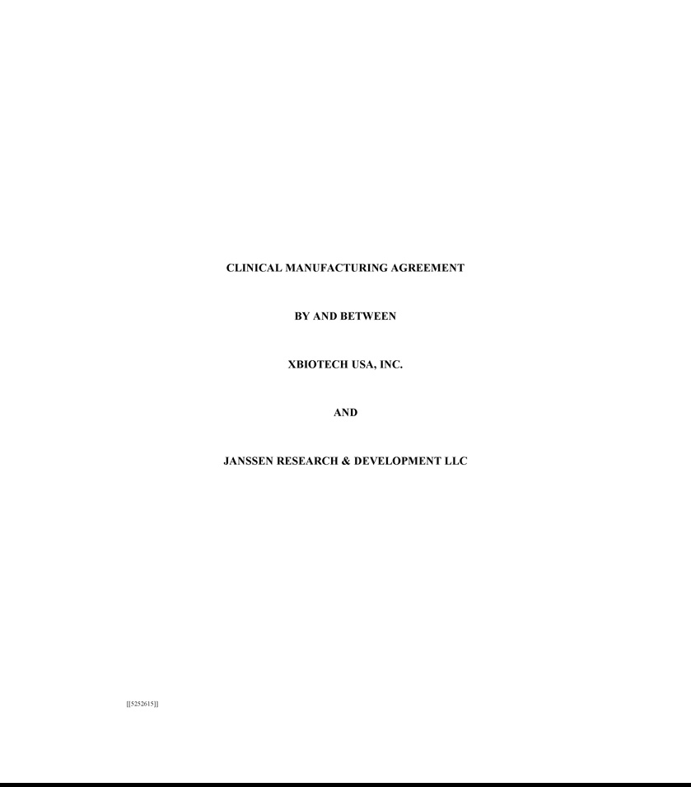

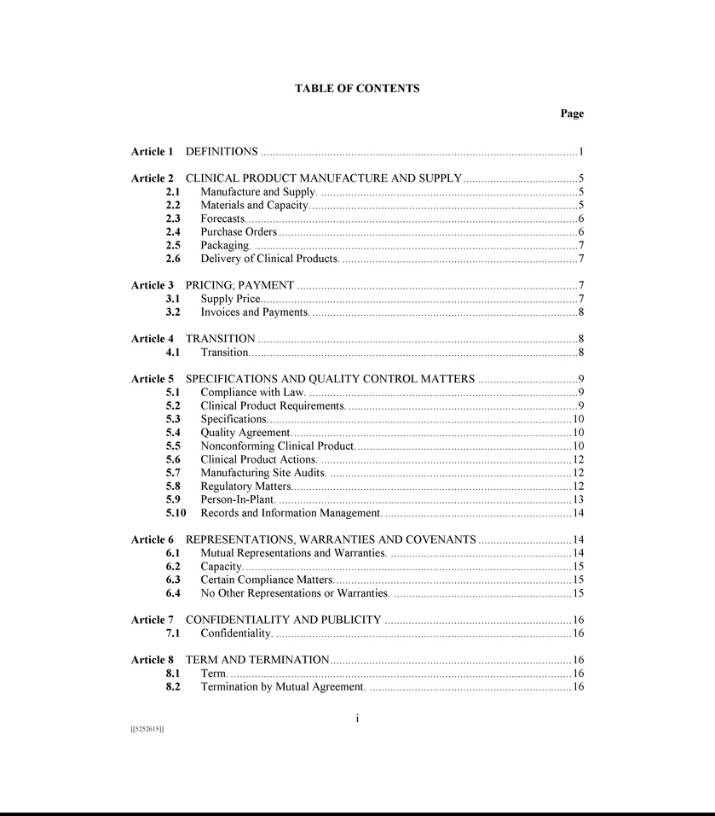

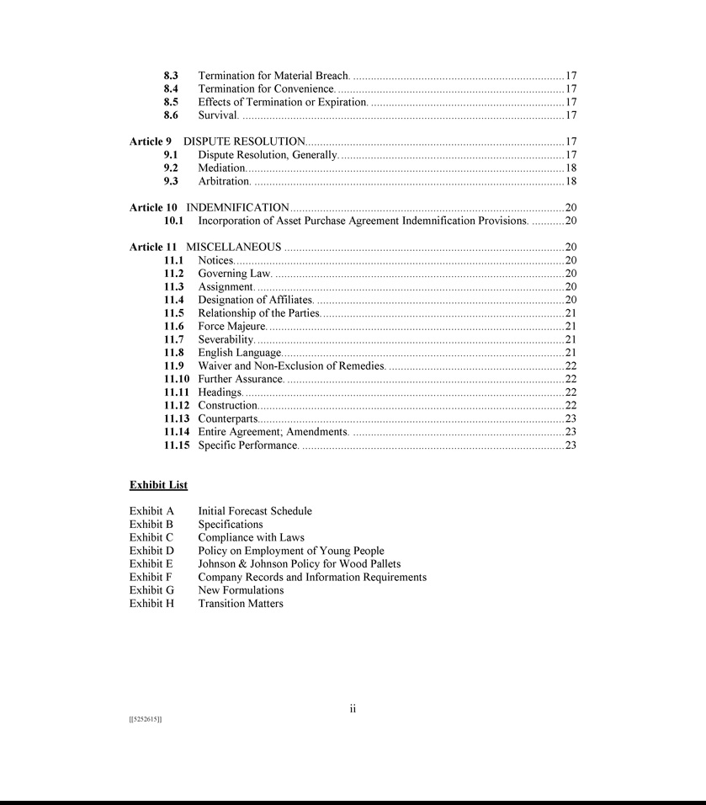

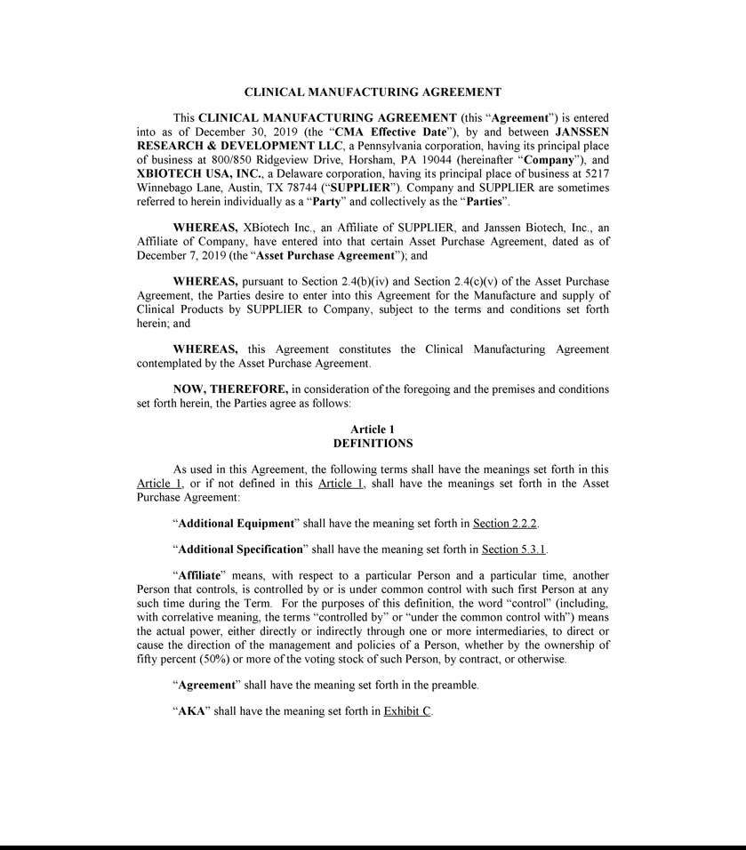

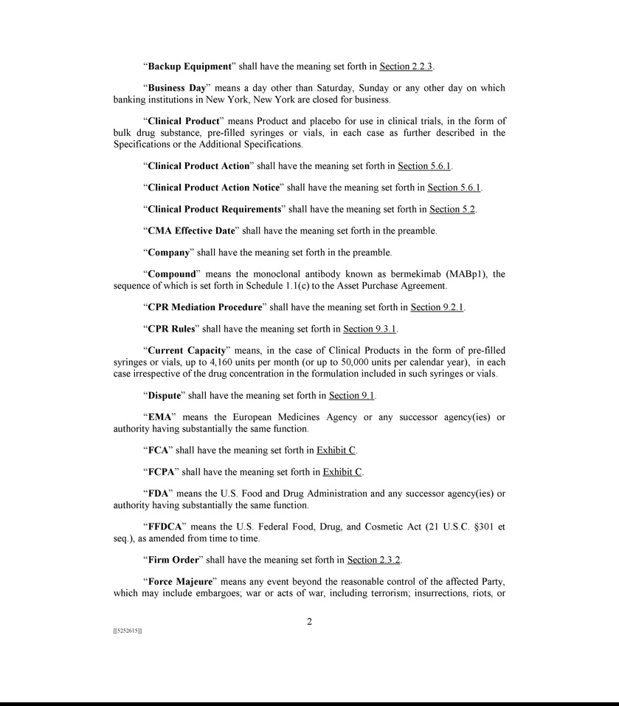

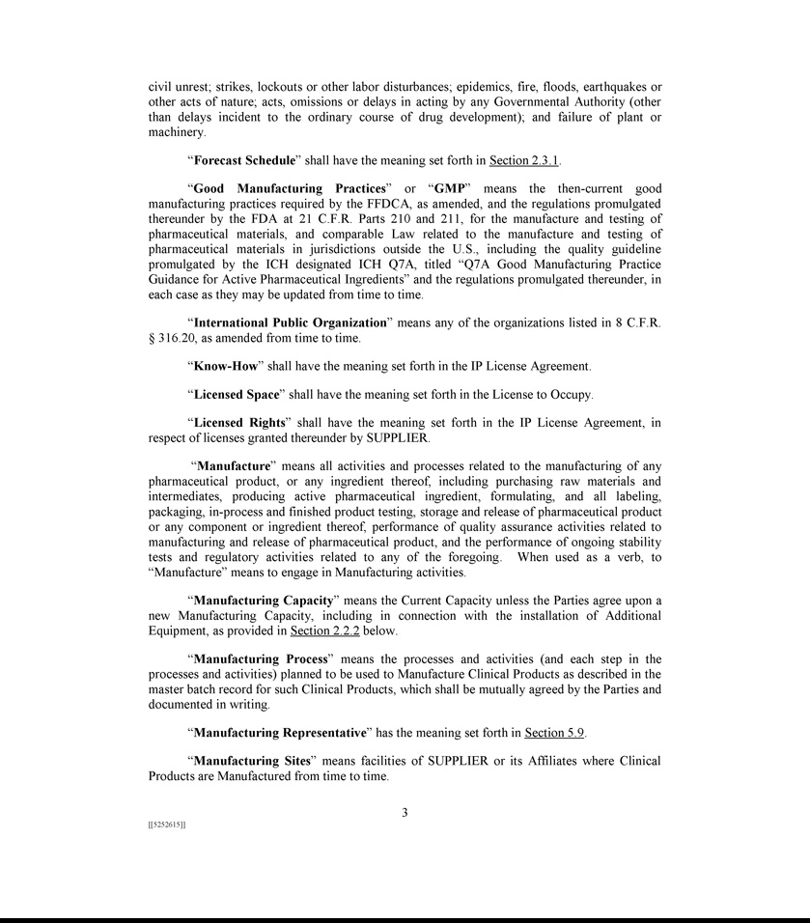

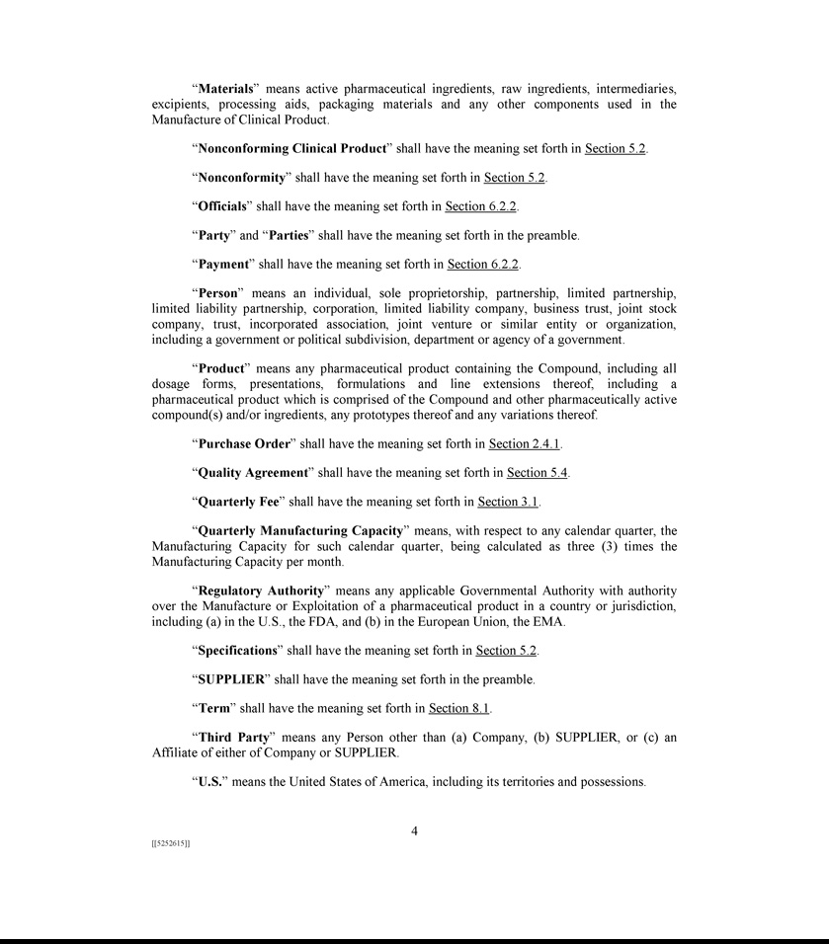

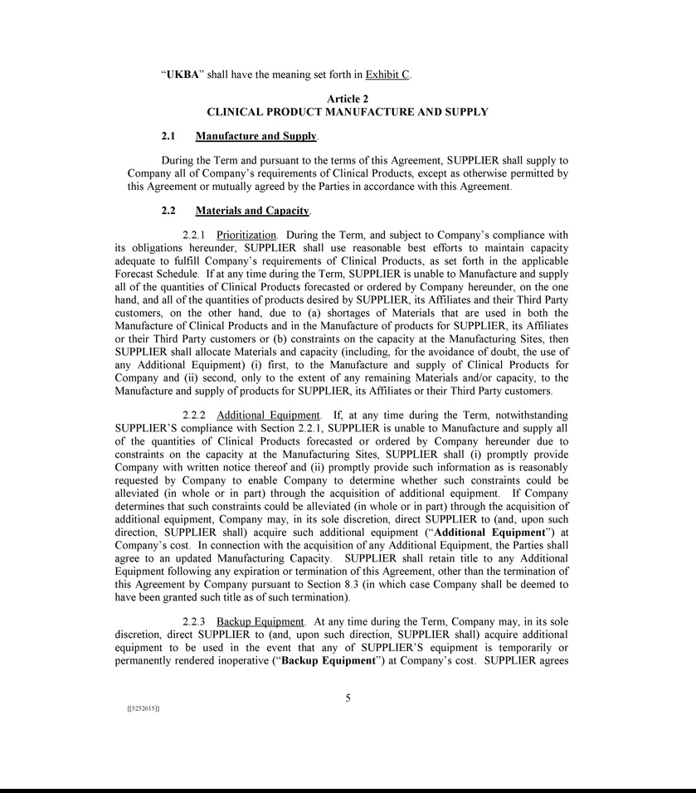

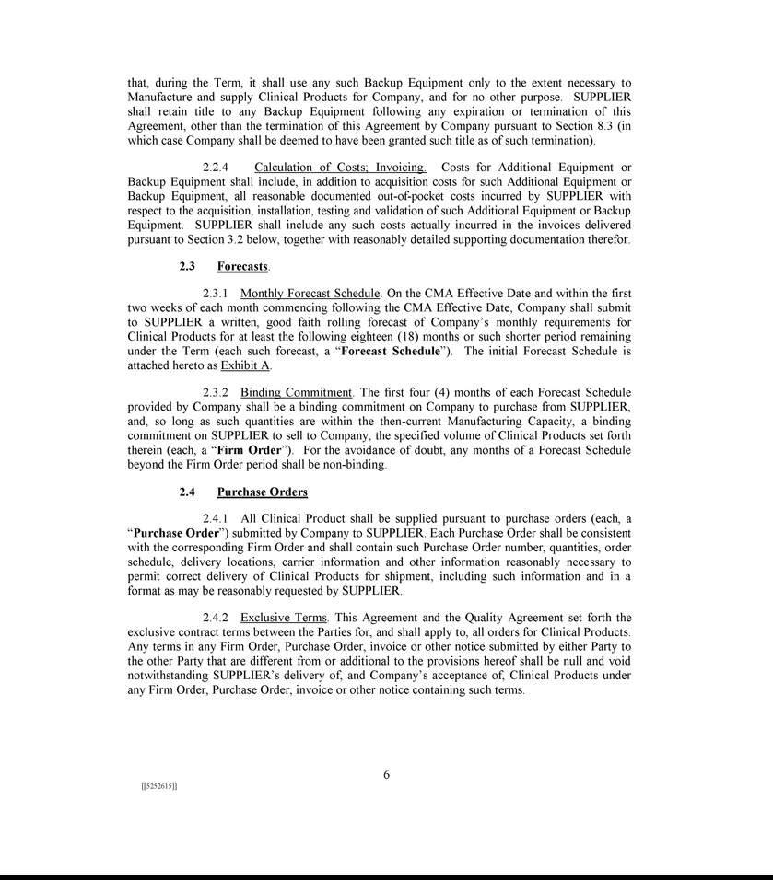

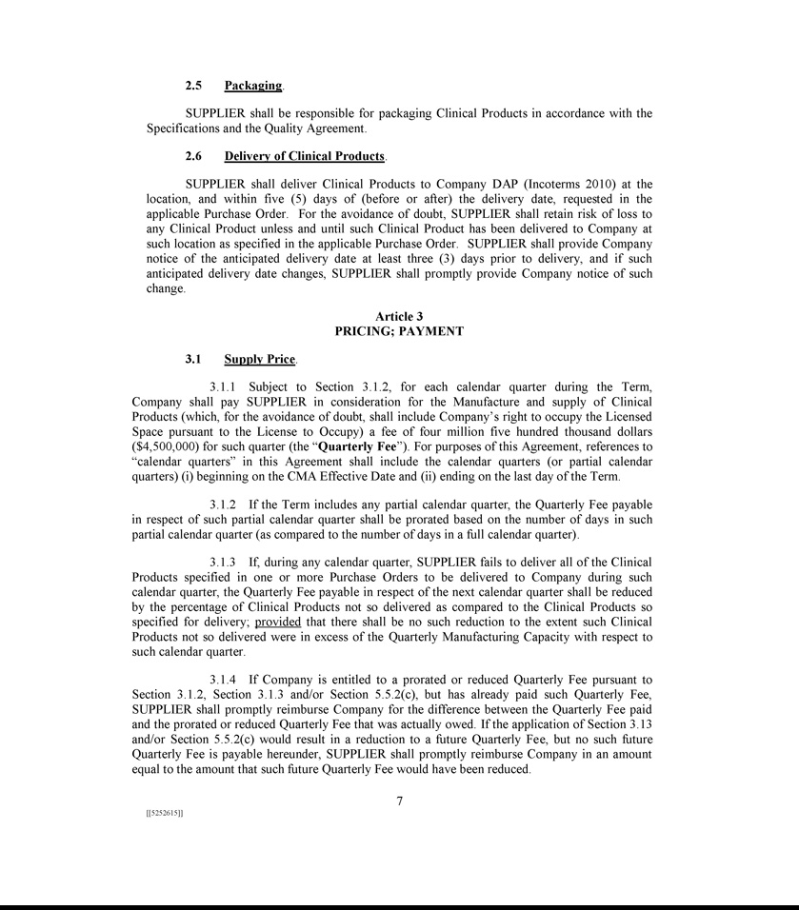

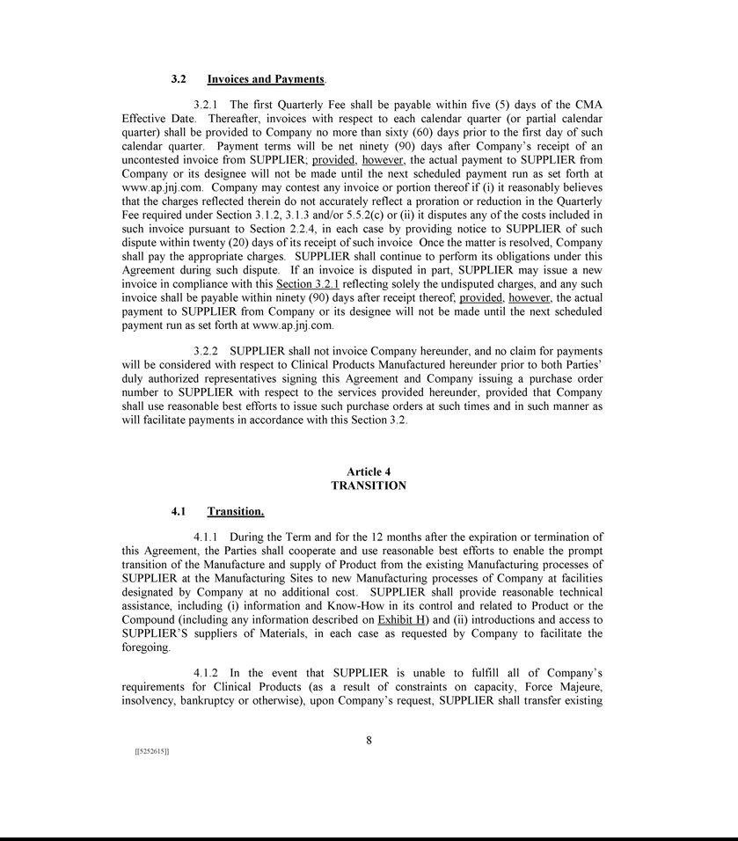

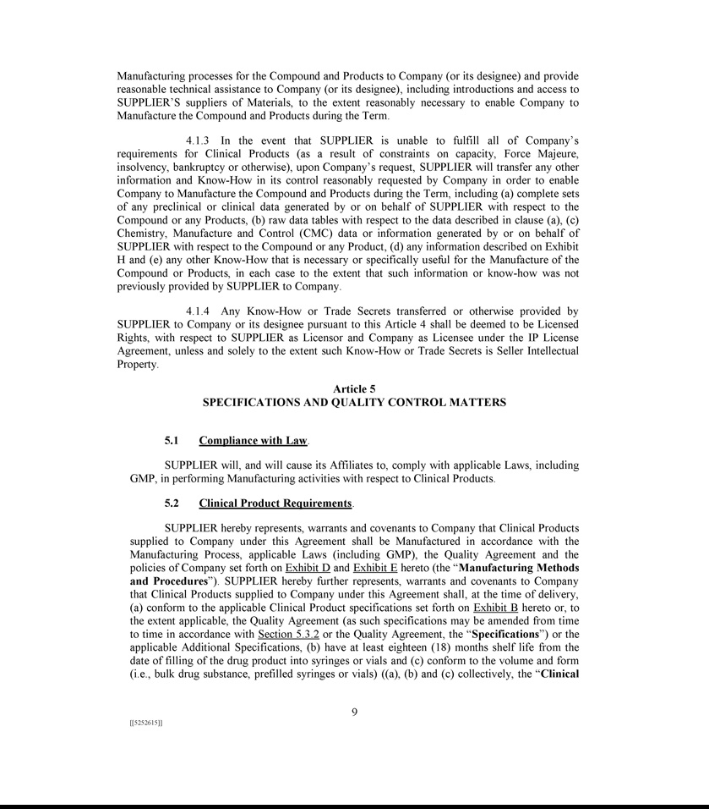

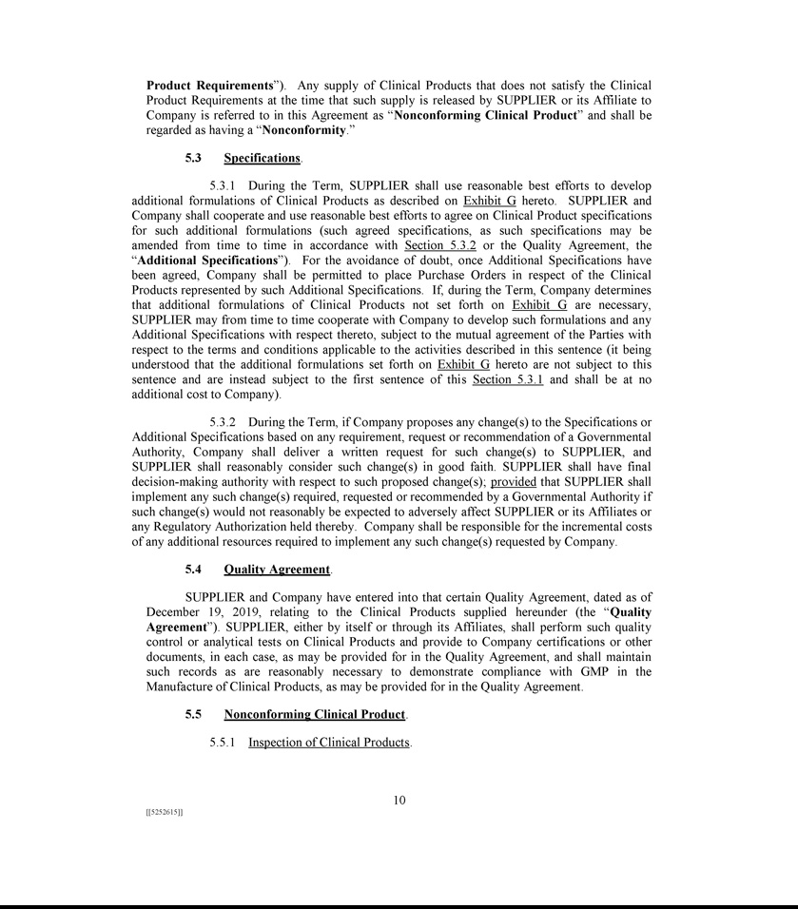

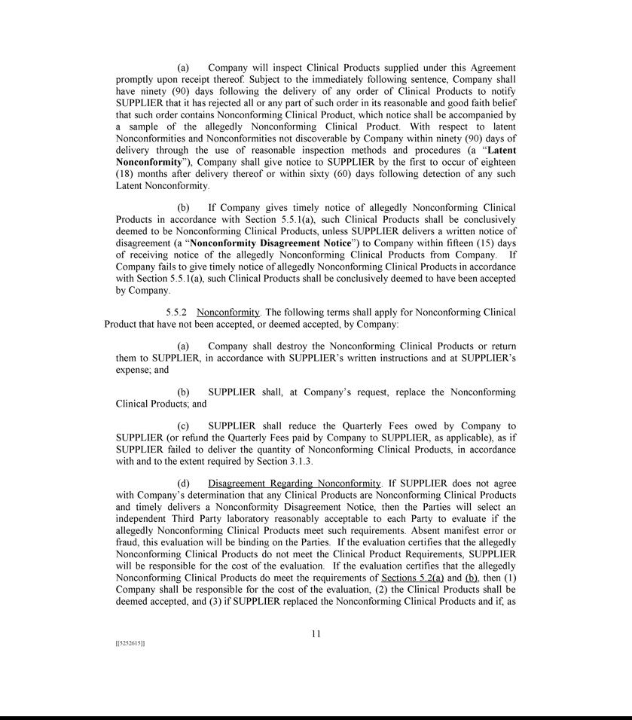

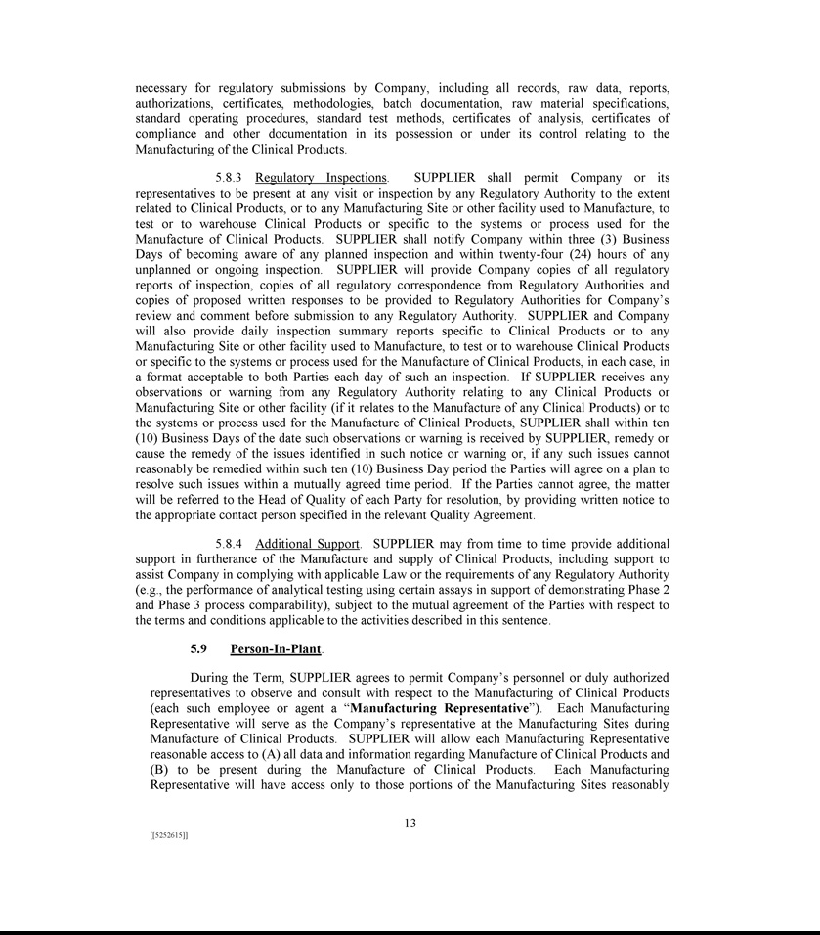

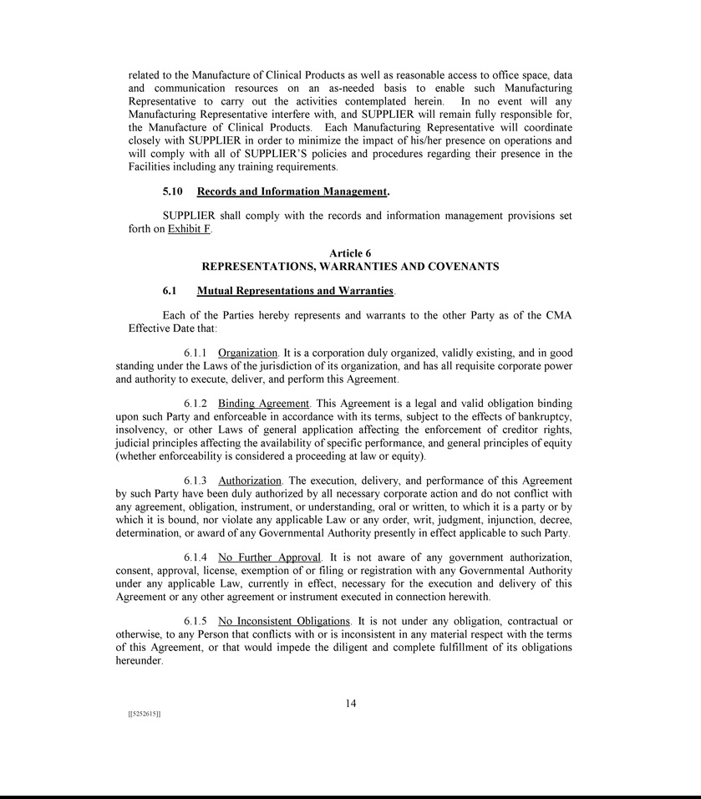

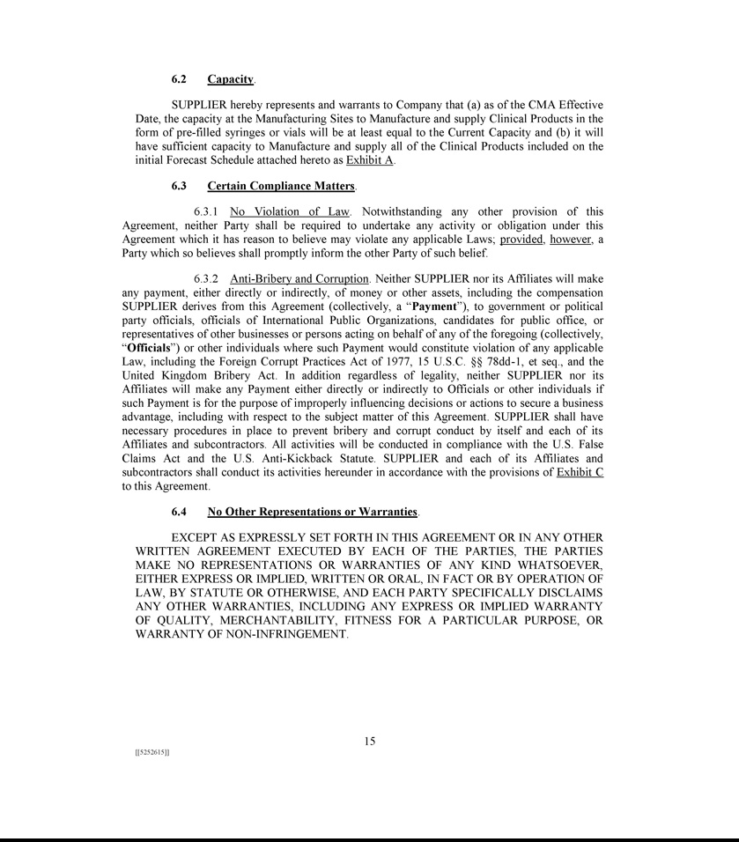

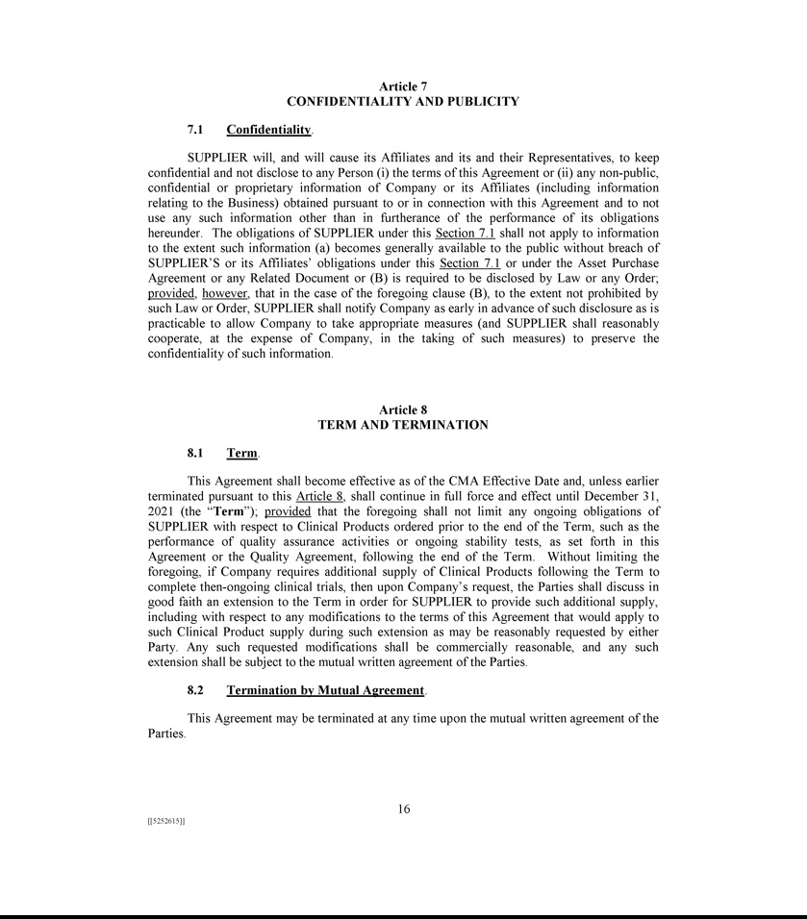

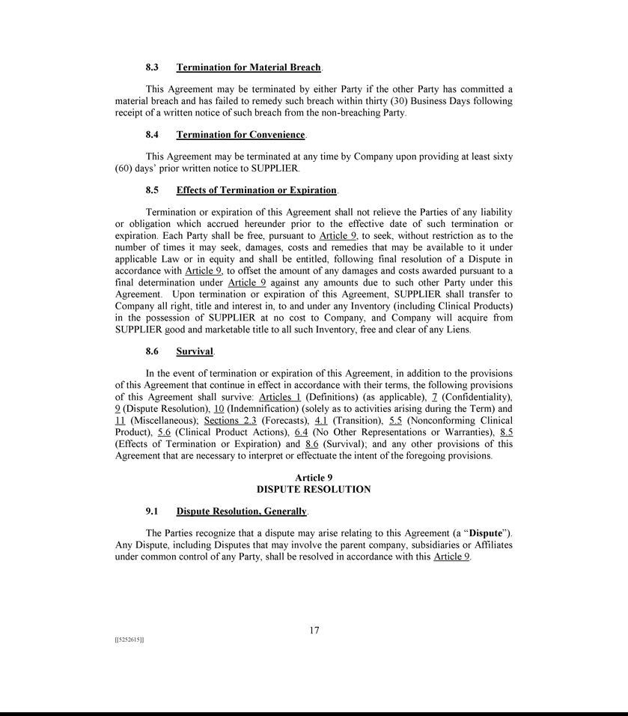

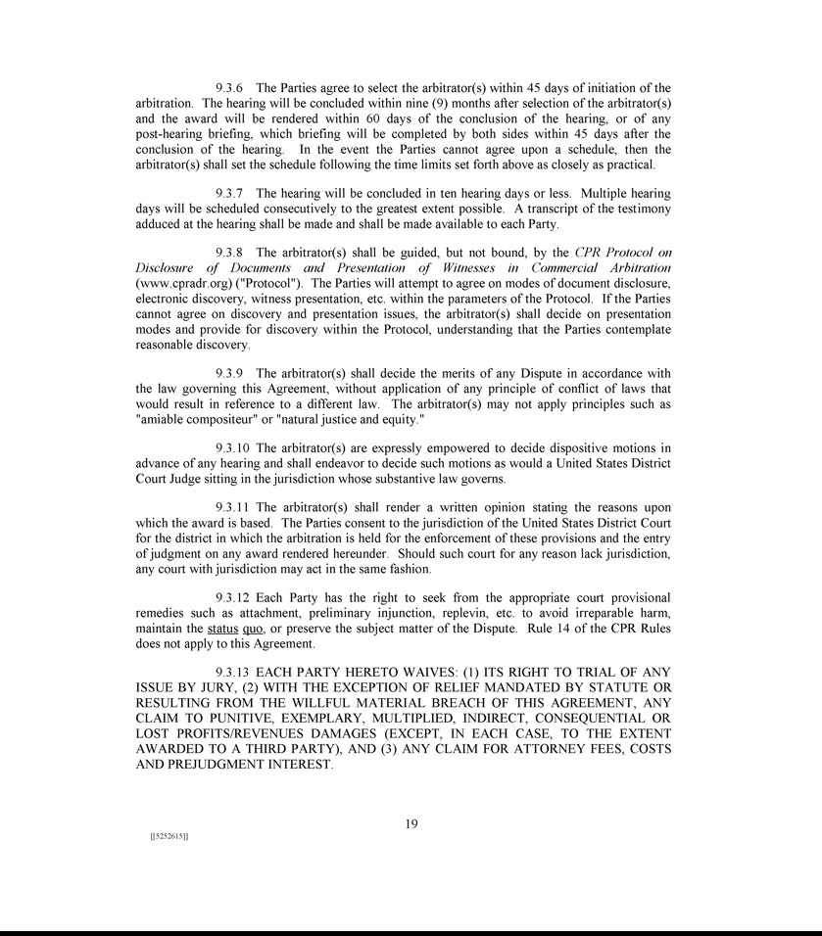

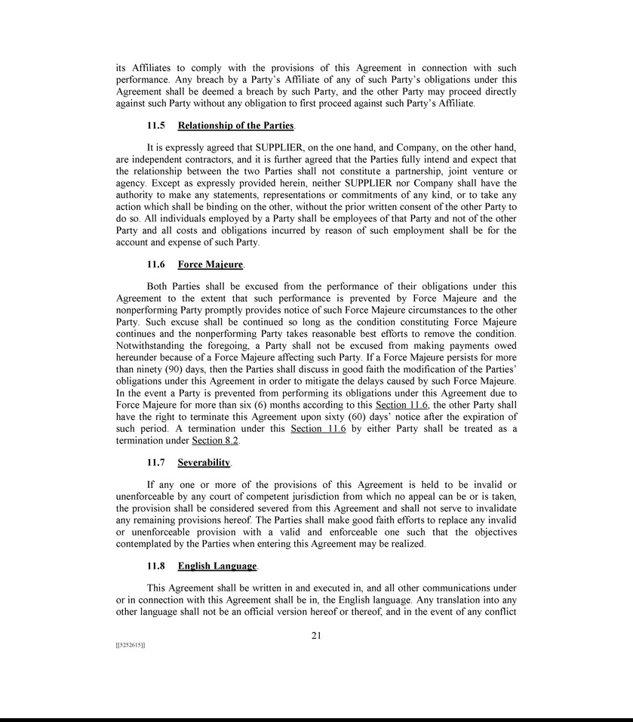

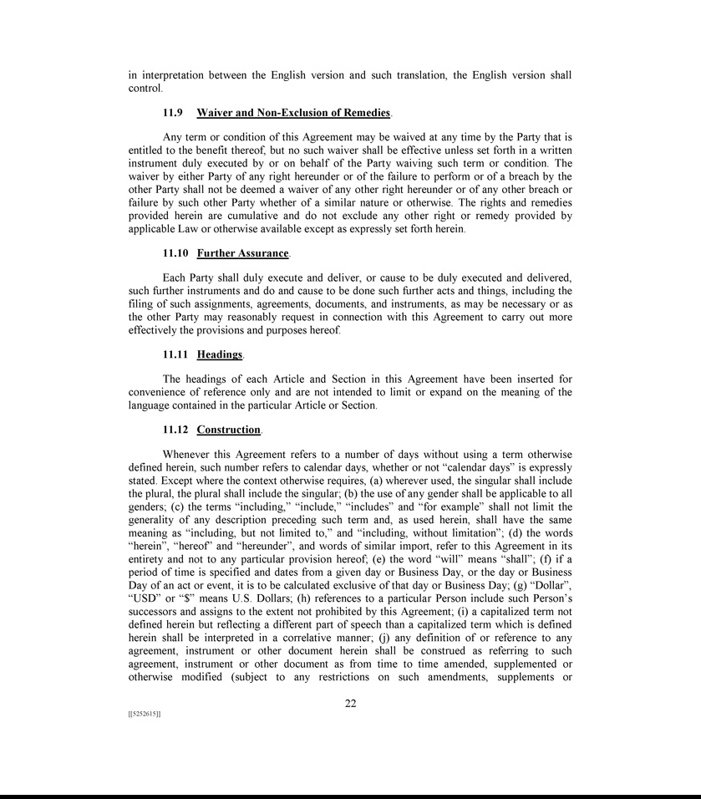

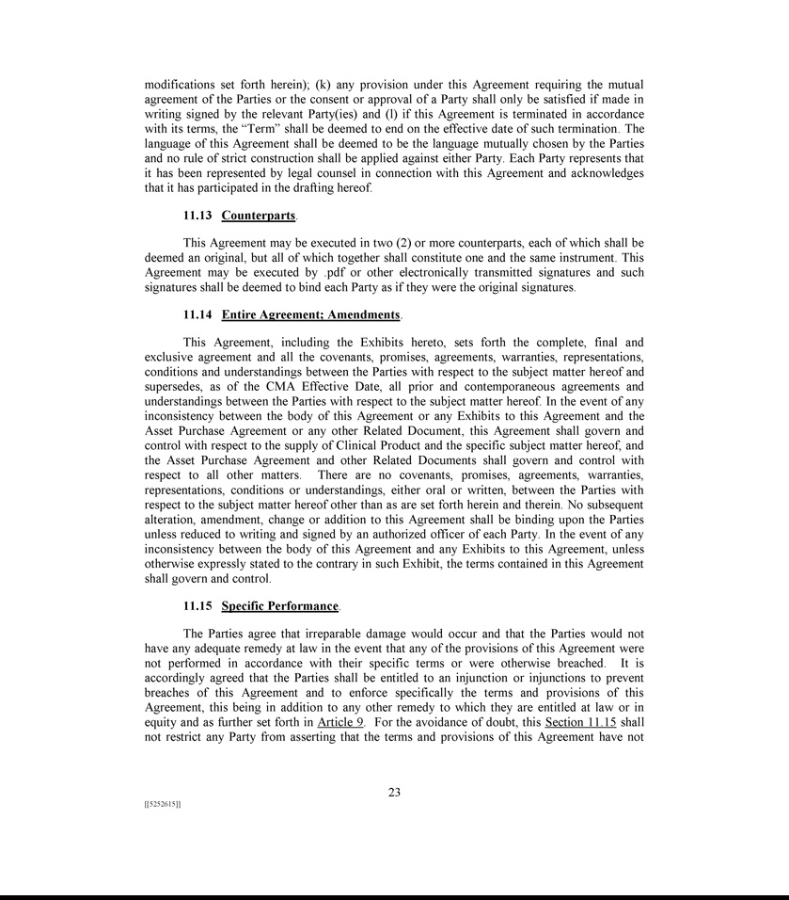



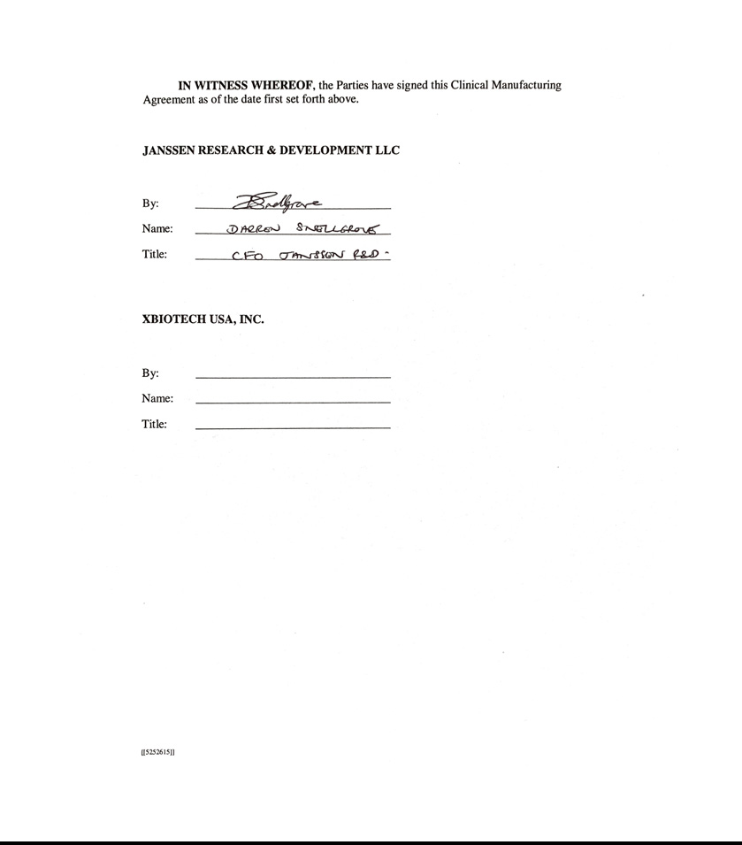

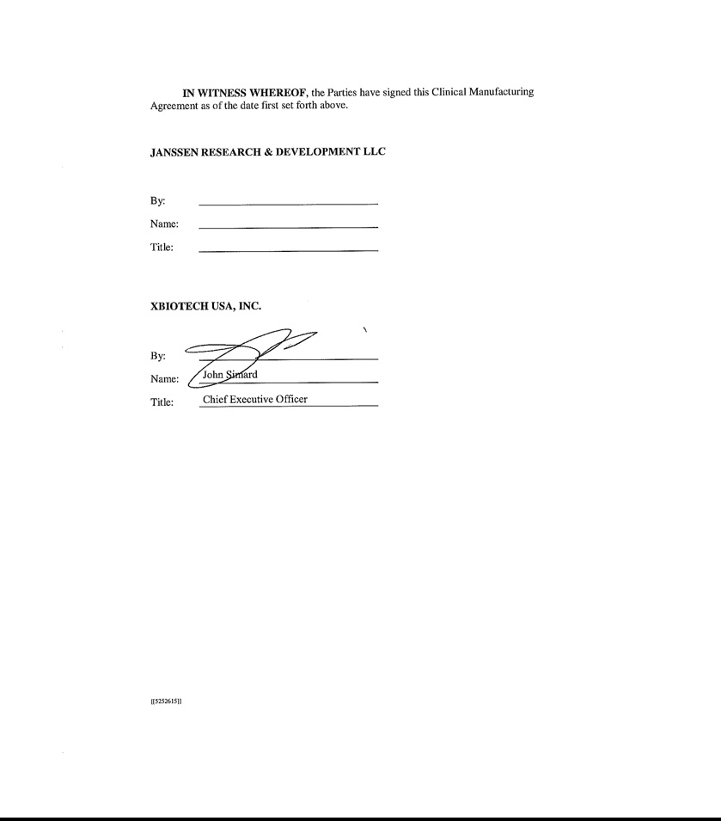

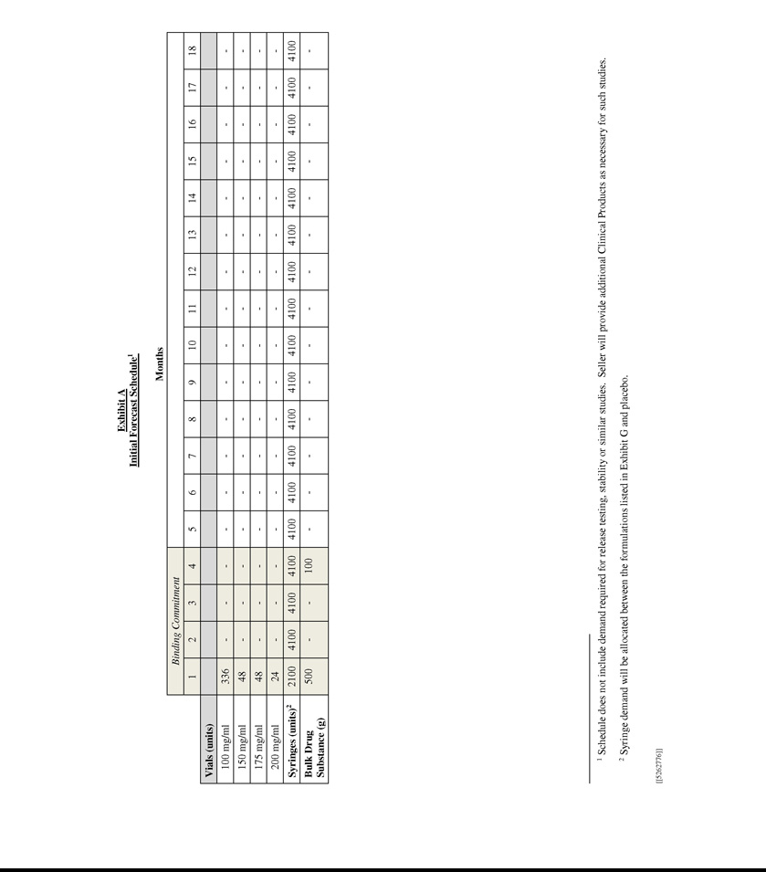

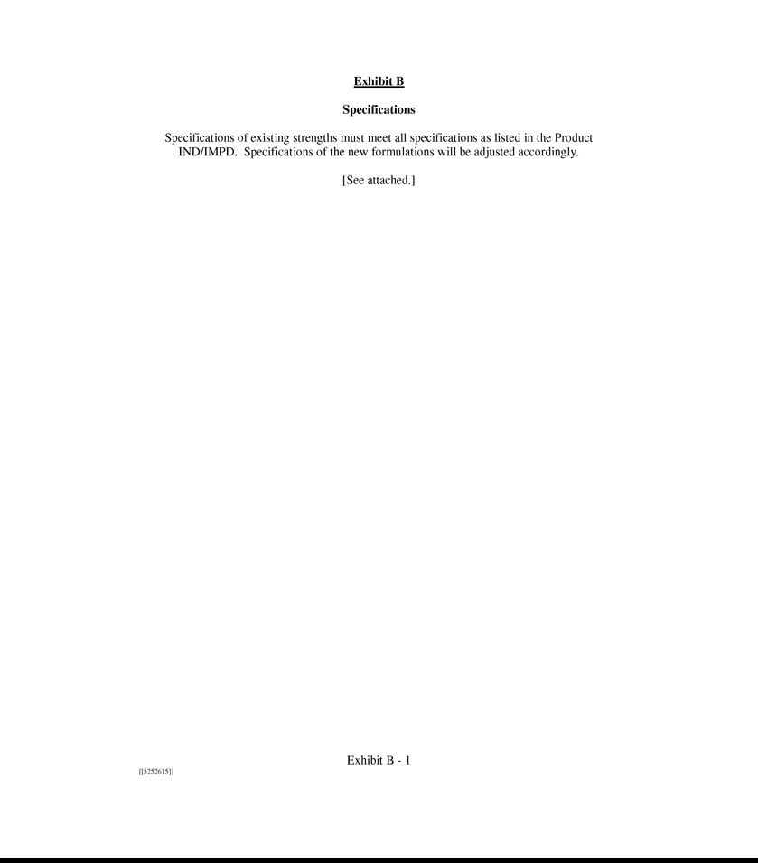

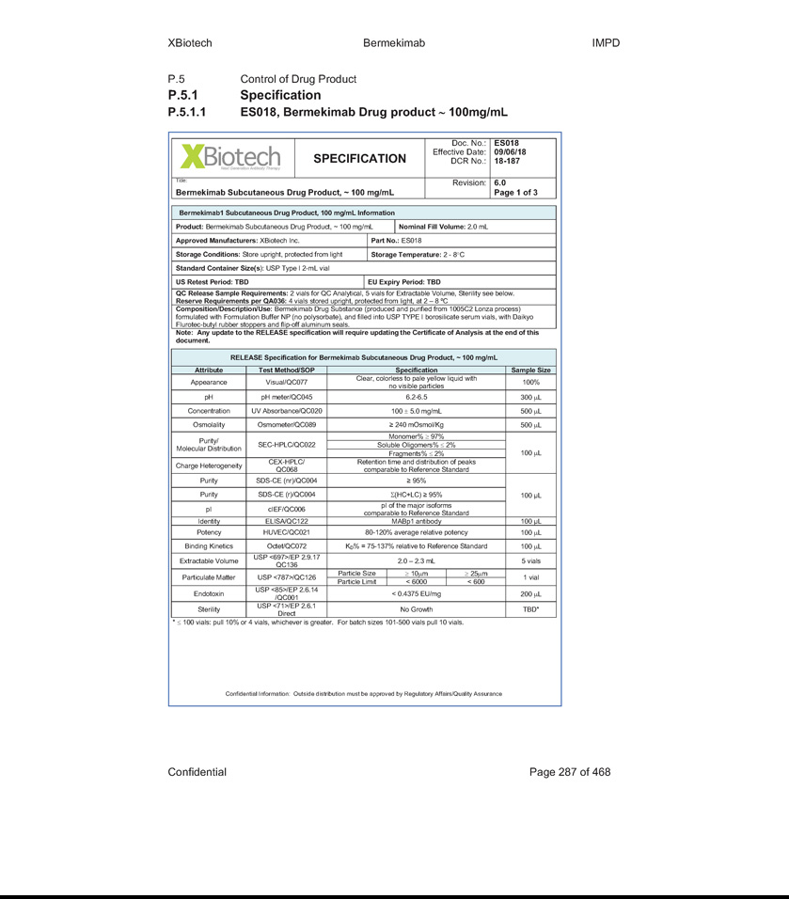

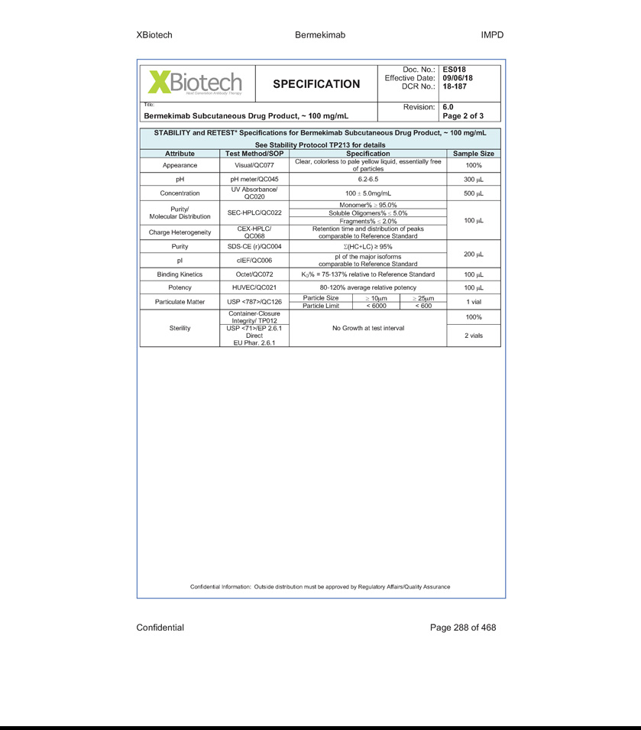

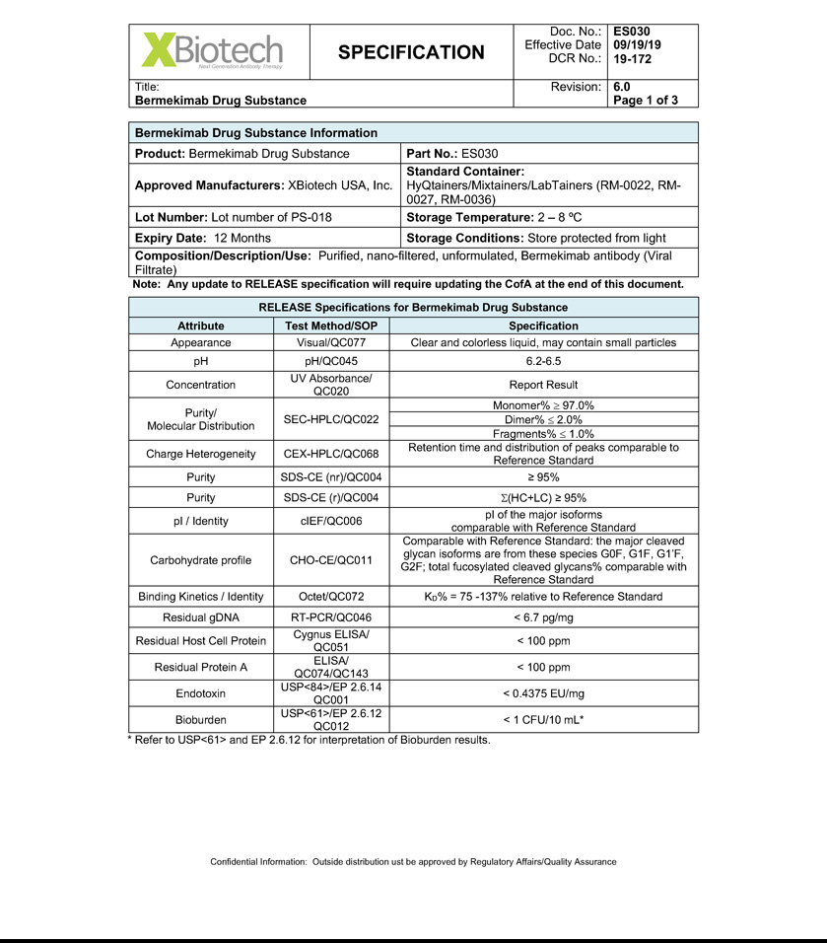

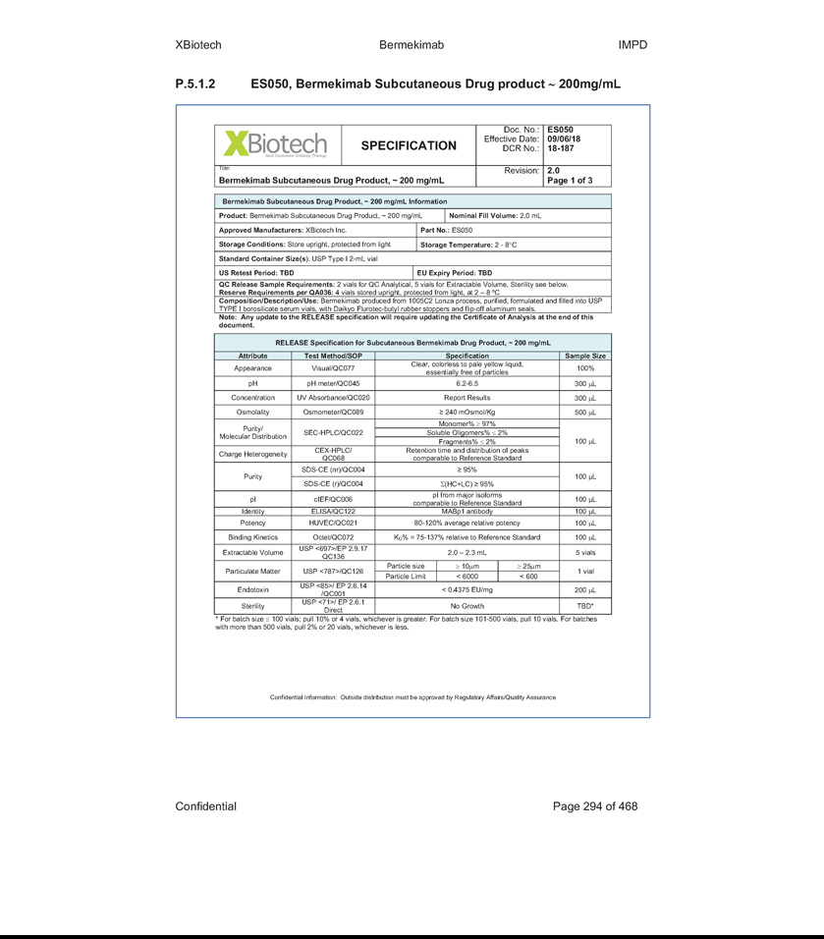

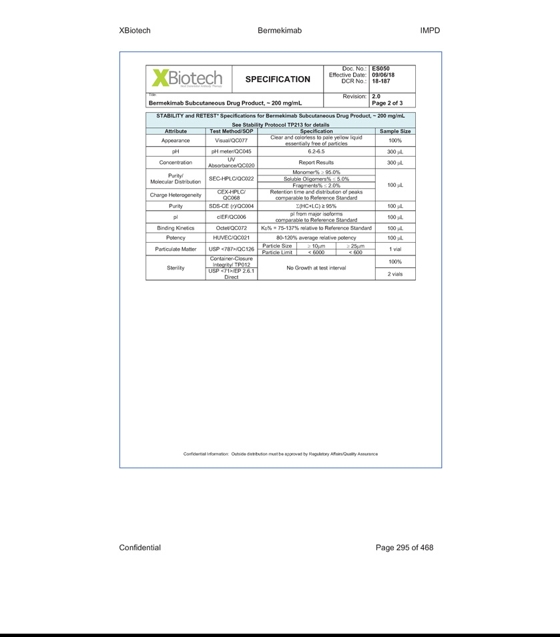

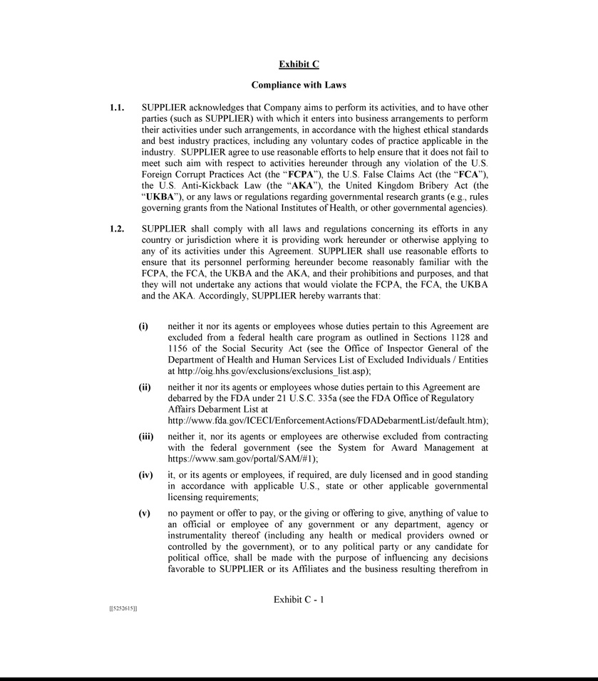

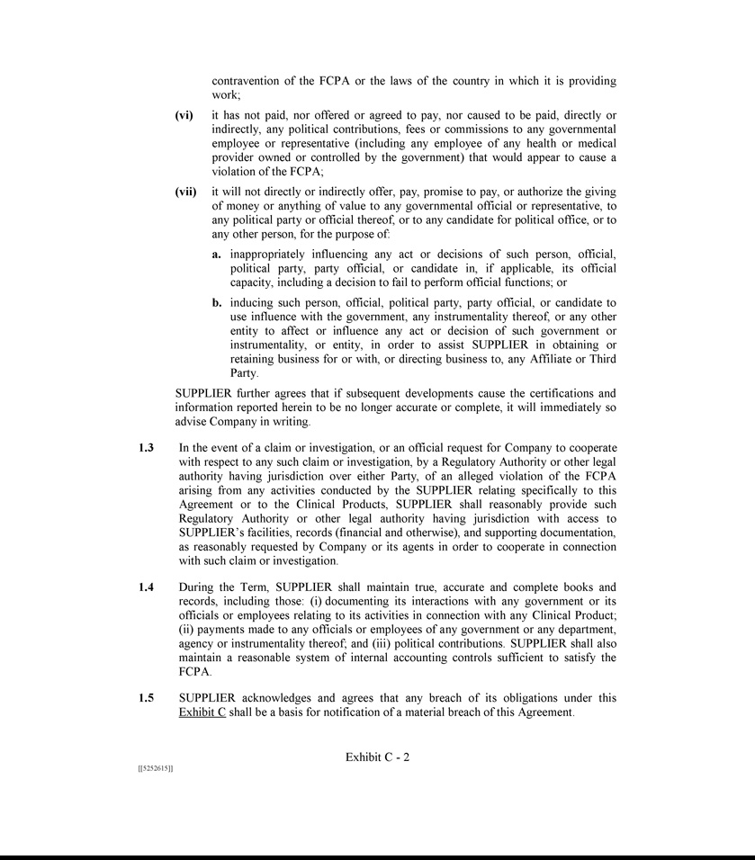

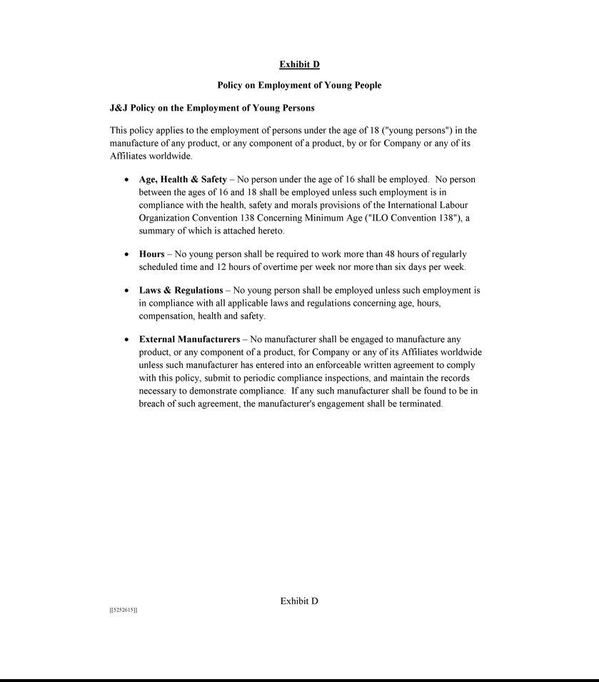

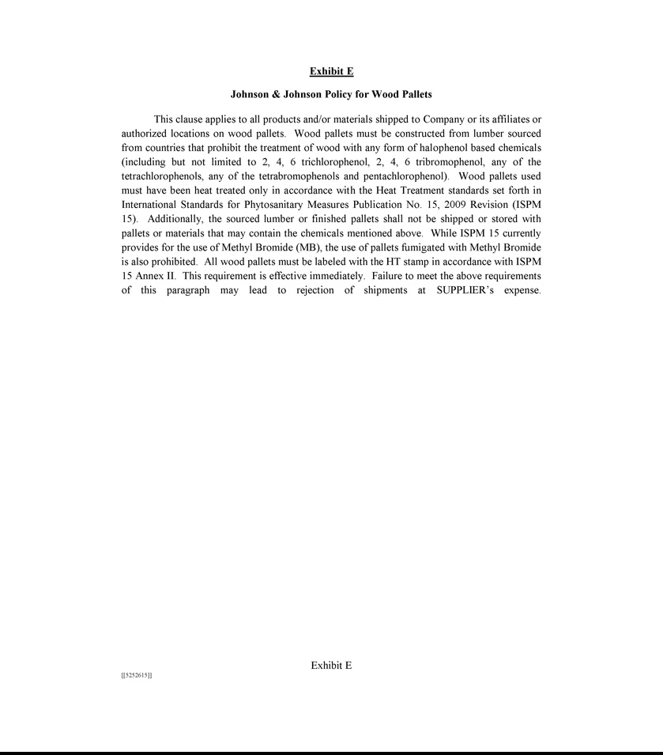

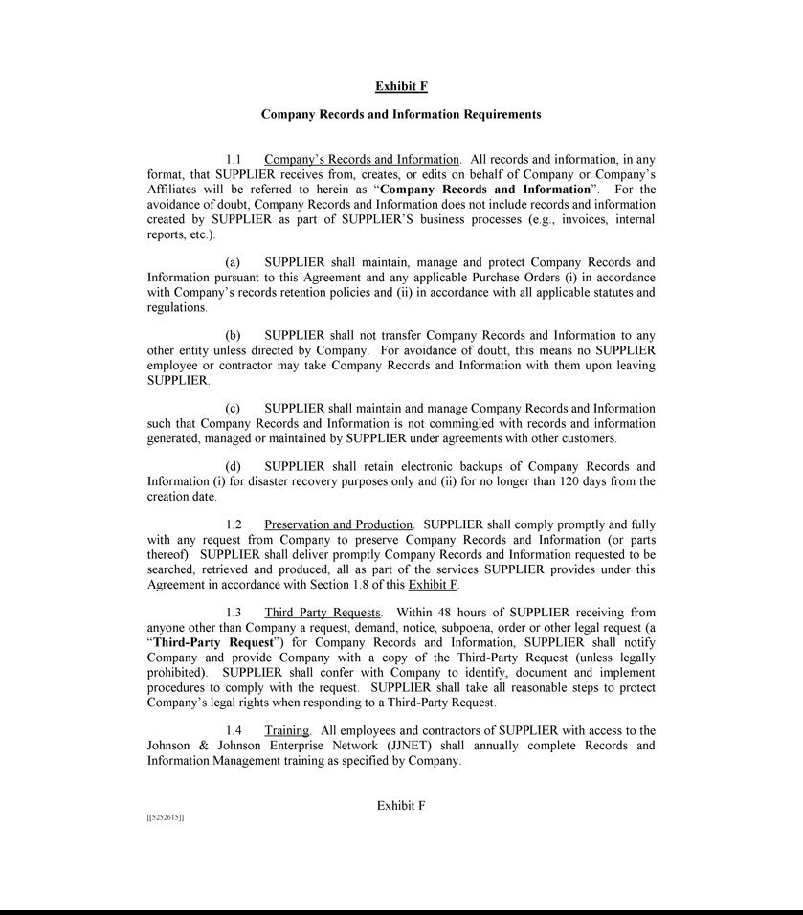

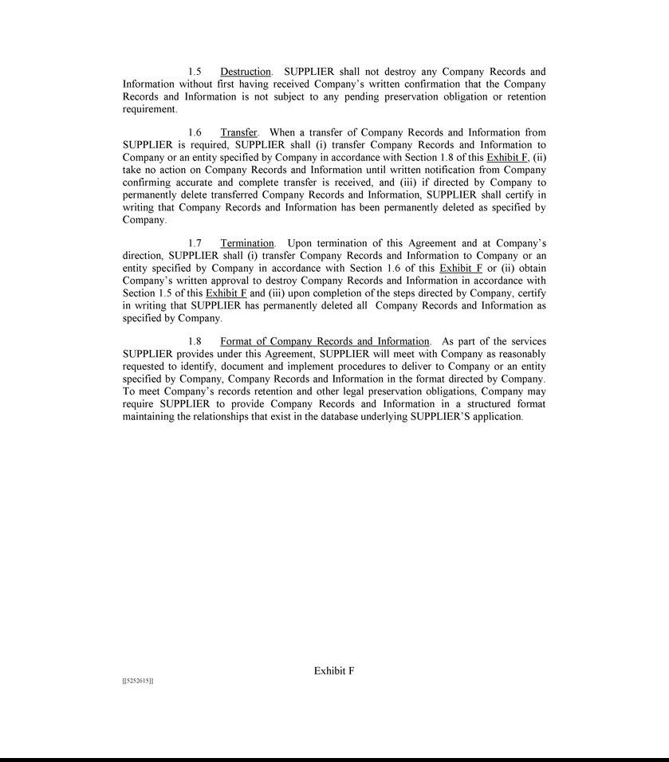

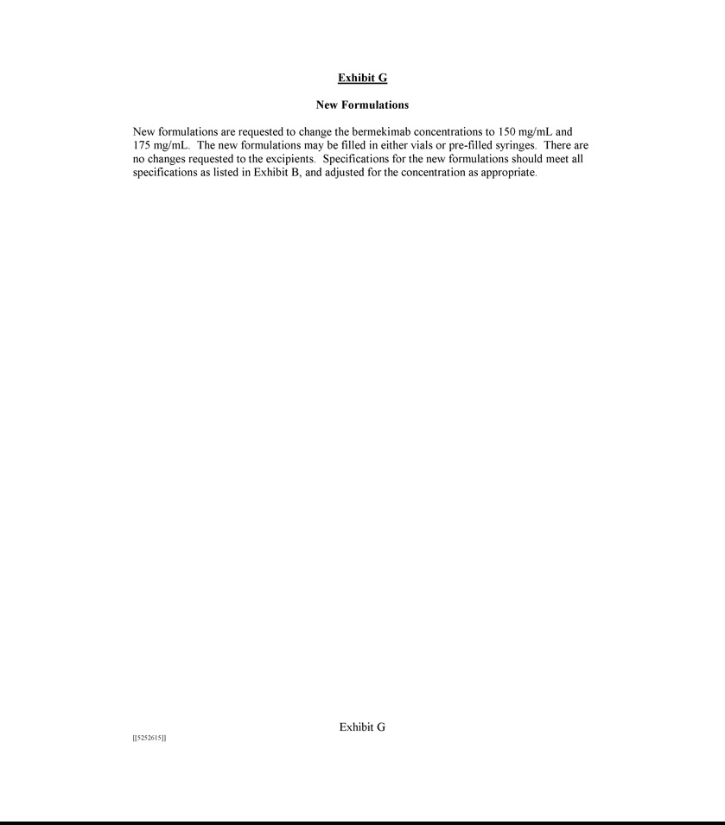

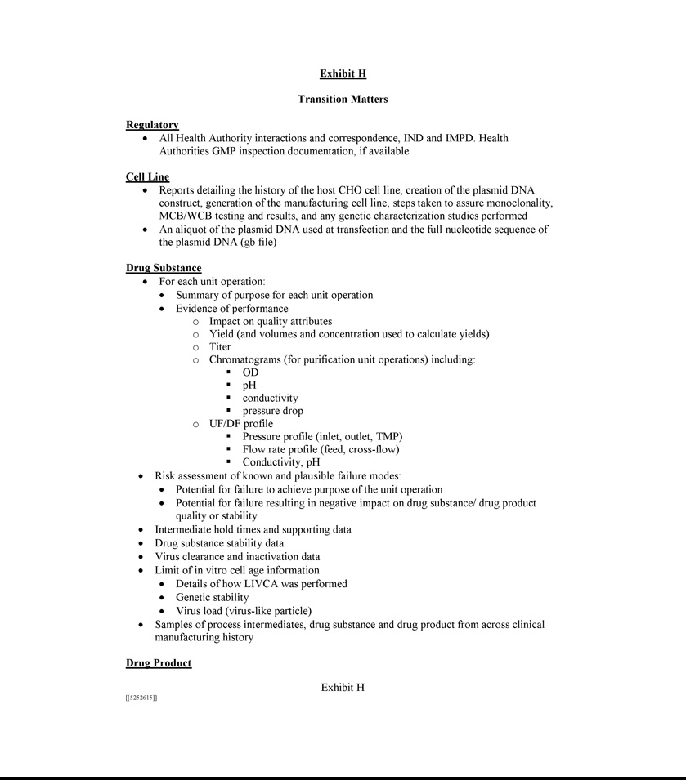

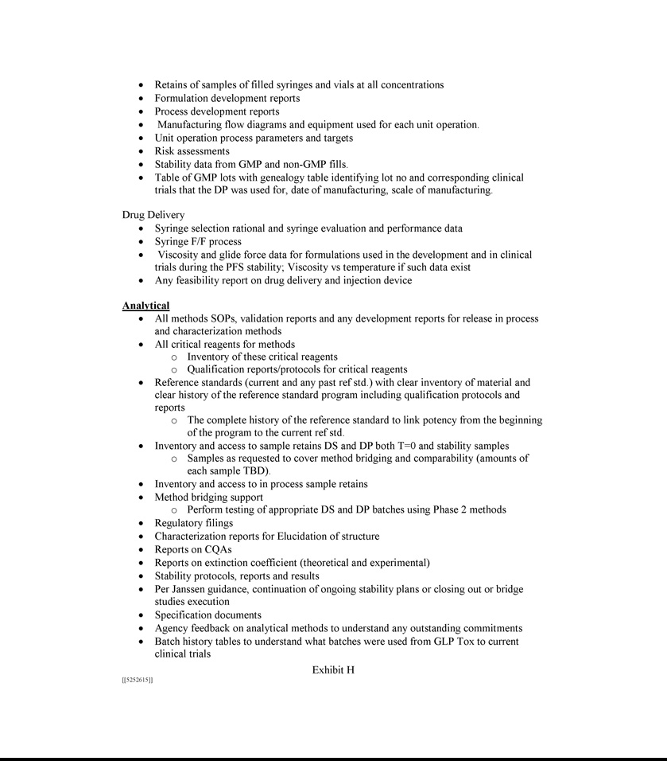



Exhibit 10.15


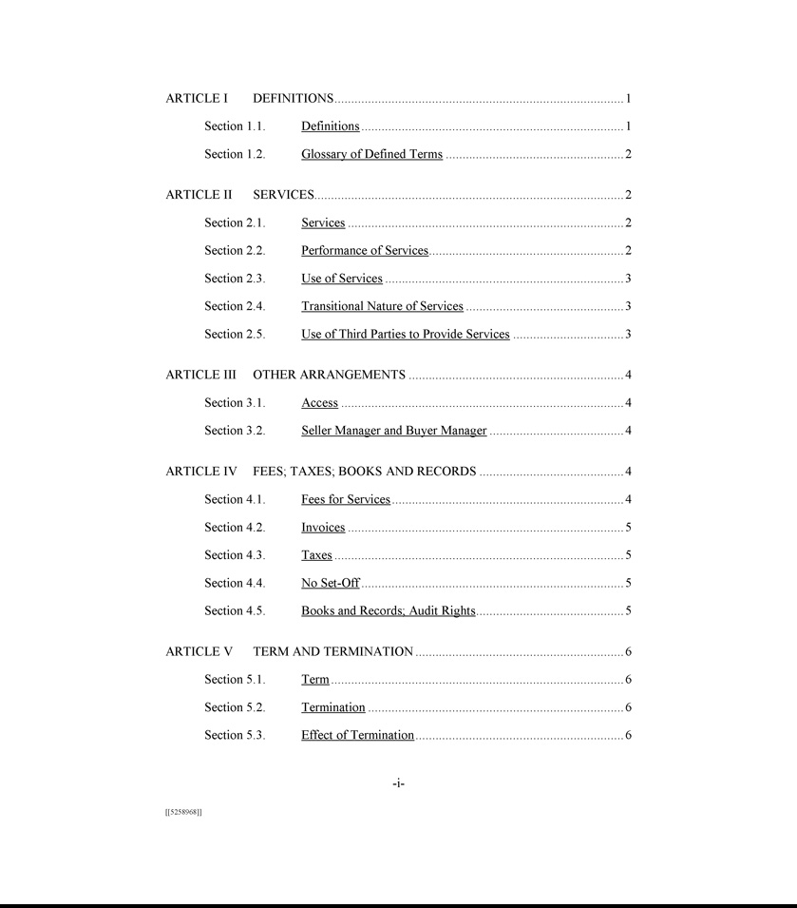

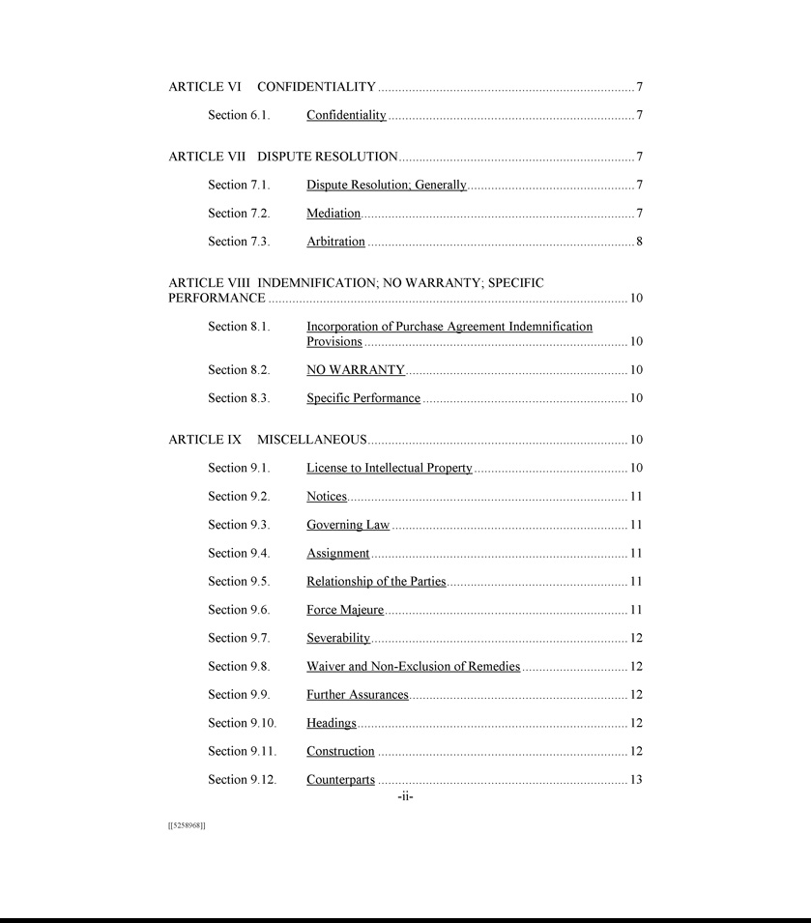





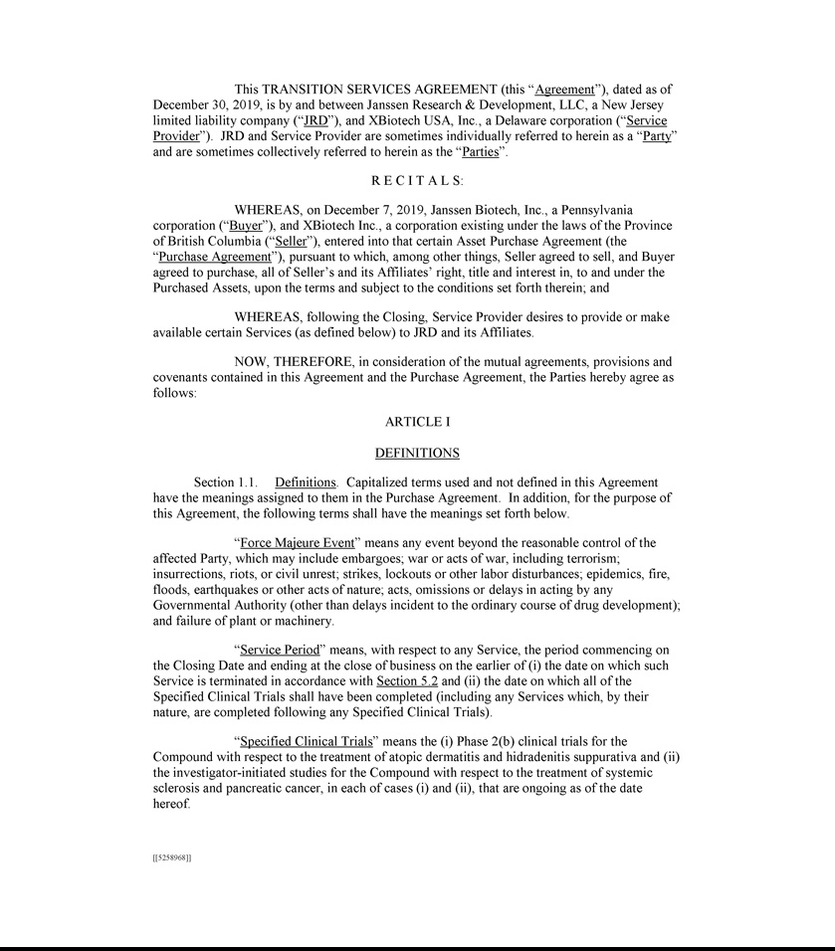

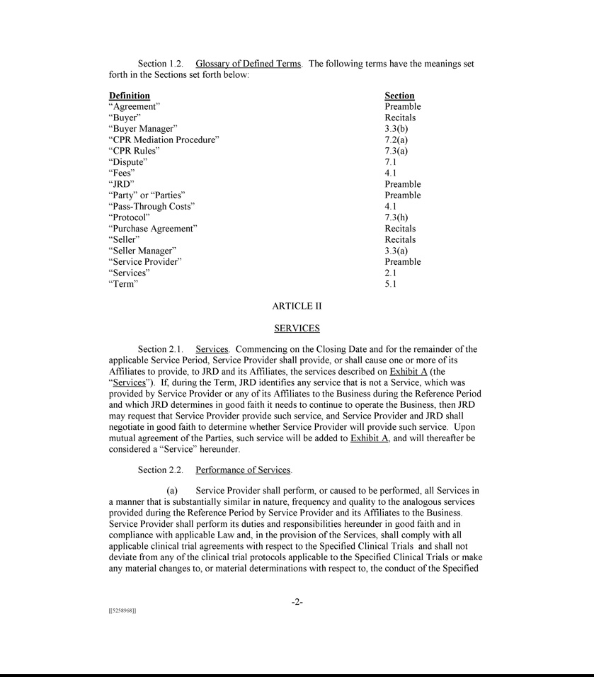

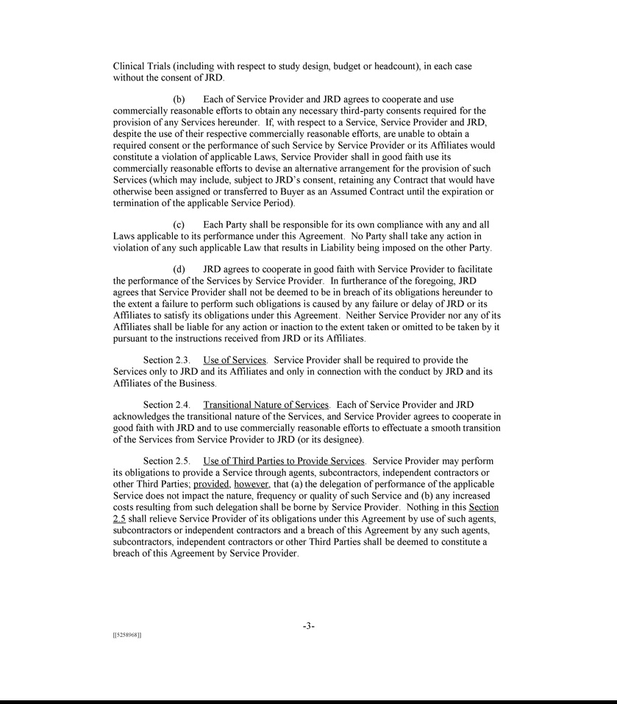

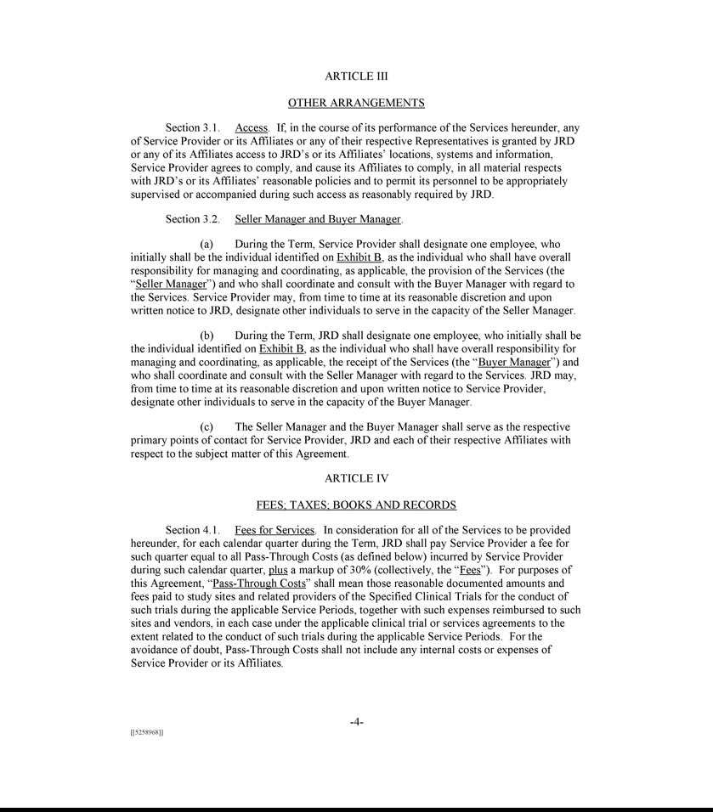

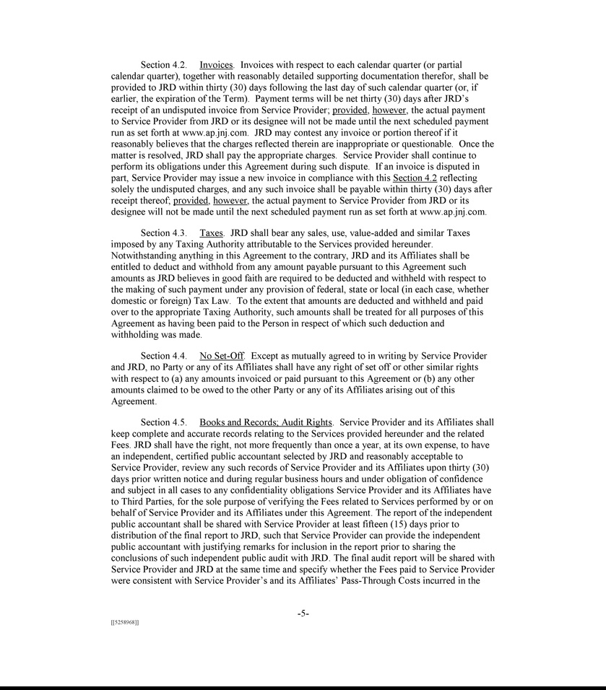

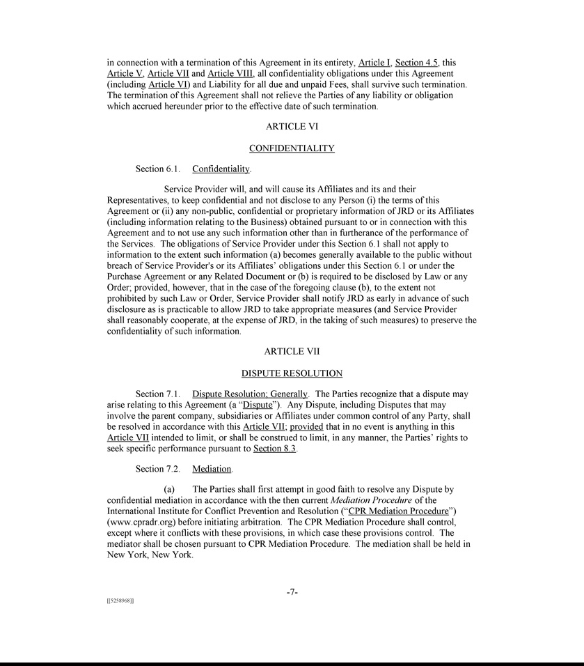

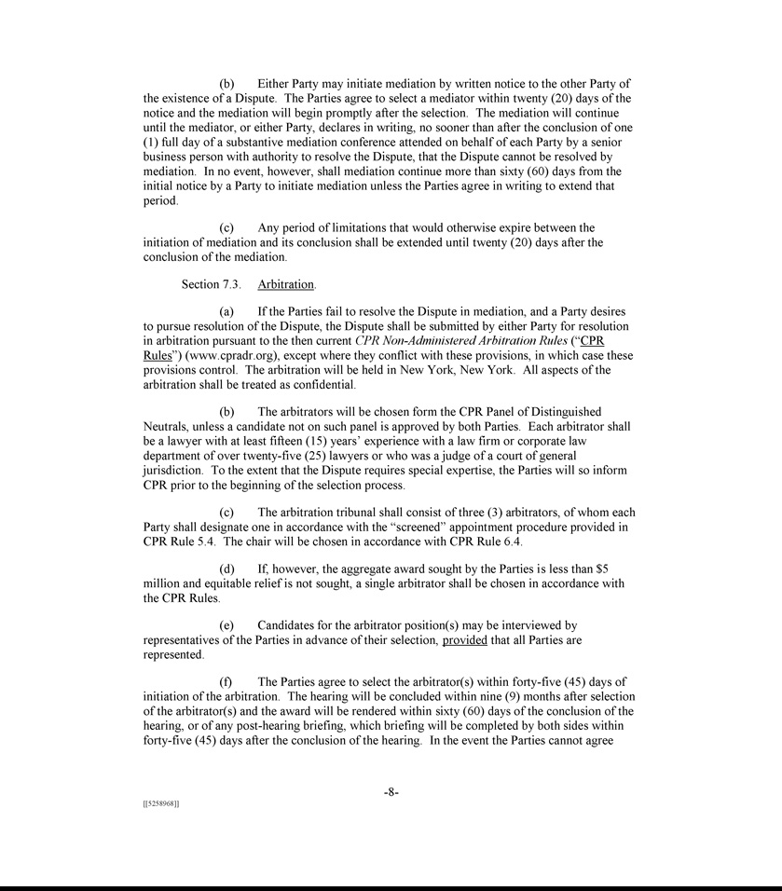

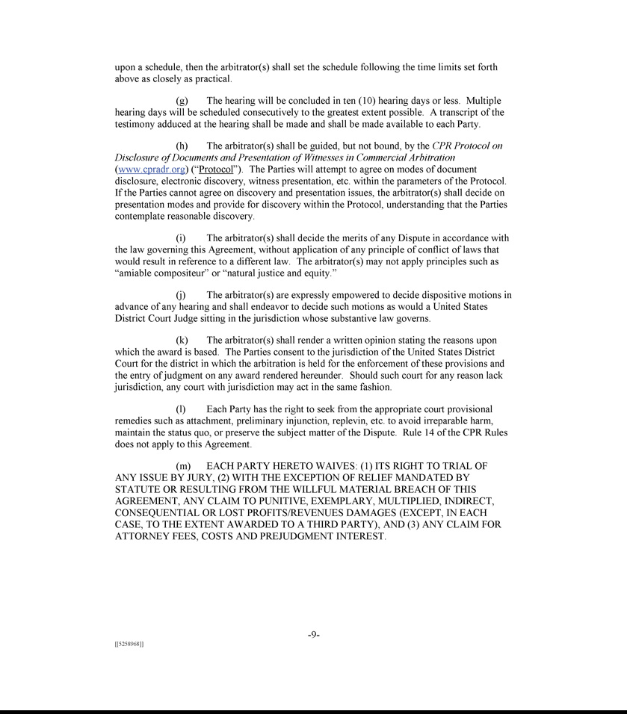

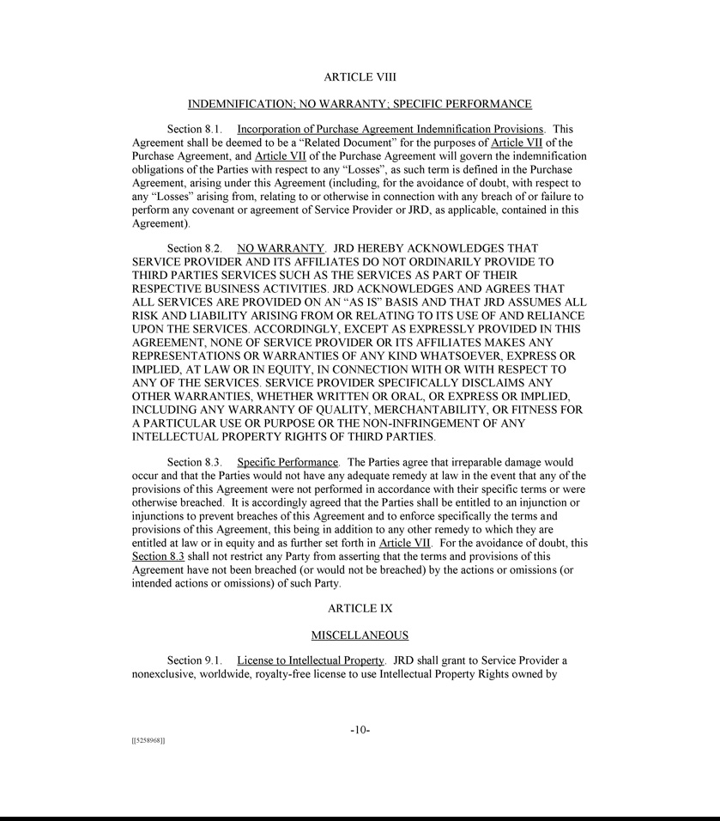

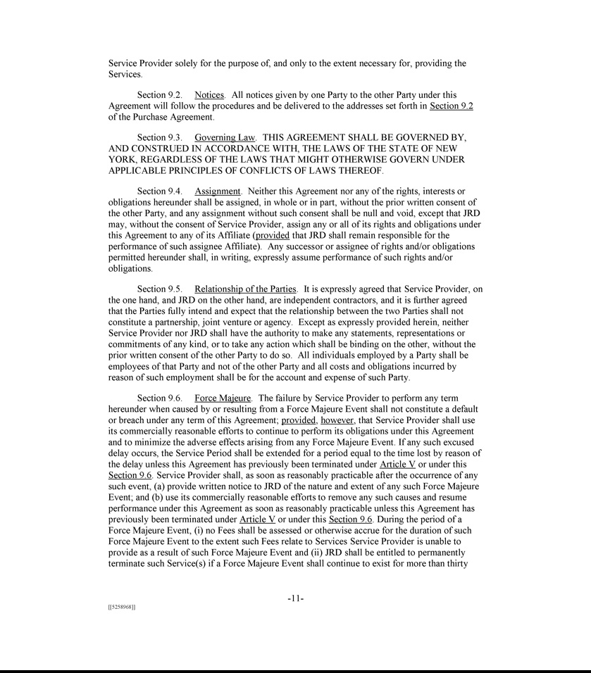

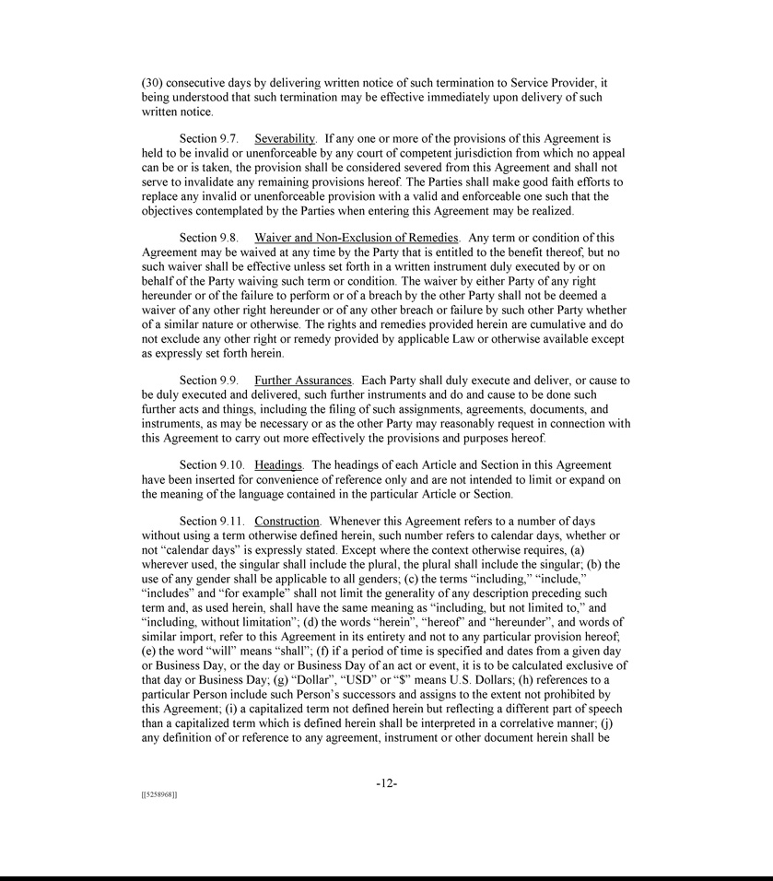

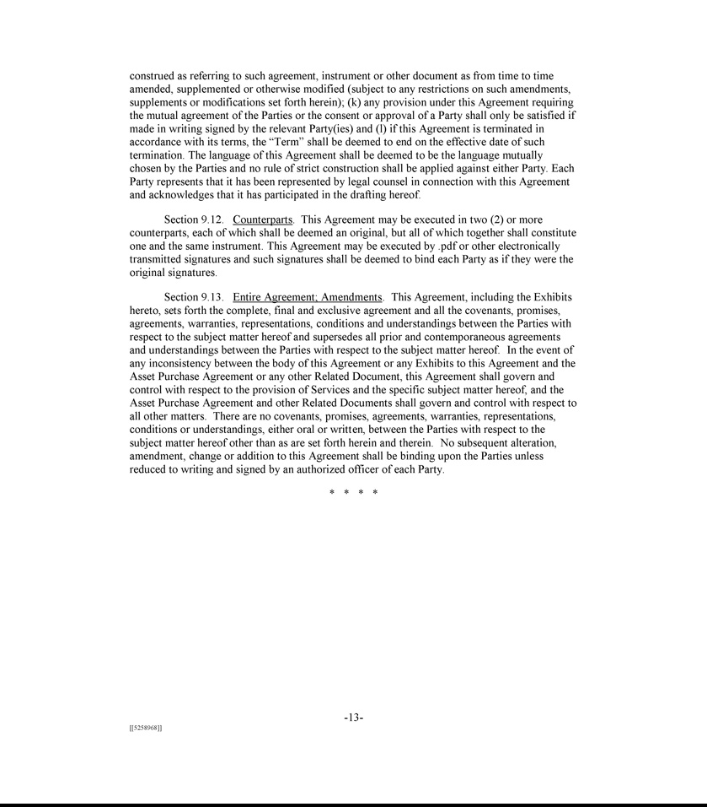

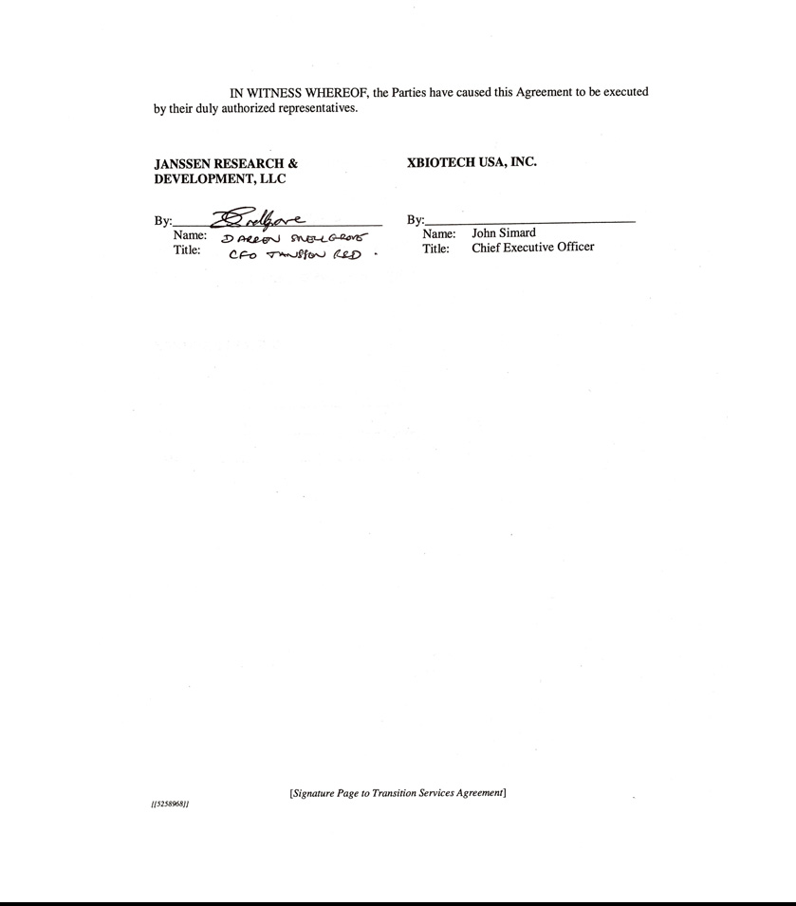

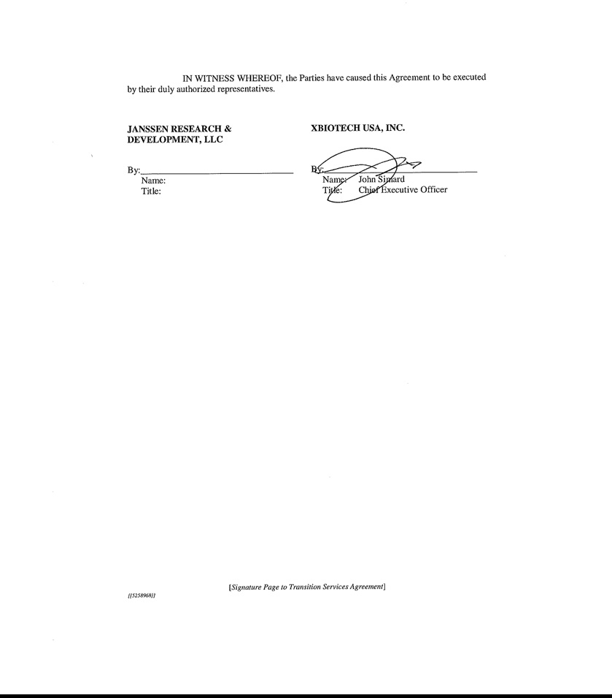

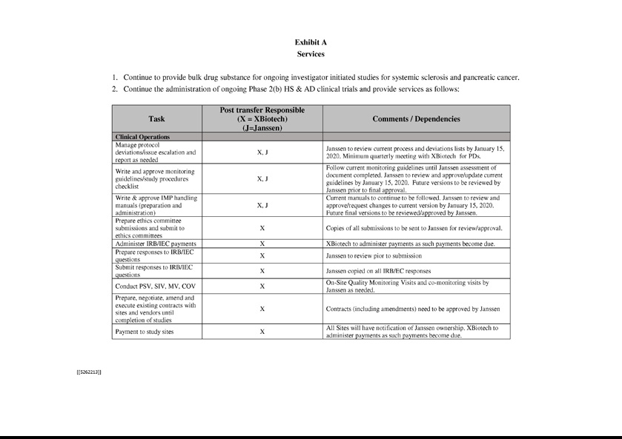

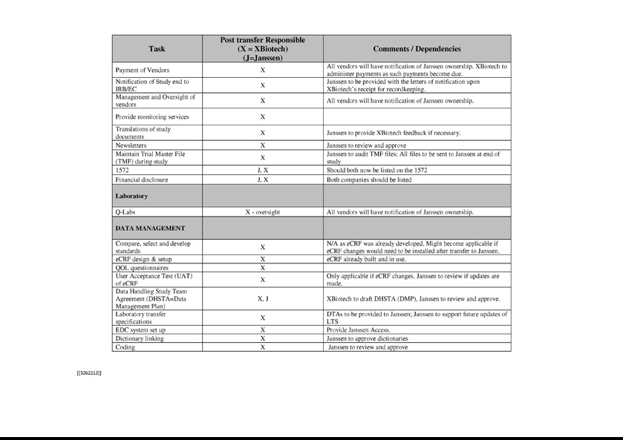

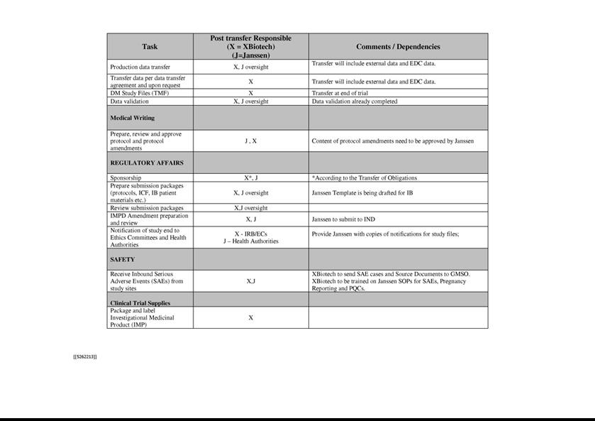

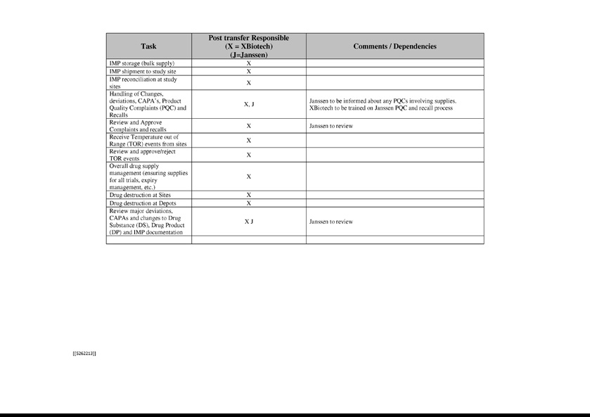

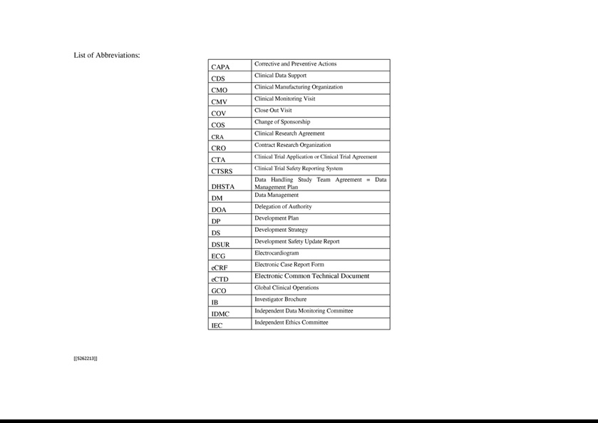

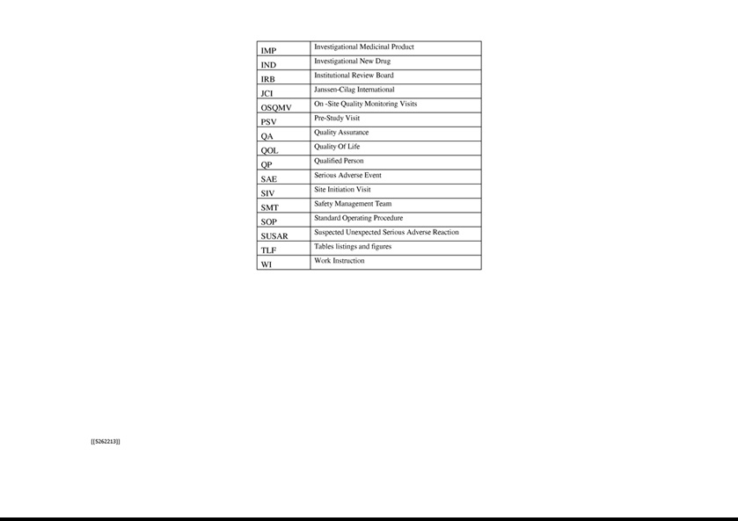



Exhibit 21.1

 | LIST OF SUBSIDIARIES
Name | Country
XBiotech USA, Inc. | United States
(Delaware)
XBiotech Switzerland AG | Switzerland
XBiotech Japan K.K. | Japan
XBiotech Germany GmbH | Germany

Exhibit 23.1

Consent of Independent Registered Public Accounting Firm

We consent to the incorporation by reference in the following Registration Statements:

- Registration Statement (Form S-3 No. 333-213218) of XBiotech Inc.,

- Registration Statement (Form S-3 No. 333-231849) of XBiotech Inc., and

- Registration Statement (Form S-8 No. 333-207476) pertaining to the 2005 Incentive Stock Option Plan and 2015 Equity Incentive Plan of XBiotech Inc.;

of our report dated March 16, 2020, with respect to the consolidated financial statements of XBiotech Inc. included in this Annual Report (Form 10-K) of XBiotech Inc. for the year ended December 31, 2019.

/s/ Ernst & Young LLP

Austin, Texas

March 16, 2020

Exhibit 31.1

CERTIFICATIONS

I, John Simard, certify that:

- I have reviewed this quarterly report on Form 10-K of XBiotech Inc.;

- Based on my knowledge, this report does not contain any untrue statement of a material fact or omit to state a material fact necessary to make the statements made, in light of the circumstances under which such statements were made, not misleading with respect to the period covered by this report;

- Based on my knowledge, the financial statements, and other financial information included in this report, fairly present in all material respects the financial condition, results of operations and cash flows of the registrant as of, and for, the periods presented in this report;

- The registrant's other certifying officer and I are responsible for establishing and maintaining disclosure controls and procedures (as defined in Exchange Act Rules 13a-15(e) and 15d-15(e)) and internal control over financial reporting (as defined in Exchange Act Rules 13a-15(f) and 15d-15(f)) for the registrant and have:

  - Designed such disclosure controls and procedures, or caused such disclosure controls and procedures to be designed under our supervision, to ensure that material information relating to the registrant, including its consolidated subsidiaries, is made known to us by others within those entities, particularly during the period in which this report is being prepared;

  - Designed such internal control over financial reporting, or caused such internal control over financial reporting to be designed under our supervision, to provide reasonable assurance regarding the reliability of financial reporting and the preparation of financial statements for external purposes in accordance with generally accepted accounting principles;

  - Evaluated the effectiveness of the registrant's disclosure controls and procedures and presented in this report our conclusions about the effectiveness of the disclosure controls and procedures, as of the end of the period covered by this report based on such evaluation; and

  - Disclosed in this report any change in the registrant’s internal control over financial reporting that occurred during the registrant’s most recent fiscal quarter (the registrant’s fourth fiscal quarter in the case of an annual report) that has materially affected, or is reasonably likely to materially affect, the registrant’s internal control over financial reporting; and

- The registrant's other certifying officer and I have disclosed, based on our most recent evaluation of internal control over financial reporting, to the registrant's auditors and the audit committee of the registrant's board of directors (or persons performing the equivalent functions):

  - All significant deficiencies and material weaknesses in the design or operation of internal control over financial reporting which are reasonably likely to adversely affect the registrant's ability to record, process, summarize and report financial information; and

  - Any fraud, whether or not material, that involves management or other employees who have a significant role in the registrant's internal control over financial reporting.

Date: March 16, 2020

/S/ John Simard

John Simard

Chief Executive Officer and President

(Principal Executive Officer)

Exhibit 31.2

CERTIFICATIONS

I, Queena Han, certify that:

- I have reviewed this quarterly report on Form 10-K of XBiotech Inc.;

- Based on my knowledge, this report does not contain any untrue statement of a material fact or omit to state a material fact necessary to make the statements made, in light of the circumstances under which such statements were made, not misleading with respect to the period covered by this report;

- Based on my knowledge, the financial statements, and other financial information included in this report, fairly present in all material respects the financial condition, results of operations and cash flows of the registrant as of, and for, the periods presented in this report;

- The registrant's other certifying officer and I are responsible for establishing and maintaining disclosure controls and procedures (as defined in Exchange Act Rules 13a-15(e) and 15d-15(e)) and internal control over financial reporting (as defined in Exchange Act Rules 13a-15(f) and 15d-15(f)) for the registrant and have:

  - Designed such disclosure controls and procedures, or caused such disclosure controls and procedures to be designed under our supervision, to ensure that material information relating to the registrant, including its consolidated subsidiaries, is made known to us by others within those entities, particularly during the period in which this report is being prepared;

  - Designed such internal control over financial reporting, or caused such internal control over financial reporting to be designed under our supervision, to provide reasonable assurance regarding the reliability of financial reporting and the preparation of financial statements for external purposes in accordance with generally accepted accounting principles;

  - Evaluated the effectiveness of the registrant's disclosure controls and procedures and presented in this report our conclusions about the effectiveness of the disclosure controls and procedures, as of the end of the period covered by this report based on such evaluation; and

  - Disclosed in this report any change in the registrant’s internal control over financial reporting that occurred during the registrant’s most recent fiscal quarter (the registrant’s fourth fiscal quarter in the case of an annual report) that has materially affected, or is reasonably likely to materially affect, the registrant’s internal control over financial reporting; and

- The registrant's other certifying officer and I have disclosed, based on our most recent evaluation of internal control over financial reporting, to the registrant's auditors and the audit committee of the registrant's board of directors (or persons performing the equivalent functions):

  - All significant deficiencies and material weaknesses in the design or operation of internal control over financial reporting which are reasonably likely to adversely affect the registrant's ability to record, process, summarize and report financial information; and

  - Any fraud, whether or not material, that involves management or other employees who have a significant role in the registrant's internal control over financial reporting.

Date: March 16, 2020

/S/ Queena Han

Queena Han

Vice President, Finance and Human Resources and Secretary

(Principal Financial Officer)

Exhibit 32.1

CERTIFICATION PURSUANT TO 18 U.S.C. SECTION 1350, AS ADOPTED PURSUANT TO

SECTION 906 OF THE SARBANES-OXLEY ACT OF 2002

In connection with the Annual Report of XBiotech Inc. on Form 10-K for the period ended December 31, 2019 as filed with the Securities and Exchange Commission on the date hereof (the “Report”), I, John Simard, Chief Executive Officer and President of the Company, certify, pursuant to 18 U.S.C. §1350, as adopted pursuant to §906 of the Sarbanes-Oxley Act of 2002, that to the best of my knowledge:

- The Report fully complies with the requirements of Section 13(a) or 15(d) of the Securities Exchange Act of 1934; and

- The information contained in the Report fairly presents, in all material respects, the financial condition and results of operations of XBiotech

Inc.

/S/ JOHN SIMARD

John Simard

Chief Executive Officer and President

(Principal Executive Officer)

Date: March 16, 2020

Exhibit 32.2

CERTIFICATION PURSUANT TO 18 U.S.C. SECTION 1350, AS ADOPTED PURSUANT TO

SECTION 906 OF THE SARBANES-OXLEY ACT OF 2002

In connection with the Annual Report of XBiotech Inc. on Form 10-K for the period ended December 31, 2019 as filed with the Securities and Exchange Commission on the date hereof (the “Report”), I, Queena Han, Vice President of Finance, Human Resources and Secretary of the Company, certify, pursuant to 18 U.S.C. §1350, as adopted pursuant to §906 of the Sarbanes-Oxley Act of 2002, that to the best of my knowledge:

- The Report fully complies with the requirements of Section 13(a) or 15(d) of the Securities Exchange Act of 1934; and

- The information contained in the Report fairly presents, in all material respects, the financial condition and results of operations of XBiotech

Inc.

/S/ QUEENA HAN

Queena Han

Vice President, Finance and Human Resources and Secretary

(Principal Financial Officer)

Date: March 16, 2020

